Conservation of Energy — Teacher Guide

Cover
Unit: Work, Energy & Power — Lesson 05: Conservation of Energy East Meadow Schools × Valley Stream Central High School District Strategy chips: ACTIVE LEARNING

Curated Resources (from East Meadow Scope & Sequence)

NYSSLS Standards
This lesson is the unit’s central computational payoff for HS-PS3-1: “Create a computational model to calculate the change in energy of one component in a system when the change in energy of the other component(s) and energy flows in and out of the system are known.” (CCC: Systems and System Models.) With no friction (no energy flow out), a drop in PE equals the gain in KE — students compute one component from the other. It also synthesizes HS-PS3-2 (energy = motion + relative position).

Phenomenon
- A skate park half-pipe / a pendulum / a roller coaster — energy trades between height and speed but the total stays the same. PhET Energy Skate Park: https://phet.colorado.edu/en/simulations/energy-skate-park-basics
- Javalab roller coaster: https://javalab.org/en/roller_coaster_en/

Javalab / Labs
- PhET Energy Skate Park Basics (bar-graph energy view): link above.
- Javalab roller coaster: link above.

Assessments
- PhET Energy Skate Park guided questions. The Exit Ticket below is the formative check; the “Make It Make Sense” items map to HS-PS3-1.

Lesson Overview
Duration | 42 minutes (1 period)
NYSSLS link | HS-PS3-1 (core — compute one energy component from another); HS-PS3-2 (synthesis)
CCC focus | Systems and System Models — with no energy flow out, total mechanical energy of the system is conserved.
Strategy chips | ACTIVE LEARNING (PhET/Javalab exploration, predict-and-test, energy bar-graph reading)
Materials | Computers/tablets (PhET + Javalab); a pendulum (string + mass) for a live demo; whiteboards.
Safety | Secure the pendulum mount; clear the swing path.
Prior knowledge | KE = ½mv² (Lesson 03), PE = mgh (Lesson 04), the joule.
Lesson objectives — students can:
- State conservation of energy: without friction, KE + PE (mechanical energy) stays constant.
- Describe the energy transformation PE ↔ KE as a skater/coaster/pendulum moves.
- Use conservation to compute a missing energy or speed: PE lost = KE gained.

Phase 1 · Engage (0 – 10 min)

0–3 min · Opening Connection (SEL)
Pair-share, one sentence: “Name something that trades back and forth — like effort and rest, or saving and spending.” Surface a couple, then frame: energy does the same trade between height and speed.

3–7 min · Phenomenon hook — the skate park / pendulum
Teacher actions. Release a pendulum from one side; it swings up to nearly the same height on the other side, again and again. (Or play a skate-park half-pipe clip.)
Sample teacher language:
“Watch how high it comes back. Almost exactly where it started — over and over. At the bottom it’s fast; at the top it’s stopped. Something is being traded. What, and is anything lost?”
Anticipated student responses:
- “It’s losing energy each swing.” — true with friction; we’ll isolate the frictionless ideal first.
- “Fast at the bottom, stopped at the top.” — capture the KE↔PE trade.
- “The energy turns into speed and back.” — exactly the transformation we’ll name.

7–10 min · Notice & Wonder + Turn-and-Talk #1
Two columns. Then:
“Turn to your partner: where is the pendulum fastest, where is it highest, and what does that tell you about where each kind of energy is biggest?”

Bridge to Phase 2
Each student leaves with an initial model: “As the pendulum swings down, its ______ energy turns into ______ energy because ______.”

Phase 2 · Explore (10 – 28 min)

10–13 min · Initial Model (silent / individual)
Prompt:
“Sketch the half-pipe (or pendulum). Mark TOP, MIDDLE, BOTTOM. At each point, predict whether KE and PE are HIGH, MEDIUM, or ZERO.”

13–28 min · Investigation — PhET Energy Skate Park + Javalab coaster
Active-learning exploration. Turn ON the energy bar-graph in PhET. With friction OFF first.
- Watch the KE and PE bars as the skater moves. At the top: which bar is tall? At the bottom?
- Read the total bar at top, middle, and bottom. Is it constant? Record three values.
- Turn friction ON. What now happens to the total over time? Where does the “missing” energy go?
- On the Javalab coaster, find a point where KE = PE and explain what that means.
Project to anchor the pattern:
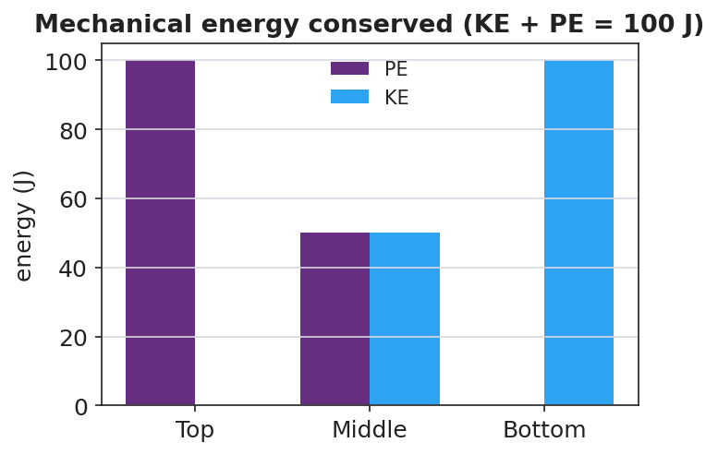
Stacked energy bar chart: PE and KE at top, middle, bottom sum to a constant 100 J
Teacher facilitation language:
“Add the two bars at each point. Do they sum to the same total? Predict the total at the middle before you look.” “With friction on, the total shrank — energy isn’t destroyed, so where did it go?”
Anticipated student responses:
- “PE plus KE is the same number everywhere — 100 J.” — the conservation insight.
- “With friction the total drops; it became heat.” — energy leaves the mechanical system as thermal energy.

Teacher facilitation during Explore
- What to look for — students summing KE + PE to a constant; locating the PE↔KE trade.
- What to resist — don’t state “conservation” before they sum the bars themselves.
- What to redirect — “energy disappeared” (friction case) → “energy is conserved overall; some left as heat — it’s not in the mechanical total anymore.”

Phase 3 · Explain (28 – 35 min)

28–31 min · Turn-and-Talk #2 + class consensus
“From the bar graphs: what is true about KE + PE without friction, and what does the skater’s motion do to those two energies?”
Target consensus:
“Without friction, mechanical energy (KE + PE) stays constant — energy is conserved. As the skater drops, PE transforms into KE; as it rises, KE transforms back into PE. With friction, some mechanical energy converts to heat, so the mechanical total drops, but total energy is still conserved.”

31–35 min · Vocabulary introduction (≤ 3 terms)
Define from the bar graphs.
Sample teacher language:
“The sum KE + PE is the mechanical energy. The rule that it doesn’t change without friction is conservation of energy. The swap from PE to KE and back is an energy transformation. So: PE lost = KE gained.”

Discussion prompts to deploy here
- “A 2.0 kg ball is dropped from 5.0 m. Ignoring friction, what is its KE just before it lands?”
  - Sample response: “PE lost = mgh = 2.0 × 9.81 × 5.0 ≈ 98 J, so KE ≈ 98 J at the bottom.”
- “Why does a pendulum eventually stop in the real world?”
  - Sample response: “Friction and air resistance transform some mechanical energy into heat each swing, so KE + PE slowly decreases.”

Phase 4 · Elaborate (35 – 40 min)

35–38 min · Revise the model + the cross-over graph
“Return to your TOP/MIDDLE/BOTTOM sketch. Now plot KE and PE vs. position along the track. Where do the curves cross, and what is true of their sum everywhere?”
Project:
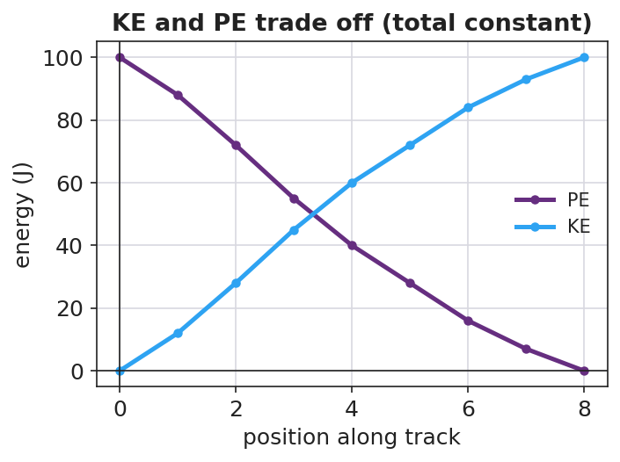
KE and PE vs position — the two curves cross while their sum stays constant
Target: the KE and PE curves are mirror images that cross where KE = PE; their sum is a flat line — the conserved mechanical energy.

38–40 min · Return to the phenomenon
“In one sentence, explain why the pendulum returns to (almost) the same height every swing, using conservation of energy and energy transformation.”

Phase 5 · Evaluate (40 – 42 min)

40–42 min · Exit Ticket + Closing Reflection
“A 0.50 kg cart starts at rest at the top of a frictionless track 2.0 m high. (Use g ≈ 9.81 m/s².) (a) What is its PE at the top? Show PE = mgh. (b) Using conservation of energy, what is its KE at the bottom? Explain. (c) On a real track with friction, would the KE at the bottom be more, less, or equal? Where does the difference go?”
Expected: (a) ≈ 9.81 J; (b) ≈ 9.81 J (PE lost = KE gained); (c) less — some energy transforms into heat. See Answer_Key.docx.
Closing Reflection (SEL, 30 seconds):
“Where did you see energy ‘trade’ today, and who helped you make sense of the swap?”

Common Misconceptions
- Misconception: “Energy gets used up / disappears.” → Correction: Energy is conserved; with friction it transforms into heat and leaves the mechanical total, but total energy is unchanged.
- Misconception: “At the bottom of the hill the cart has both maximum PE and maximum KE.” → Correction: At the lowest point PE is minimum and KE is maximum; they trade off.
- Misconception: “A pendulum can swing higher than it started.” → Correction: Without added energy, it can at most return to its starting height (conservation); friction makes it return lower.

Access & Differentiation
- ELL/ENL supports: Sentence frame: *“As the skater goes down, ___ energy turns into ___ energy, but the total (KE + PE) stays ___ because energy is ___.”* Word box: {mechanical energy, conservation of energy, energy transformation, constant, heat}. Use up/down hand gestures for PE/KE.
- IEP/SPED supports: Provide the PhET bar-graph screenshot with TOP/MIDDLE/BOTTOM pre-labeled; students fill HIGH/MEDIUM/ZERO. Provide the “PE lost = KE gained” relationship as a formula card.
- Extensions: Solve for speed at the bottom by setting mgh = ½mv² and canceling mass: v = √(2gh). Predict the skater’s speed at the bottom of a given hill and check in PhET.

Strategy Spotlight
ACTIVE LEARNING. Students discover conservation by manipulating the PhET skater and reading their own energy bar graphs — turning friction on and off to see the mechanical total hold, then leak. Require a prediction before each manipulation (predict-and-test), and have pairs report the total energy they measured at three points so the class sees the constant emerge from shared data, not from the teacher. The friction toggle is the key “aha”: energy is still conserved; it just left as heat.

NYSSLS Observation Checklist Crosswalk
# | Checklist item | Where it appears in this lesson
1 | Local/relatable phenomenon | Phase 1 — skate park / pendulum / coaster
2 | Turn and Talk (2–3×) | Phase 1 (TT#1 — fastest vs. highest), Phase 3 (TT#2 — KE + PE constant)
3 | Students develop questions/models/procedures | Phase 1 (initial model), Phase 2 (PhET/Javalab exploration), Phase 4 (revise model)
4 | CCC defined and used | Lesson Overview · Systems and System Models, applied in Phase 2 (friction on/off)
5 | ENL — ≤ 3 vocab, second half | Phase 3 — vocabulary at 31–35 min (mechanical energy / conservation / transformation)
6 | Revisit phenomenon with evidence | Phase 4 — KE/PE cross-over graph; restate pendulum return
7 | ENL/SPED supports | Access & Differentiation block
8 | Assessment check | Phase 5 — Exit Ticket (0.50 kg cart)

Companion Materials
- Student_Worksheet.docx — the 5E student investigation + PhET/Javalab guide (hand out at start of Phase 2)
- Student_Notes.docx — guided note-guide for vocabulary and the worked example
- Answer_Key.docx — answers to “Make It Make Sense” prompts and the Exit Ticket

Key Vocabulary (max 3)
- mechanical energy — the sum of an object’s kinetic and potential energy (KE + PE)
- conservation of energy — energy is never created or destroyed; without friction, mechanical energy stays constant
- energy transformation — the conversion of energy from one form to another, such as PE ↔ KE

