Energy in Systems: Wheels to Watts — Student Worksheet
Unit: Work, Energy & Power — Lesson 06 Name: _______________________ Date: __________ Period: ____

Phenomenon
When a car with regenerative braking slows down, it captures some of its motion as electricity instead of throwing it all away as heat in the brakes. A bike generator does the same: your pedaling lights a bulb — but the generator gets warm. Not all of the energy makes it through. “Wheels to Watts.”
Driving question: When a device converts one form of energy into another, how much comes out useful, where does the rest go, and how can we make it better?

Notice & Wonder
I notice… | I wonder…
Turn & Talk #1: Of all the energy you put into the crank, how much do you think comes out as useful electricity? Where does the rest go?

Initial Model
Draw your Wheels-to-Watts device (generator → load). Label the energy at each stage.
Energy goes IN as ____________ , comes OUT useful as ____________ , and is WASTED as ____________ .

Investigation — Wheels to Watts (build → measure → refine)
Work at your group’s board.
Step | Result
1. Trace the flow (input → useful → wasted)
2. Split a 100 J input: ___ J useful, ___ J wasted
3. Efficiency = useful ÷ input =
4. Rank devices by efficiency (incandescent ~5%, LED ~40%, generator ~75%)
5. Refine: one change to raise efficiency, and your predicted new efficiency
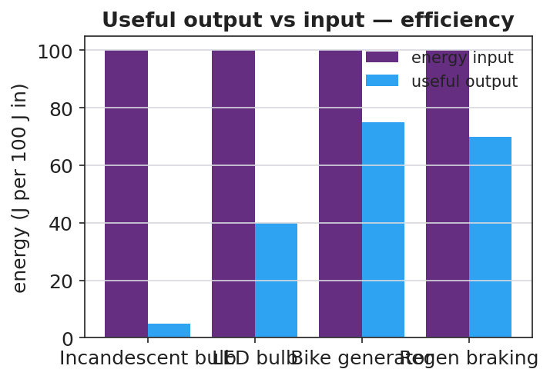
Useful output vs input for several devices
Key question: If 100 J go in and 75 J come out useful, where are the other 25 J — are they destroyed?

Make It Make Sense
- A motor uses 200 J of electrical energy and delivers 150 J of useful work. What is its efficiency? Show useful ÷ input.
- An incandescent bulb is about 5% efficient; an LED is about 40% efficient. For every 100 J supplied, how much useful light energy does each give? Where does the rest go?
- Why can no real device be 100% efficient?

Vocabulary in Action
Use each term in a sentence about today’s phenomenon.
- efficiency: _______________________________________________
- energy transfer: _______________________________________________
- system: _______________________________________________

Revise Your Model
Using a 100 J input, chart how much is useful vs. wasted for your refined device. Did your refinement move energy from the wasted bar into the useful bar?
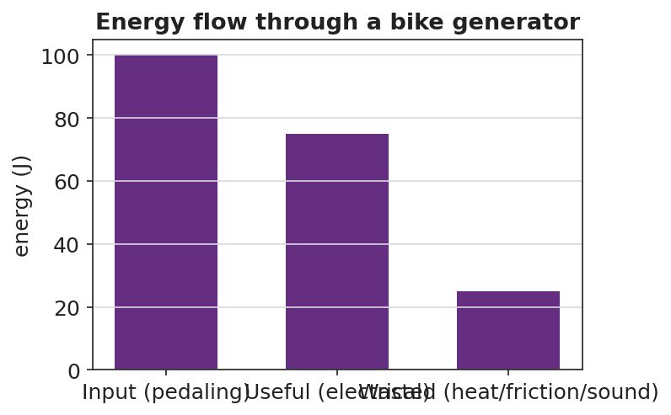
Energy flow through a bike generator
My refinement was ____________ . It raises efficiency because it reduces ____________ , which means more energy comes out as ____________ .

Exit Ticket
A bike generator takes in 400 J of pedaling energy and delivers 300 J of useful electrical energy.
- Calculate the efficiency. Show useful ÷ input.
- Where did the other 100 J go? Did it disappear?
- Propose ONE refinement that would raise the efficiency, and explain why it works.

