Thermal Energy and Temperature — Student Notes
Unit: Thermal Energy & Conservation — Lesson 01 Name: _______________________ Date: __________ Period: ____

Learning Targets
By the end of today’s 42 minutes I can:
- Define temperature as the average kinetic energy of the particles.
- Define thermal energy as the total kinetic energy of all the particles.
- Explain how two objects can be the same temperature but hold different amounts of thermal energy.

Key Vocabulary
- temperature — _______________________________________________
- thermal energy — _______________________________________________
- kinetic energy — _______________________________________________

Guided Notes
Big idea: Everything is made of particles that are always __________. The energy of that motion is __________ energy.
- Temperature measures the __________ kinetic energy of the particles → how __________ they move, on average.
- Heating a substance makes its particles move __________ (not bigger). Cooling makes them move __________.
- Thermal energy is the __________ kinetic energy of __________ the particles.
- Thermal energy depends on two things: the __________ (average speed) and the __________ of substance (how many particles).
Same temperature, different thermal energy:
- A cup and a swimming pool can both read 20 °C → the particles move at the same __________ speed.
- But the pool has far more __________, so it holds far more __________ energy.
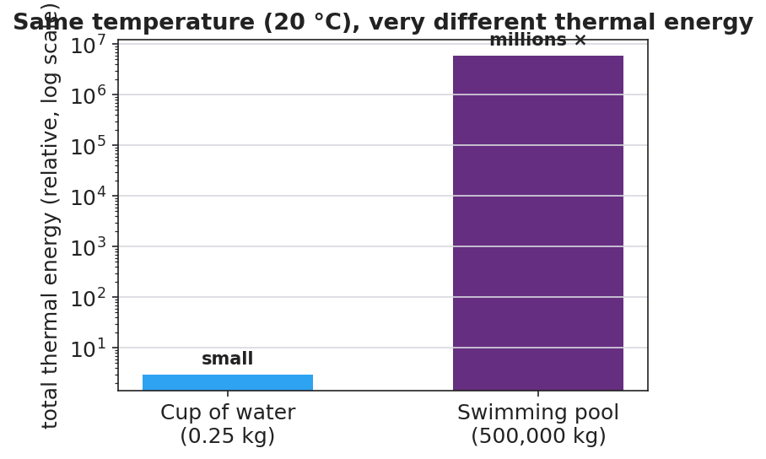
Cup vs pool — same temperature, very different thermal energy

Worked Example
Problem. A 0.25 kg cup of tea and a 500,000 kg swimming pool both read 25 °C. Which holds more thermal energy, and why?
Solution. 1. Same temperature → the particles move at the same __________ speed (same average kinetic energy each). 2. Thermal energy = average KE × the __________ of particles. 3. The pool has about __________ times as many particles → far more __________ kinetic energy. The pool holds vastly more thermal energy, even though it is not hotter.

Summary
Finish the sentence (Because / But / So):
A sparkler is hotter than a bathtub because __________________________________________, but __________________________________________, so __________________________________________.

