Thermal Energy and Temperature — Student Worksheet
Unit: Thermal Energy & Conservation — Lesson 01 Name: _______________________ Date: __________ Period: ____

Phenomenon
A lit sparkler burns at over 1,000 °C — yet a child can hold it inches away and be fine. A warm bath is only about 40 °C, but if it were ever 1,000 °C it would be deadly. Same idea, very different danger.
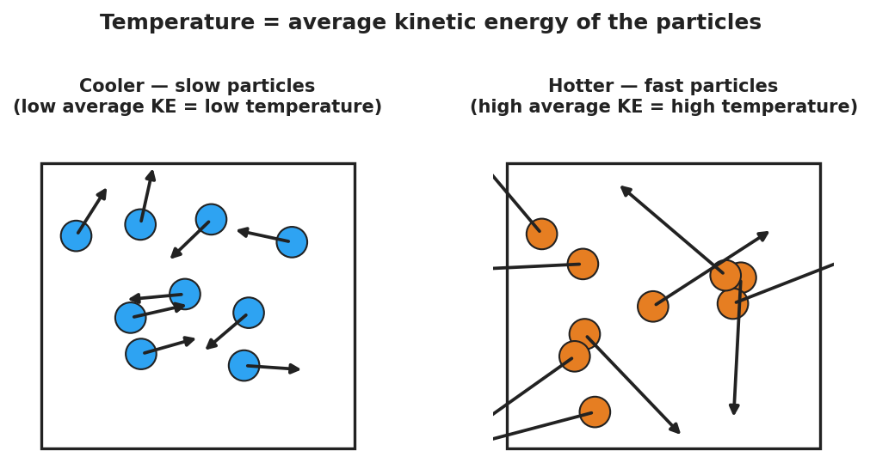
Slow particles versus fast particles
Driving question: What is the difference between something being hot and something holding a lot of energy?

Notice & Wonder
I notice… | I wonder…
Turn & Talk #1: What is the difference between a thing being hot and a thing having a lot of heat energy? Use the word particles.

Initial Model
Draw the particles inside the sparkler tip and inside the bathtub. Use arrow length to show how fast each particle moves and dots to show how many there are.
Sketch here:
Which has faster particles? __________ Which has more total particle motion? __________

Investigation
Use the particle simulation and the two beakers of room-temperature water.
Step | What I did | What I observed | What it tells me
1. Add heat in the sim
2. Cool it down in the sim
3. Small cup vs. large container (same temperature)
Key question: Both beakers read the same temperature. Why would the larger one take far more energy to boil away?

Make It Make Sense
- A cup of tea and a backyard pool both read 30 °C. Which has more thermal energy, and why?
- Why is a sparkler safe to hold even though it is far hotter than bathwater?
- If you double the amount of water but keep the temperature the same, what happens to the average particle speed? What happens to the total thermal energy?

Vocabulary in Action
Use each term in a sentence about today’s phenomenon.
- temperature: _______________________________________________
- thermal energy: _______________________________________________
- kinetic energy: _______________________________________________

Revise Your Model
Return to your Initial Model. Re-label one side “high average KE = high temperature” and use dots to show the total amount of substance. Rewrite your explanation using temperature and thermal energy.

Exit Ticket
A lit sparkler tip is about 1,000 °C. A warm bath is about 40 °C.
- Which has the higher temperature, and what does temperature measure about the particles?
- Which one could transfer more thermal energy to your body, and why?
- Two buckets of water read exactly 25 °C, but one holds 1 L and the other holds 50 L. Which has more thermal energy? Explain.

