Heat Transfer and the Second Law of Thermodynamics — Student Notes
Unit: Thermal Energy & Conservation — Lesson 02 Name: _______________________ Date: __________ Period: ____

Learning Targets
By the end of today’s 42 minutes I can:
- Describe how heat flows from a hotter object to a cooler one until thermal equilibrium.
- Identify conduction, convection, and radiation as the three modes of heat transfer.
- State the second law of thermodynamics in my own words.

Key Vocabulary
- heat — _______________________________________________
- thermal equilibrium — _______________________________________________
- second law of thermodynamics — _______________________________________________

Guided Notes
Big idea: When two objects at different temperatures touch, thermal energy flows from the __________ object to the __________ object. It never flows the other way on its own.
- The energy moving because of a temperature difference is called __________.
- The flow continues until both objects reach the __________ temperature — this is __________.
- At equilibrium there is no __________ flow of energy (particles still move, but energy is spread evenly).
Three ways thermal energy transfers:
- Conduction — energy passes by __________ (particle to particle), e.g. a spoon handle warming.
- Convection — a moving __________ (liquid or gas) carries the energy, e.g. warm water rising.
- Radiation — energy travels as __________ waves and needs no medium, e.g. warmth from the Sun.
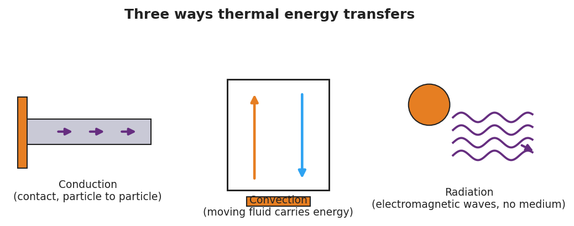
Conduction, convection, radiation
Second law of thermodynamics: In a __________ system, thermal energy spontaneously spreads to a more __________ distribution.
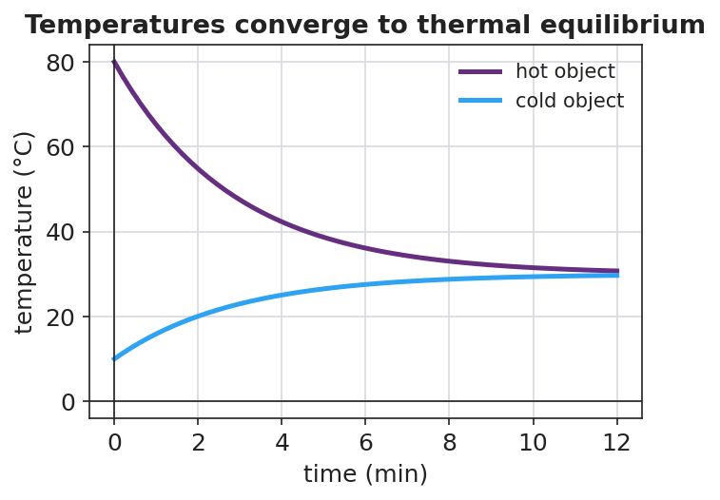
Two temperatures converging to equilibrium

Worked Example
Problem. A hot rock at 80 °C is placed in a sealed, insulated box with cool water at 10 °C. Describe what happens over time.
Solution. 1. Thermal energy flows from the __________ rock to the __________ water (hot → cold). 2. The rock’s temperature __________ and the water’s temperature __________. 3. They keep changing until both reach the __________ temperature → thermal equilibrium. 4. The energy that was concentrated in the rock is now spread more __________ across the system — the second law in action.

Summary
Finish the sentence (Because / But / So):
Thermal energy flows from the hot object to the cold object because __________________________________________, but __________________________________________, so __________________________________________.

