Heat Transfer and the Second Law of Thermodynamics — Student Worksheet
Unit: Thermal Energy & Conservation — Lesson 02 Name: _______________________ Date: __________ Period: ____

Phenomenon
Emperor penguins survive −40 °C winters by packing into a tight huddle and slowly rotating, so the warm birds in the center and the freezing birds on the edge keep trading places. Meanwhile, on your desk, an ice cube is melting in a cup of warm water.
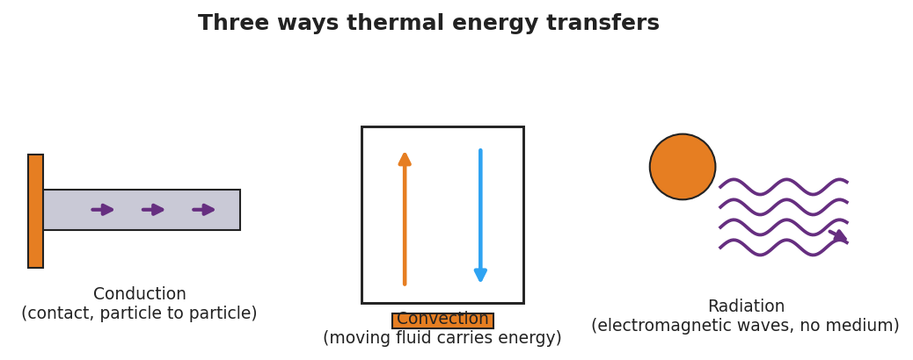
Conduction, convection, and radiation
Driving question: Which way does thermal energy move when a hot thing and a cold thing meet — and where do they end up?

Notice & Wonder
I notice… | I wonder…
Turn & Talk #1: Does energy move from the warm water to the ice, or from the ice to the water? How do you know?

Initial Model
Draw the warm water and the ice cube the instant they meet. Use arrows to show which way thermal energy flows.
Sketch here:
My prediction — the final temperature will be: closer to the ice / closer to the warm water / in between (circle one)

Investigation
Measure both temperatures every 30 seconds and record them.
Time (s) | Warm-water temp (°C) | Cold/ice temp (°C)
0
30
60
90
120
Then sketch the two curves on the same axes (warm one starts high, cold one starts low):
[ graph space ]
Key question: Do the two temperatures cross, or do they meet and stop? What is that endpoint called?

Make It Make Sense
- Which way does thermal energy flow when a hot object touches a cold object? Why never the other way on its own?
- A metal spoon left in hot soup gets warm at the handle, even though only the bowl end touches the soup. Which transfer mode explains this?
- Why do the penguins keep rotating through the huddle? Use the idea that energy “spreads out.”

Vocabulary in Action
Use each term in a sentence about today’s phenomenon.
- heat: _______________________________________________
- thermal equilibrium: _______________________________________________
- second law of thermodynamics: _______________________________________________

Revise Your Model
Expand this kernel sentence using all three conjunctions (Because / But / So):
“Thermal energy flows from the hot water into the ice because _______________________________________________, but _______________________________________________, so _______________________________________________.”

Exit Ticket
You drop a warm metal spoon into a cup of cold water in an insulated (closed) container.
- Which way does thermal energy flow, and why?
- What is the final situation called, and how do the two temperatures compare then?
- Name the heat-transfer mode that warms the spoon’s handle, and state the second law of thermodynamics in your own words.

