Calorimetry — Thermal Tales — Student Notes
Unit: Thermal Energy & Conservation — Lesson 03 Name: _______________________ Date: __________ Period: ____

Learning Targets
By the end of today’s 42 minutes I can:
- Use Q = m·c·ΔT to calculate the heat gained or lost by a sample.
- Show that, in a closed system, heat lost = heat gained.
- Plan and conduct a calorimetry investigation and predict the final temperature.

Key Vocabulary
- calorimetry — _______________________________________________
- specific heat — _______________________________________________
- heat — _______________________________________________

Guided Notes
The formula (Reference Table): Q = m · c · ΔT
- Q = __________ transferred, in joules (J)
- m = __________ of the substance, in kilograms (kg)
- c = __________ heat (for water, c = __________ J/kg·°C)
- ΔT = change in __________ = T_final − T_start (°C)
Closed-system rule: When a hot object and a cold object mix in an insulated container, no energy escapes, so:
heat __________ by the hot object = heat __________ by the cold object
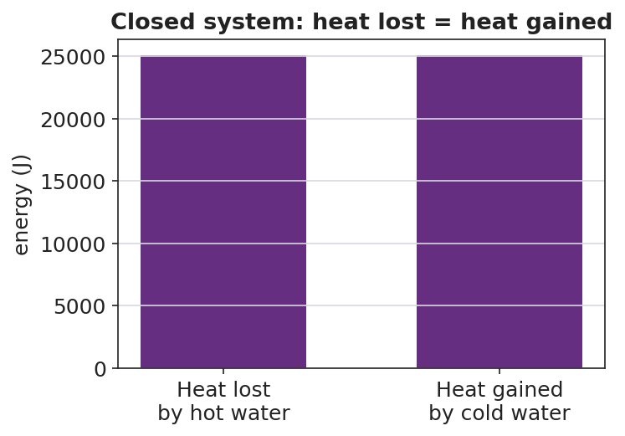
Heat lost = heat gained
- For equal masses of the same substance, the final temperature is the __________ of the two starting temperatures.
- For unequal masses, the final temperature lands closer to the __________ (larger-mass) sample.
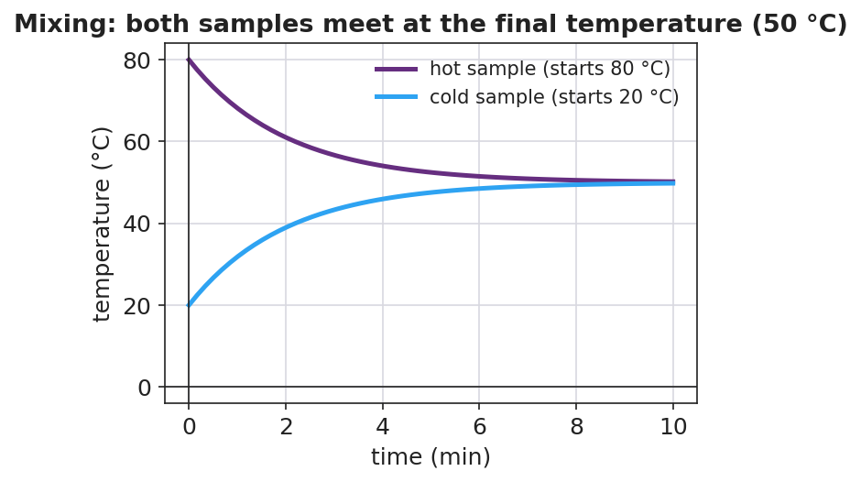
Hot and cold samples meeting at the final temperature

Worked Example
Problem. Mix 0.20 kg of water at 80 °C with 0.20 kg of water at 20 °C in an insulated cup. Find the final temperature and the heat transferred. (c = 4,186 J/kg·°C.)
Solution. 1. Equal masses of the same substance → final temperature is the __________ → T_f = __________ °C. 2. Heat gained by the cold water: Q = m·c·ΔT = (0.20)(4,186)(50 − 20) = __________ J. 3. Heat lost by the hot water: Q = (0.20)(4,186)(80 − 50) = __________ J. 4. The two Q’s are __________ in size → energy is conserved (heat lost = heat gained).

Summary
Finish the sentence (Because / But / So):
When hot water and cold water mix in a closed cup, the final temperature settles in between because __________________________________________, but __________________________________________, so __________________________________________.

