Calorimetry — Thermal Tales — Student Worksheet
Unit: Thermal Energy & Conservation — Lesson 03 Name: _______________________ Date: __________ Period: ____

Phenomenon
Your teacher holds equal amounts of hot water (80 °C) and cold water (20 °C). They are about to be poured together into an insulated cup. What will the thermometer read after they mix?
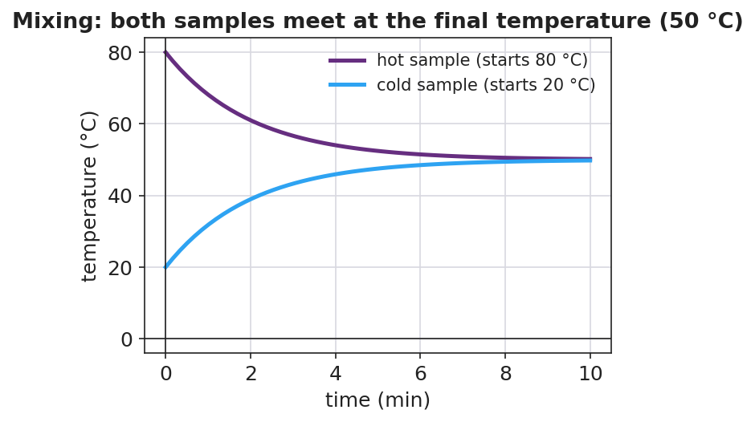
Hot and cold samples meeting at one final temperature
Driving question: When hot and cold water mix in a closed cup, what decides the final temperature?
Reference Table formula: Q = m·c·ΔT (c_water = 4,186 J/kg·°C)

Notice & Wonder
I notice… | I wonder…
My prediction (commit to a number before mixing): final temperature = __________ °C
Turn & Talk #1: The hot water cools and the cold water warms. Is the energy that leaves the hot water the same amount the cold water gains? Why?

Initial Model
With your group, plan the investigation. Write your procedure:
- What will you measure (masses, starting temperatures)? ____________________
- How will you keep the system closed? ____________________
- How will you know you have reached the final temperature? ____________________

Investigation
Record your calorimetry run.
 | Hot water | Cold water
Mass m (kg)
Starting temp (°C)
Final temp T_f (°C)
ΔT = T_f − start (°C)
Q = m·c·ΔT (J)

Time (s) | Mixed temperature (°C)
0
15
30
45
60
Key question: Compare the size of Q for the hot water and the cold water. What is the relationship?

Make It Make Sense
- Why does mixing equal masses of hot and cold water give a final temperature in the middle (the average)?
- If you mixed a little hot water into a lot of cold water, would the final temperature land above or below the average? Why?
- Why did we use a foam cup with a lid instead of an open metal beaker?

Vocabulary in Action
Use each term in a sentence about today’s investigation.
- calorimetry: _______________________________________________
- specific heat: _______________________________________________
- heat: _______________________________________________

Revise Your Model
Predict: 0.10 kg of 80 °C water poured into 0.30 kg of 20 °C water. Will the final temperature be above or below 50 °C? Justify using Q = m·c·ΔT (heat lost = heat gained).

Exit Ticket
In an insulated cup you mix 0.20 kg of water at 80 °C with 0.20 kg of water at 20 °C. (c_water = 4,186 J/kg·°C.)
- Using heat lost = heat gained, what is the final temperature?
- Calculate the heat gained by the cold water with Q = m·c·ΔT.
- How does that compare to the heat lost by the hot water, and what principle does that show?

