Classification of Matter — Student Notes
Unit: Physical Behavior of Matter — Lesson 01 Name: _______________________ Date: __________ Period: ____

Learning Targets
By the end of today’s 42 minutes I can:
- Distinguish a pure substance from a mixture using particle-level reasoning.
- Distinguish an element from a compound (one kind of atom vs. two or more kinds bonded).
- Distinguish a homogeneous mixture from a heterogeneous mixture (uniform vs. visibly non-uniform).
- Classify a named or pictured sample of matter and justify my answer using Structure and Function.

Key Vocabulary
- pure substance — _______________________________________________ _______________________________________________
- mixture — _______________________________________________ _______________________________________________
- homogeneous — _______________________________________________ _______________________________________________

Guided Notes
The big idea — Structure and Function: How a sample is put together at the __________ level decides how we classify it. The first question is always: can the sample be physically __________ into different substances? If it cannot, it is a __________ substance. If it can, it is a __________.
The two-question classification test:
- Question 1 — Can it be physically separated?
  - No → it is a __________ substance.
  - Yes → it is a __________.
- Question 2a — If it is a pure substance: is it made of one kind of atom, or two or more kinds bonded?
  - One kind of atom → __________ (e.g. copper, O₂)
  - Two or more kinds of atoms bonded in a fixed ratio → __________ (e.g. H₂O, NaCl)
- Question 2b — If it is a mixture: does it look uniform, or can you see the parts?
  - Uniform all the way through → __________ mixture (e.g. saltwater, air)
  - You can see the separate parts → __________ mixture (e.g. trail mix, sand + iron)
Prefix hint: homo- means __________ ; hetero- means __________ .
The classification tree:
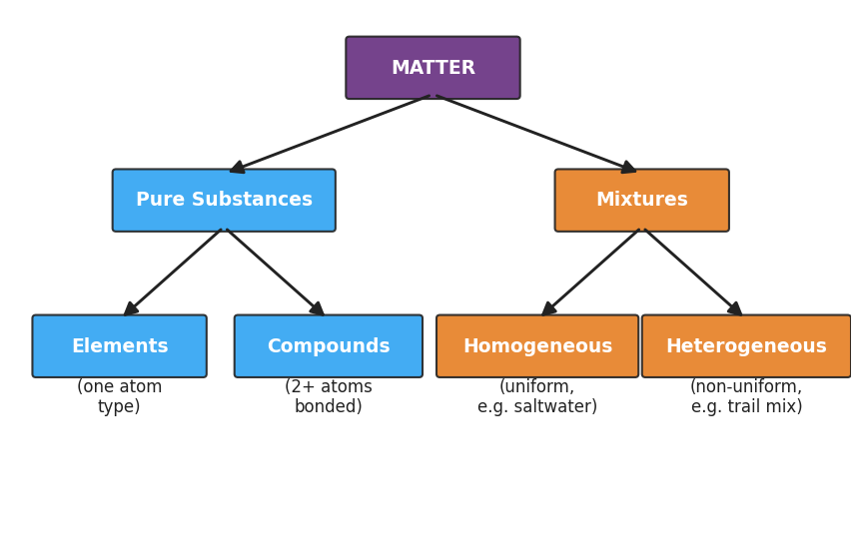
Flowchart classifying matter: MATTER branches into Pure Substances and Mixtures; Pure Substances branches into Elements (one kind of atom) and Compounds (two or more kinds of atoms bonded); Mixtures branches into Homogeneous (uniform, e.g. saltwater) and Heterogeneous (non-uniform, e.g. trail mix).
From the tree above, fill in the blanks:
- The two branches directly under MATTER are __________ and __________ .
- The two kinds of pure substance are __________ and __________ .
- The two kinds of mixture are __________ and __________ .
Particle-level pictures (one kind of atom = purple; a second kind = blue):
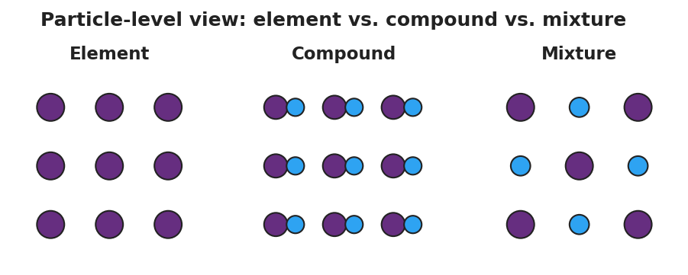
Three side-by-side particle diagrams: an element shown as a grid of identical purple atoms; a compound shown as purple-and-blue atom pairs bonded together; and a mixture shown as separate purple and blue atoms that are not bonded.
- Element: ___ kind(s) of atom.
- Compound: ___ kinds of atoms, and they are __________ together.
- Mixture: ___ kinds of atoms, and they are __________ bonded — just mixed.
The key trap: A homogeneous mixture (like saltwater) looks uniform, just like a pure substance. But it can be physically separated, so it is a __________ , not a pure substance.

Worked Example
Scenario: You are handed a cup of clear, colorless saltwater and a separate jar of clear, colorless distilled water. They look identical. Classify each one.
Step 1 — Question 1: Can it be physically separated?
- Saltwater: if you boil it, water vapor escapes and solid __________ is left behind → it CAN be separated → __________ .
- Distilled water: if you boil it, only water vapor leaves and __________ is left behind → it CANNOT be separated → __________ substance.
Step 2 — Sub-classify each one:
- Saltwater is a mixture. Does it look uniform or can you see the parts? It looks __________ all the way through → it is a __________ mixture.
- Distilled water is a pure substance. Is it one kind of atom or two kinds bonded? Water is H₂O — __________ kinds of atoms (hydrogen and oxygen) bonded → it is a __________ .
Step 3 — State the classification:
- Saltwater = __________________________________________
- Distilled water = __________________________________________
Step 4 — Because / But / So
Saltwater and distilled water look identical because _______________________________________________, but _______________________________________________, so _______________________________________________.
Check your reasoning: “because” should name the shared appearance; “but” should name the separability difference; “so” should state the two different classifications.

Summary
Complete the sentence:
To classify any sample of matter, I first ask whether it can be physically __________ . If it cannot, it is a __________ substance — either an __________ (one kind of atom) or a __________ (two or more kinds bonded). If it can, it is a __________ — either __________ (uniform) or __________ (you can see the parts).
Complete the Because / But / So sentence:
A homogeneous mixture like saltwater is NOT a pure substance because __________________________________________, but __________________________________________, so __________________________________________.
Reminder: Appearance does not classify matter. A homogeneous mixture can look exactly like a pure substance — the real test is whether the components can be physically separated, which depends on how the particles are put together.

