Classification of Matter — Student Worksheet
Unit: Physical Behavior of Matter — Lesson 01 Name: _______________________ Date: __________ Period: ____

Phenomenon
Four samples are on the front bench: a strip of copper wire, a jar of distilled water, a cup of saltwater, and a spoonful of trail mix. Each one is matter — but is each made of just one substance, or many substances mixed together? The trail mix is obviously many things. But the distilled water and the saltwater look identical — two clear, colorless liquids — and yet one is a single substance and the other is a mixture. Appearance alone won’t tell you which is which.
Driving question: How can we tell whether a sample is one substance or many?

Notice & Wonder
I notice… | I wonder…
Turn & Talk #1: The distilled water and the saltwater look identical. What test — not just looking — could you actually do to find out which one is a single substance and which one is a mixture?

Initial Model
Before your teacher names anything, sort the ten samples below into groups that make sense to you. You decide the rule. Then, in the last column, write a short note on what each group has in common.
Samples: copper, oxygen gas (O₂), distilled water, table salt (NaCl), saltwater, air, trail mix, sand + iron filings, carbon dioxide (CO₂), brass.
Sample | My group (1, 2, 3, or 4) | My rule — what does this group have in common?
copper
oxygen gas (O₂)
distilled water
table salt (NaCl)
saltwater
air
trail mix
sand + iron filings
carbon dioxide (CO₂)
brass

Investigation

Part 1 — Re-sort into four bins
Now re-sort using this rule. First decide if each sample is a PURE substance (cannot be physically separated) or a MIXTURE (can be physically separated). Then split each into two. Don’t worry about the names yet — just get the four piles right.
Bin | Rule for this bin | Samples I placed here
Bin A | Pure — one kind of atom
Bin B | Pure — two or more kinds of atoms bonded together
Bin C | Mixture — looks uniform all the way through
Bin D | Mixture — you can see the separate parts

Part 2 — Mystery Samples
Your teacher will give you 3–4 numbered unknown samples. For each one, observe its appearance, try a physical separation (evaporate a drop, filter, or test with a magnet), and classify it.
Sample # | Looks uniform or non-uniform? | What happened when you tried to separate it? | Pure substance or mixture?
1
2
3
4
Key question: Two of the bench samples — distilled water and saltwater — look identical. Which physical test would separate one of them but leave the other unchanged, and what would that prove?

Part 3 — Draw the particle models
Look at the figure below. In the boxes, draw your own particle diagrams: an element (one kind of atom), a compound (two kinds of atoms bonded), and a mixture (two kinds of atoms, not bonded). Label each one.
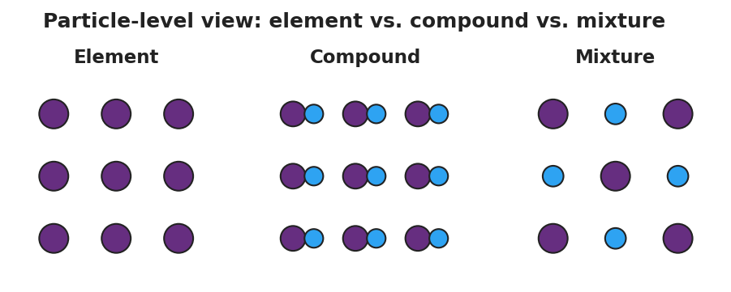
Three side-by-side particle diagrams: an element shown as a grid of identical purple atoms; a compound shown as purple-and-blue atom pairs bonded together; and a mixture shown as separate purple and blue atoms that are not bonded.
My ELEMENT drawing | My COMPOUND drawing | My MIXTURE drawing
- How many kinds of atoms are in your element drawing? _______________
- What is the difference between your compound drawing and your mixture drawing?

Make It Make Sense
For each sample below, classify it as fully as you can and give a particle-level reason. Use the words pure substance, mixture, element, compound, homogeneous, and heterogeneous where they fit.
- Copper wire. A strip of clean, shiny copper.
  - Pure substance or mixture? _______________________________________________
  - If pure: element or compound? _______________________________________________
  - Particle-level reason: _______________________________________________
- Saltwater. A clear, colorless liquid made by dissolving table salt in water.
  - Pure substance or mixture? _______________________________________________
  - If a mixture: homogeneous or heterogeneous? _______________________________________________
  - How could you physically separate it? _______________________________________________
- Trail mix. Raisins, peanuts, and chocolate pieces in a bag.
  - Pure substance or mixture? _______________________________________________
  - If a mixture: homogeneous or heterogeneous? _______________________________________________
  - How do you know without any test? _______________________________________________
- Carbon dioxide (CO₂). A colorless gas.
  - Pure substance or mixture? _______________________________________________
  - If pure: element or compound? _______________________________________________
  - How many kinds of atoms are in one CO₂ particle? _______________________________________________

Vocabulary in Action
Use each term in a sentence about today’s investigation. Do not copy the definition — describe something you actually sorted, observed, or tested.
- pure substance: _______________________________________________ _______________________________________________
- mixture: _______________________________________________ _______________________________________________
- homogeneous: _______________________________________________ _______________________________________________

Revise Your Model
Return to your four-bin sort. Now that you have the vocabulary, re-label each bin with the correct term:
- Bin A = _______________ (Pure — one kind of atom)
- Bin B = _______________ (Pure — two or more kinds of atoms bonded)
- Bin C = _______________ mixture (looks uniform)
- Bin D = _______________ mixture (you can see the parts)
Then finish this Because / But / So sentence about the opening phenomenon:
Distilled water and saltwater look identical because __________________________________________, but __________________________________________, so __________________________________________.

Exit Ticket
- Classify helium gas (He). Is it a pure substance or a mixture? An element or a compound? Explain your reasoning at the particle level.

- Classify a bottle of Italian salad dressing that has separated into an oil layer and a vinegar-and-herb layer. Pure substance or mixture? Homogeneous or heterogeneous? Explain.

- In one sentence, explain how a homogeneous mixture (like saltwater) is different from a compound (like water), even though both can look like a single clear liquid.

