States of Matter & Phase Changes — Student Notes
Unit: Physical Behavior of Matter — Lesson 02 Name: _______________________ Date: __________ Period: ____

Learning Targets
By the end of today’s 42 minutes I can:
- Describe and draw the particle arrangement and motion in a solid, a liquid, and a gas.
- Name the six phase changes (melting, freezing, vaporization, condensation, sublimation, deposition) and state whether energy is absorbed or released.
- Explain, in terms of kinetic energy and particle motion, why adding energy changes a substance’s state without changing the substance.
- Use Energy and Matter to explain why dry ice sublimes directly from solid to gas while water ice melts first.

Key Vocabulary
- phase change — _______________________________________________ _______________________________________________
- sublimation — _______________________________________________ _______________________________________________
- kinetic energy — _______________________________________________ _______________________________________________

Guided Notes
The big idea — Energy and Matter: Every phase change is driven by __________. Adding energy makes particles move __________ and spread __________ apart (toward gas). Removing energy makes particles move __________ and pack __________ together (toward solid). Through it all, the __________ stays the same — only its state changes. Matter is conserved; energy moves.
The three states — fill in the particle model:
State | Particle arrangement | Particle motion | Shape / Volume
Solid |  |  | definite / definite
Liquid |  |  | takes container / definite
Gas |  |  | takes container / takes container
The figure — particle arrangement in the three states:
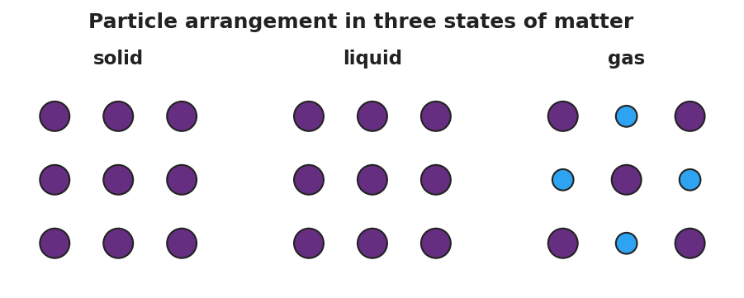
Three side-by-side particle-model panels for one substance: a ‘solid’ panel with particles packed in a tight orderly grid, a ‘liquid’ panel with particles still touching but shifted out of rows so they can slide past one another, and a ‘gas’ panel with particles spread far apart with large empty gaps between them.
From the figure: as you move solid → liquid → gas, the space between particles gets __________ and the particle motion gets __________.
The six phase changes — fill in the name and the energy direction:
Starting → Ending | Phase change | Energy (in / out)
solid → liquid | __________ | __________
liquid → solid | __________ | __________
liquid → gas | __________ | __________
gas → liquid | __________ | __________
solid → gas | __________ | __________
gas → solid | __________ | __________
Pattern to remember: changes that move toward gas (more spread out) __________ energy; changes that move toward solid (more packed) __________ energy.
The heating curve:
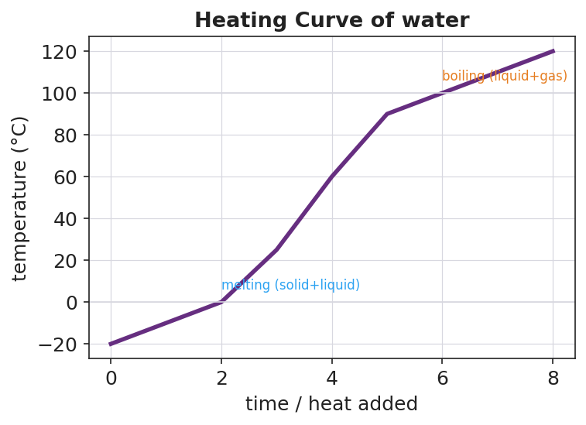
A temperature-versus-time heating curve for water as energy is added, with a flat plateau at 0 °C labeled melting and a second flat plateau at 100 °C labeled boiling, and rising sections between and after the plateaus.
- The two flat plateaus are where a __________ is happening. The temperature stays steady because the added energy is used to __________ the particles, not to speed them up.
- The first plateau (0 °C for water) is __________; the second plateau (100 °C for water) is __________.
The Hochman appositive definition:
Sublimation — _________________________ — is exactly what dry ice does.

Worked Example
Scenario: A teacher places solid carbon dioxide (dry ice, CO₂) in a warm room. It gives off thick white fog and shrinks, but the tray under it stays completely dry — no liquid ever appears.
Work through the reasoning:
- Starting state of the CO₂: _______________ Ending state: _______________
- Name the phase change: _______________________________________________
- Is energy absorbed or released? _______________ Where does that energy come from? _______________________________________________
- What happens to the particles? As the CO₂ particles gain __________ energy, they move __________ and spread __________ apart — jumping straight from the tightly packed solid arrangement to the far-apart gas arrangement.
- Why is there no puddle? Unlike water, carbon dioxide has no stable __________ state at normal room pressure, so the solid goes directly to __________.
- Because / But / So: Dry ice never leaves a puddle because _______________________________________________, but _______________________________________________, so _______________________________________________.
Check your reasoning: “because” should describe the particles gaining energy and spreading out; “but” should note that CO₂ has no stable liquid state; “so” should conclude that it sublimes (solid → gas) and stays dry.

Summary
Complete the appositive sentence:
A phase change — _________________________ — never changes _________________________.
Complete the Because / But / So sentence:
Adding energy to a solid can turn it into a gas because __________________________________________, but __________________________________________, so __________________________________________.
Reminder: A phase change is a physical change — the substance is conserved. Ice, liquid water, and steam are all H₂O. Dry ice and CO₂ gas are both carbon dioxide. Only the energy and arrangement of the particles change, never the identity of the matter.
Key idea (Energy and Matter): - Energy in → particles speed up and spread out → toward gas. - Energy out → particles slow down and pack together → toward solid. - Matter is conserved through every phase change.

