States of Matter & Phase Changes — Student Worksheet
Unit: Physical Behavior of Matter — Lesson 02 Name: _______________________ Date: __________ Period: ____

Phenomenon
A block of dry ice — solid carbon dioxide, CO₂(s) — and a beaker of ordinary water ice both sit on the warm front table. Both are cold solids in the same warm room. But they behave completely differently. The water ice melts into a puddle of liquid water and then slowly evaporates. The dry ice gives off thick white fog and shrinks — but it never leaves a puddle. The solid turns straight into a gas, skipping the liquid phase entirely.
Driving question: Why does dry ice (solid CO₂) skip the liquid phase entirely?

Notice & Wonder
I notice… | I wonder…
Turn & Talk #1: Both solids are absorbing energy from the same warm room. The water ice becomes a liquid first; the dry ice goes straight to gas. In one sentence, what might be different about how tightly the particles are held in each solid?

Initial Model
Before your teacher names anything, draw the particles of one substance in three boxes — as a solid, as a liquid, and as a gas. In each box, show how close together the particles are and add arrows for how fast they move. Between the boxes, draw an arrow and label whether you ADD or REMOVE energy to get from one state to the next.
SOLID | LIQUID | GAS
Energy arrows (label ADD or REMOVE):
Solid → Liquid: ____________ Liquid → Gas: ____________

Investigation

Part 1 — Particle model: compare the three states
Study the figure below. For each state, record how the particles are arranged, how much they move, and whether the shape and volume are fixed.
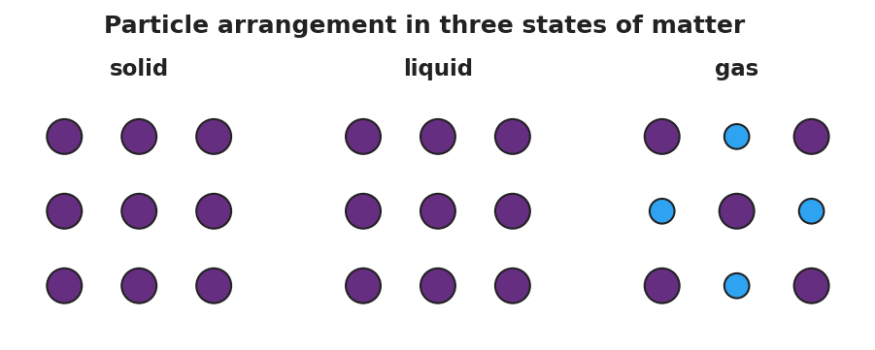
Three side-by-side particle-model panels for one substance. The ‘solid’ panel shows identical purple particles packed in a tight, orderly grid with no gaps. The ‘liquid’ panel shows the same particles still touching but shifted out of perfect rows, able to slide past one another. The ‘gas’ panel shows particles spread far apart with large empty gaps between them, moving fast and independently.
State | How are the particles arranged? | How much do they move? | Definite shape? Definite volume?
Solid
Liquid
Gas
Key question: As you go from solid → liquid → gas, what happens to the space between the particles, and what must you add to make that happen?

Part 2 — The heating curve and the six phase changes
Watch the Javalab “Boiling Point” simulation (or study the figure) as energy is added to a sample at a steady rate.
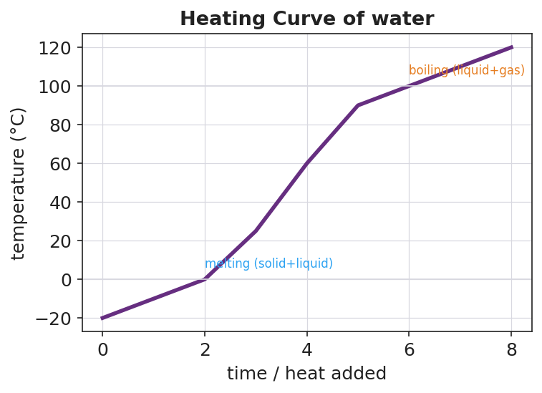
A temperature-versus-time heating curve for water as energy is added at a steady rate. The line rises from below 0 °C, flattens into a horizontal plateau at 0 °C labeled ‘melting (solid+liquid)’, rises through the liquid range, flattens into a second plateau at 100 °C labeled ‘boiling (liquid+gas)’, then rises again above 100 °C. The y-axis is temperature in degrees Celsius and the x-axis is time / heat added.
- The line goes flat at 0 °C and again at 100 °C. What is happening to the substance during each flat part?
0 °C plateau: _______________________________________________
100 °C plateau: _______________________________________________
- During a flat plateau you are still adding energy, but the temperature does not rise. Where is that energy going?

- Complete the phase-change table. Name each change and mark whether energy is absorbed (added) or released (removed).
Starting state | → Ending state | Phase change | Energy absorbed or released?
solid | → liquid
liquid | → solid
liquid | → gas
gas | → liquid
solid | → gas
gas | → solid

Make It Make Sense
For each scenario, name the phase change, state whether energy is absorbed or released, and explain in one sentence what is happening to the particles.
- Solid iodine crystals are gently warmed in a sealed tube and a purple gas appears above the crystals — no liquid forms.
  - Phase change: _______________________________________________
  - Energy absorbed or released? _______________________________________________
  - What is happening to the particles? _______________________________________________
- Liquid water in a freezer tray turns into solid ice cubes overnight.
  - Phase change: _______________________________________________
  - Energy absorbed or released? _______________________________________________
  - What is happening to the particles? _______________________________________________
- The dry ice on the front table (solid CO₂) shrinks and gives off gas, but never leaves a puddle.
  - Phase change: _______________________________________________
  - Energy absorbed or released? _______________________________________________
  - Why is there no puddle? _______________________________________________

Vocabulary in Action
Use each term in a sentence about today’s phenomenon or investigation. Do not copy the definition — use the word to describe something you observed or did.
- phase change: _______________________________________________ _______________________________________________
- sublimation: _______________________________________________ _______________________________________________
- kinetic energy: _______________________________________________ _______________________________________________

Revise Your Model
Return to your Initial Model (the three particle boxes). Improve it:
- Label each box with its kinetic-energy level: lowest, middle, or highest.
- Label each arrow between boxes with the correct phase-change name and “energy in” or “energy out.”
- Add one new arrow drawn directly from the solid box to the gas box (skipping the liquid). Label it: _______________
Then finish this Because / But / So sentence about the phenomenon:
Dry ice gives off gas and shrinks but never leaves a puddle because __________________________________________, but __________________________________________, so __________________________________________.

Exit Ticket
- On a cool night, white naphthalene vapor from a mothball forms solid crystals directly on the underside of a cold jar lid — no liquid ever forms.
Phase change: _________________ Energy absorbed or released? _________________
- Hot steam from a shower turns into tiny liquid droplets that fog a cold bathroom mirror.
Phase change: _________________ Energy absorbed or released? _________________
- In one sentence, explain in terms of energy and particle motion why dry ice sublimes instead of melting.

