Physical vs. Chemical Properties & Changes — Student Notes
Unit: Physical Behavior of Matter — Lesson 03 Name: _______________________ Date: __________ Period: ____

Learning Targets
By the end of today’s 42 minutes I can:
- Distinguish a physical change from a chemical change and justify the call using observable evidence.
- Name the five common signs of chemical change and identify them in a new scenario.
- Classify a property as intensive (independent of amount) or extensive (depends on amount).
- Explain, using Cause and Effect, why a chemical change produces a new substance while a physical change does not.

Key Vocabulary
- physical change — _______________________________________________ _______________________________________________
- chemical change — _______________________________________________ _______________________________________________
- intensive property — _______________________________________________ _______________________________________________

Guided Notes
The big idea — Cause and Effect: A change is an effect caused by some input (cutting, heating, igniting). To classify it, ask one question: is it still the same substance?
- If the substance keeps its identity → __________ change (only the form changed).
- If one or more __________ substances form → __________ change.
Physical change — what happens to the particles:
Adding energy can re-space or rearrange particles without breaking the bonds inside them. Examples:
Example | Why it is physical
Cutting paper
Melting ice
Dissolving salt in water
Chemical change — the five signs:
When enough __________ is added to break and remake bonds, the atoms recombine into new substances. Watch for these clues:
- __________ change (a new color appears)
- __________ produced (bubbles or a new odor — not from boiling)
- __________ or __________ released or absorbed (light, or the container warms/cools)
- a __________ forms (a solid appears in a liquid)
- the change is hard to __________
Warning — these can fool you:
- Bubbles from boiling are just water becoming vapor → __________ change.
- A bubble counts as a chemical-change sign only when the gas is a __________ substance.
Intensive vs. extensive properties:
 | Depends on amount? | Examples
Intensive property |  | density, color, boiling point, melting point
Extensive property |  | mass, volume, length
To identify an unknown substance, use __________ properties — they stay the same for any sample size.
The figure — cut paper vs. burn paper:
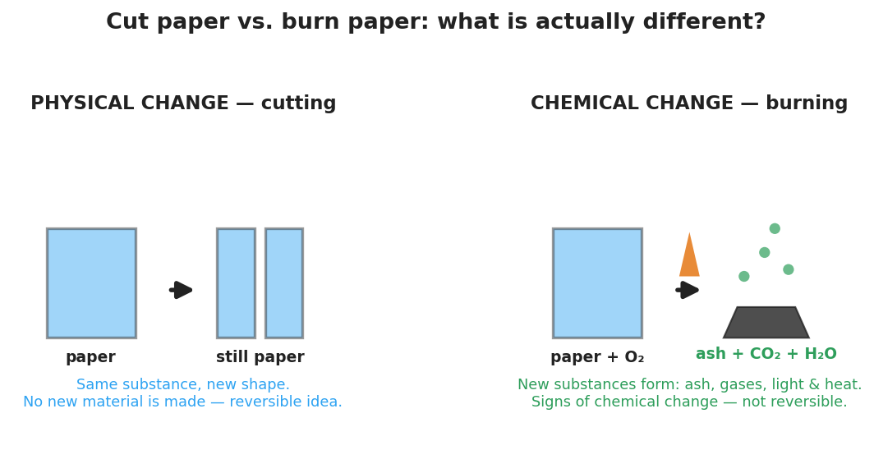
Two-panel diagram. Left: cutting paper is a physical change — the paper stays paper and no new substance forms. Right: burning paper is a chemical change — new substances (ash, carbon dioxide, water vapor) form along with light and heat.
From the figure, fill in:
- The cut paper at the end is still ___________ → __________ change.
- The burned paper becomes ___________, ___________, and ___________ → __________ change.

Worked Example
Scenario: A student observes steel wool (mostly iron, Fe) left in vinegar over a class period. The steel wool warms up and turns reddish-brown.
Step 1 — Ask the key question: Is it still the same substance?

Step 2 — Look for signs of chemical change: List every sign you observe.
Sign 1: _______________________________________________ Sign 2: _______________________________________________
Step 3 — Classify the change: This is a ___________ change because _______________________________________________.
Step 4 — Name the new substance idea: The reddish-brown material is iron oxide (rust), a __________ substance — not the original iron.
Step 5 — Intensive or extensive? The color of the rust (reddish-brown) is a(n) ___________ property; the mass of rust formed is a(n) ___________ property.
Step 6 — Because / But / So:
Rusting steel wool is a chemical change because _______________________________________________, but simply cutting the steel wool would be _______________________________________________, so _______________________________________________.
Check your reasoning: “because” should name a sign of chemical change and the new substance; “but” should contrast a physical change; “so” should state what makes this one chemical.

Summary
Complete the Because / But / So sentence:
A chemical change makes a new substance but a physical change does not because __________________________________________, but __________________________________________, so __________________________________________.
Quick reference — the five signs of chemical change: color change · gas produced (new gas, not boiling) · light/heat released or absorbed · precipitate forms · hard to reverse
Remember: Intensive properties (density, color, boiling point) do not depend on amount and help you identify a substance. Extensive properties (mass, volume, length) do depend on amount.

