Distinguishing Elements, Compounds, and Mixtures — Student Notes
Unit: Physical Behavior of Matter — Lesson 04 Name: _______________________ Date: __________ Period: ____

Learning Targets
By the end of today’s 42 minutes I can:
- Classify a sample of matter as an element, a compound, or a mixture from a description, a particle diagram, or a chemical formula.
- Draw a particle-level diagram for an element, a compound, and a mixture.
- Use a chemical symbol or formula to decide whether a substance is an element or a compound.
- Explain, using Structure and Function, why a compound has different properties than the elements that form it, while a mixture keeps its parts’ properties.

Key Vocabulary
- element — _______________________________________________ _______________________________________________
- compound — _______________________________________________ _______________________________________________
- mixture — _______________________________________________ _______________________________________________

Guided Notes
The big idea — Structure and Function: How the particles are __________ and __________ (the structure) decides how the substance __________ (the function). Bonding different atoms makes a brand-new substance; physically mixing does __________ make a new substance.
The three categories — sort by the particles:
Category | How many kinds of atom? | Are the atoms bonded? | Example
Element | __________ kind | (may be bonded as a molecule, but all the same kind) | Cu, O₂
Compound | two or more __________ kinds | __________ — in a fixed ratio | H₂O, NaCl
Mixture | two or more substances | __________ — just physically combined | salt water, air
Reading symbols and formulas:
- A single symbol or a formula with only one kind of element (Cu, O₂) → __________.
- A formula with two or more different element symbols (H₂O, NaCl, CO₂) → __________.
- A substance with no single fixed formula and no fixed ratio → __________.
The watch-out (O₂): O₂ has two atoms __________ together — but they are the same element, so O₂ is still an __________, not a compound. A compound needs two or more __________ elements.
Separating them:
- A mixture can be separated by __________ means (magnet, filtering, evaporating) because the parts kept their own properties.
- A compound cannot be separated this way — it would take a __________ reaction, because the atoms are bonded into one new substance.
The figure — three particle “grammars”:
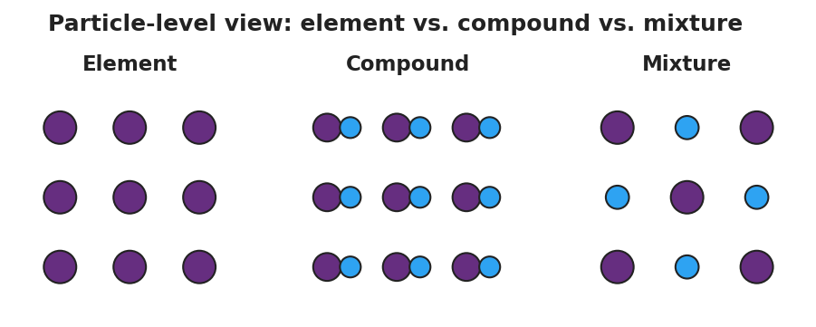
Three side-by-side particle panels labeled Element, Compound, and Mixture. The Element panel is a grid of identical circles. The Compound panel is a grid of identical bonded two-atom units (a large circle joined to a small circle). The Mixture panel shows two unbonded circle types intermingled but not joined.
From the figure above, fill in the blanks:
- The element panel has only ___ kind(s) of circle.
- The compound panel shows ___ different kinds of circle, and they are __________ together in identical units.
- The mixture panel shows two kinds of circle that are __________ to each other.
The classification flowchart:
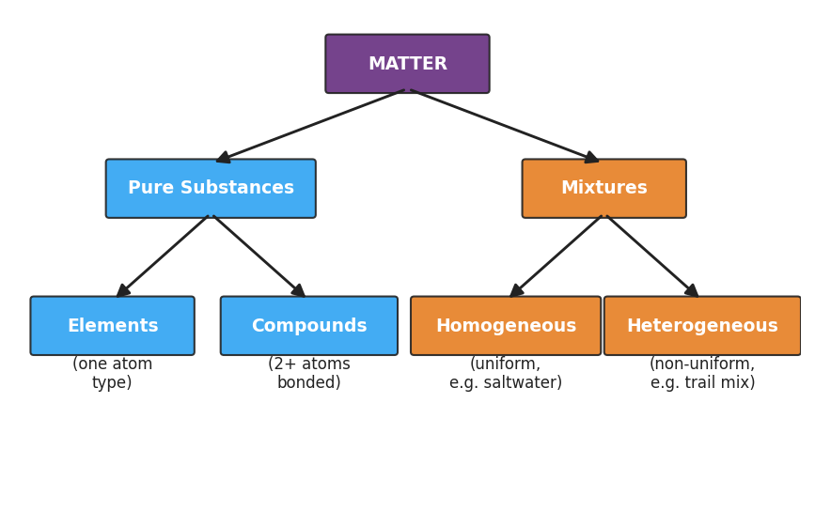
Flowchart classifying matter: MATTER branches into Pure Substances and Mixtures; Pure Substances branches into Elements (one atom type) and Compounds (two or more atoms bonded); Mixtures branches into Homogeneous (uniform, e.g. saltwater) and Heterogeneous (non-uniform, e.g. trail mix).

Worked Example
Scenario: Classify each of these four substances — He, CO, brass (copper + zinc), N₂ — as element, compound, or mixture, using the formula or description.
Step 1 — He (helium):
Number of different elements in the formula: ___ → Classification: __________
Step 2 — CO (carbon monoxide):
Number of different elements in the formula: ___ (which two? ___ and ) → Are they bonded in a fixed ratio? → Classification: __________
Step 3 — Brass (copper mixed with zinc):
Are copper and zinc bonded into a new substance, or just physically combined? __________ → Classification: __________
Step 4 — N₂ (nitrogen gas):
The two atoms are bonded — but are they the same kind or different kinds? __________ → Classification: __________
Step 5 — The tricky pair (CO vs. N₂): Both CO and N₂ have two bonded atoms. What single question separates them into different categories?

Step 6 — Because / But / So:
N₂ has two atoms bonded together, but it is classified as an element because _______________________________________________, but _______________________________________________, so _______________________________________________.
Check your reasoning: “because” should name how many kinds of atom; “but” should contrast with a compound like CO; “so” should state N₂’s correct classification.

Summary
Complete each sentence.
An element is a pure substance made of __________ kind of atom. A compound is two or more __________ elements __________ in a fixed ratio, with new properties. A mixture is two or more substances __________ combined, where each part keeps its own properties.
Complete the Because / But / So sentence (the phenomenon):
Table salt is safe to eat even though it is made of dangerous sodium and chlorine because __________________________________________, but __________________________________________, so __________________________________________.
Remember: Bonding alone does not make a compound — you need two or more different elements bonded. O₂ and N₂ are bonded elements. CO₂ and NaCl are bonded compounds.

