Distinguishing Elements, Compounds, and Mixtures — Student Worksheet
Unit: Physical Behavior of Matter — Lesson 04 Name: _______________________ Date: __________ Period: ____

Phenomenon
Sodium is a soft metal that catches fire when it touches water — it has to be stored under oil. Chlorine is a poisonous green-yellow gas. But when one sodium atom bonds to one chlorine atom, you get sodium chloride — ordinary table salt — which is safe to eat and which your body needs every day. Same two ingredients. A dangerous metal and a poisonous gas combine into the harmless salt on your french fries.
Driving question: Why does table salt taste, look, and behave so differently from the sodium and chlorine that make it?

Notice & Wonder
I notice… | I wonder…
Turn & Talk #1: If you stirred a pinch of pepper into a salt shaker, you’d have a mixture — you could still taste the salt and the pepper separately, and even pick the pepper out. But the salt itself, made of sodium and chlorine, tastes like neither metal nor gas. In one sentence: what is different about how the salt was made versus how the salt-and-pepper was made?

Initial Model
Before your teacher names anything, sort these eight substances into three piles by how their particles are put together — not by solid/liquid/gas. Then write your own one-sentence rule for each pile.
Cards to sort: copper wire · oxygen gas · water · carbon dioxide · salt water · trail mix · table salt · air
Pile 1 | Pile 2 | Pile 3
- My rule for Pile 1: _______________________________________________
- My rule for Pile 2: _______________________________________________
- My rule for Pile 3: _______________________________________________

Investigation

Part 1 — Draw the three particle “grammars”
Use the model panel below as your key: identical circles = one kind of atom; a large circle bonded to a small circle = two different atoms bonded; scattered different circles, not joined = separate substances mixed.
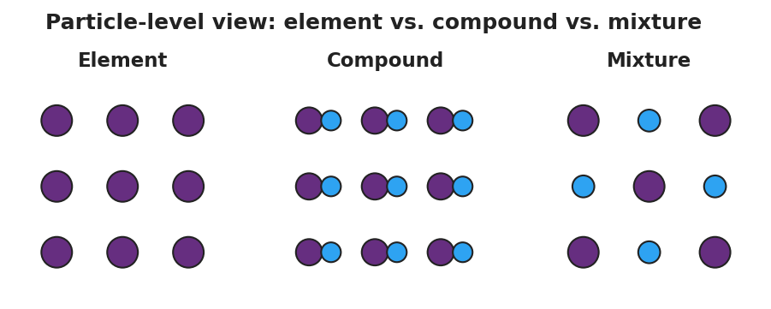
Three side-by-side particle panels labeled Element, Compound, and Mixture. The Element panel is a grid of identical circles (one kind of atom). The Compound panel is a grid of identical bonded two-atom units (a large circle joined to a small circle). The Mixture panel shows two unbonded circle types intermingled but not joined.
Draw a particle-level diagram for each substance in the box. Then circle whether each is an element, compound, or mixture.
- Copper (Cu)
(draw here) | element / compound / mixture
- Water (H₂O) — one large O bonded to two small H, all units the same
(draw here) | element / compound / mixture
- Salt water (NaCl dissolved in H₂O)
(draw here) | element / compound / mixture
- Oxygen gas (O₂) — two oxygen atoms bonded together (careful!)
(draw here) | element / compound / mixture
Stop and think: In #4, the two oxygen atoms are bonded — so why isn’t O₂ a compound? (Hint: count the kinds of atom.)

Part 2 — Components vs. compound (iron + sulfur)
Iron filings are gray and magnetic. Sulfur is yellow and not magnetic. Watch (or read about) what happens when they are mixed versus when they are bonded by heating. Fill in the “after bonding” column.
Property | Before bonding — Fe + S mixture | After bonding — FeS compound
Color | gray iron + yellow sulfur (both visible)
Magnetic? | yes — a magnet pulls the iron out
Can you separate the parts physically? | yes
Key question: How does the magnet test help you tell a mixture from a compound?

Make It Make Sense
Classify each substance below as an element, a compound, or a mixture, and give the reason. These are the same substances you sorted and drew in the Investigation — confirm your thinking here.
- Copper wire (Cu) — a single shiny metal, all one kind of atom.
  - Classification: _______________
  - Reason (about its particles): _______________________________________________
- Carbon dioxide (CO₂) — one carbon atom bonded to two oxygen atoms; a pure substance with a fixed formula.
  - Classification: _______________
  - Reason: _______________________________________________
- Trail mix — peanuts, raisins, and chocolate, scooped together; you can pick out each part.
  - Classification: _______________
  - Reason: _______________________________________________
- Oxygen gas (O₂) — two oxygen atoms bonded into a molecule.
  - Classification: _______________
  - Reason (why is bonding not enough to make it a compound?): _______________________________________________
- Table salt (NaCl) — sodium and chlorine bonded in a fixed 1-to-1 ratio.
  - Classification: _______________
  - Using the phenomenon: explain why salt is safe to eat even though sodium and chlorine are dangerous.

Vocabulary in Action
Use each term in a sentence about today’s sort, drawings, or the salt phenomenon. Do not just copy the definition — describe something you actually did or observed.
- element: _______________________________________________ _______________________________________________
- compound: _______________________________________________ _______________________________________________
- mixture: _______________________________________________ _______________________________________________

Revise Your Model
Return to your particle drawings from the Investigation. Add vocabulary labels:
- Next to your O₂ drawing, write why it is an element and not a compound: _______________________________________________
- Next to your salt water drawing, write why it is a mixture and not a compound: _______________________________________________
- Finish this Because / But / So sentence about the phenomenon:
Table salt is safe to eat even though it is made only of sodium and chlorine because __________________________________________, but __________________________________________, so __________________________________________.

Exit Ticket
(a) From a description. “A clear liquid; when you boil the water away, solid sugar is left behind, and the sweetness was spread evenly throughout.” Element, compound, or mixture? How do you know?
Classification: _______________ How I know: _______________________________________________
(b) From a picture. A diagram shows identical bonded three-atom units — each one large red atom bonded to two small white atoms, every unit the same. Element, compound, or mixture?
Classification: _______________ How I know: _______________________________________________
(c) From formulas. Classify each, and state how the formula told you.
CO₂ is a(n) _______________ because ____________________________________ Ne is a(n) _______________ because ____________________________________
(d) In one sentence, use Structure and Function to explain why a compound has different properties than the elements it is made from.

