Types of Mixtures — Student Notes
Unit: Physical Behavior of Matter — Lesson 05 Name: _______________________ Date: __________ Period: ____

Learning Targets
By the end of today’s 42 minutes I can:
- Distinguish a solution, a colloid, and a suspension by the size of their dispersed particles.
- Use the Tyndall effect (whether a light beam scatters and becomes visible) as evidence to classify an unknown mixture.
- Predict whether a mixture’s components will settle on standing or be caught by a filter, based on its classification.
- Explain, using Scale, Proportion, and Quantity, why one invisible variable — particle size — produces three different observable behaviors.

Key Vocabulary
- solution — _______________________________________________ _______________________________________________
- colloid — _______________________________________________ _______________________________________________
- Tyndall effect — _______________________________________________ _______________________________________________

Guided Notes
The big idea — Scale, Proportion, and Quantity: Three mixtures can look almost the same, yet behave completely differently. The one thing that changes is the __________ of the dispersed particles — a quantity far too small to see directly, but one you can __________ from how the mixture behaves.
Three mixtures, three particle sizes:
Mixture type | Particle size | Beam visible? (Tyndall) | Settles on standing? | Caught by filter? | Example
Solution | smallest (dissolved) |  |  |  | salt water
Colloid | medium |  |  |  | milk, fog
Suspension | largest |  |  |  | cornstarch, mud
The Tyndall effect — what the light beam reveals:
- A light beam stays invisible in a __________ because its particles are too small to scatter light.
- A light beam glows in a colloid or a suspension because its particles are large enough to __________ the light sideways into your eye.
- So the beam test is really an indirect measurement of __________.
Two more tests for particle size:
- Standing test: Only __________ particles are heavy enough to settle to the bottom — so only a __________ settles out.
- Filter test: A filter only catches particles __________ than its pores — so a filter separates a __________ but not a solution or a colloid.
The Hochman appositive definition:
The Tyndall effect — _________________________ — is why a flashlight beam glows in fog but vanishes in clear water.
The figure — the laser test in three mixtures:
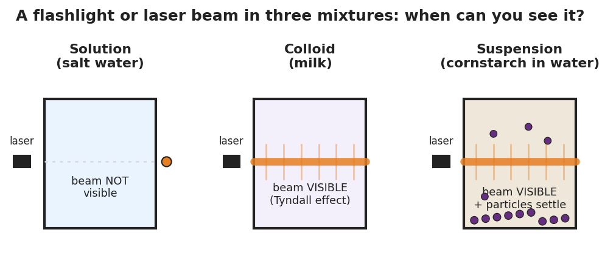
Three identical beakers in a row, each with a laser entering from the left. In the first beaker, labeled Solution (salt water), the beam passes straight through and is not visible. In the second beaker, labeled Colloid (milk), the beam glows as a bright visible shaft scattering light along its whole path. In the third beaker, labeled Suspension (cornstarch in water), the beam is also visible and scattering, and large particles are settling toward the bottom.
From the figure above, fill in the blanks:
- Beaker where the beam is invisible: ___________ (mixture type: ___________)
- Beaker(s) where the beam is visible: ___________
- Beaker where particles settle to the bottom: ___________ (mixture type: ___________)

Worked Example
Scenario: A student is given an unknown cloudy liquid and must decide whether it is a solution, a colloid, or a suspension. She runs the three tests in order.
Step 1 — The laser test: She shines a laser through the liquid. The beam is visible (it glows).
→ What does a visible beam tell her? The particles are large enough to scatter light, so the liquid is not a __________. It must be a colloid or a suspension.
Step 2 — The standing test: She lets the cup sit for 5 minutes. Nothing settles to the bottom; the liquid stays uniform.
→ What does “nothing settles” tell her? The particles are not heavy enough to settle, so it is not a __________. That points to a colloid.
Step 3 — The filter test: She pours a sample through a coffee filter. Nothing is caught; the liquid passes straight through.
→ What does “nothing caught” confirm? The particles are too small to be trapped by the filter — consistent with a __________.
Conclusion: Beam visible + does not settle + passes the filter → the liquid is a __________.
Appositive sentence:
A colloid — _________________________ — scatters light (the Tyndall effect) but never settles out.
Because / But / So
The beam glows in this liquid but the particles never settle because _______________________________________________, but _______________________________________________, so _______________________________________________.
Check your reasoning: “because” should name why the beam is visible (particles scatter light); “but” should note why the particles do not settle (they are small/light); “so” should name the classification (colloid).

Summary
Complete the appositive sentence:
The Tyndall effect — _________________________ — is why a flashlight beam glows in fog but vanishes in clear water.
Complete the Because / But / So sentence:
A flashlight beam shows up in fog but not in clear air because __________________________________________, but __________________________________________, so __________________________________________.
Reminder — three tests, one variable: The laser test, the standing test, and the filter test are all indirect ways of measuring particle size. Tiny particles (solution) hide the beam, never settle, and pass any filter. Medium particles (colloid) scatter light but stay suspended and pass a filter. Large particles (suspension) scatter light, settle out, and are caught by a filter.
Key idea (the trap to avoid): Color is not the same as cloudiness. A solution can be brightly colored and still let a beam pass invisibly — only the scattering of light, not the color, signals a colloid or suspension.

