Types of Mixtures — Student Worksheet
Unit: Physical Behavior of Matter — Lesson 05 Name: _______________________ Date: __________ Period: ____

Phenomenon
In a darkened room, your teacher shines a laser pointer (or a flashlight) horizontally through three identical clear cups: salt water, milky water, and cornstarch stirred into water. In the salt water, the beam is invisible as it crosses the liquid — you see only the dot where it lands on the far wall. In the milky water and the cornstarch water, the whole beam lights up as a glowing shaft. Same laser, same kind of cup, same dark room — but the beam disappears in one liquid and glows in the others.
Driving question: Why does a flashlight beam show up in fog or milk but not in clear water?

Notice & Wonder
I notice… | I wonder…
Turn & Talk #1: The salt water, the milky water, and the cornstarch water are all mixtures of something in water. The light beam behaves in two different ways across them. In one sentence — what do you think is different about the something mixed into each cup?

Initial Model
Before your teacher names anything, you have three pieces of evidence about each cup: 1. Laser test — is the beam visible inside the liquid? 2. Standing test — after 5 minutes, does anything settle to the bottom? 3. Filter test — poured through a coffee filter, is anything caught?
Record what you observed (or predict) for each cup:
Cup | Beam visible inside? | Settles on standing? | Caught by filter?
Salt water
Milky water
Cornstarch water
- What single property of the particles in each cup could explain ALL three behaviors at once? _______________________________________________
- Which cup has the smallest particles? _______________ The largest? _______________

Investigation

Part 1 — ABCs: Sort by behavior before naming
You now have three behavior groups, each matching one cup. For each new mixture below, predict the three behaviors and decide which cup it behaves most like.
Mixture | Beam visible? | Settles on standing? | Caught by filter? | Behaves like… (which cup?)
Sugar fully dissolved in water
Muddy river water
Gelatin (jello) re-liquefied
Fine sand stirred into water
Food-colored water (clear, dyed)
Watch the trap: one mixture above has color but is still clear. Will a laser beam show up in it? Why or why not?

Part 2 — Reading the figure
Look at figures/tyndall_three_mixtures.png:
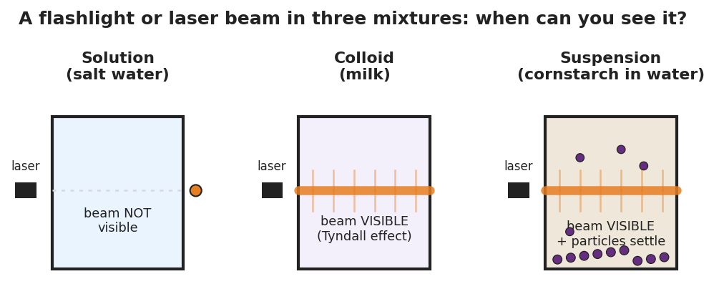
Three identical beakers in a row, each with a laser entering from the left. In the first beaker, labeled Solution (salt water), the beam passes straight through and is not visible. In the second beaker, labeled Colloid (milk), the beam glows as a bright visible shaft scattering light along its whole path. In the third beaker, labeled Suspension (cornstarch in water), the beam is also visible and scattering, and large particles are settling toward the bottom.
- In which beaker is the laser beam invisible? _______________
- In which beaker(s) is the beam visible? _______________
- Which beaker shows particles settling to the bottom? _______________
- The beam is visible in two beakers but particles settle in only one of them. What does that tell you about the difference between those two beakers’ particles?

Make It Make Sense
For each scenario, classify the mixture (by behavior: like the salt water, the milky water, or the cornstarch water), name the evidence, and answer the question.
- A glass of clear iced tea is brightly colored but you can read print through it. You shine a laser through it and the beam stays invisible.
  - This mixture behaves like the: _______________________________________________
  - The evidence is: _______________________________________________
  - Does the iced tea show the Tyndall effect? _______ Why? _______________________________________________
- Muddy river water looks cloudy. The beam glows when you shine a laser through it, and after a few minutes a layer of sediment settles at the bottom.
  - This mixture behaves like the: _______________________________________________
  - The two pieces of evidence are: _______________________________________________
  - If you poured it through a coffee filter, what would happen? _______________________________________________
- Re-liquefied gelatin looks slightly cloudy. The beam glows when you shine a laser through it, but it never settles and passes straight through a filter.
  - This mixture behaves like the: _______________________________________________
  - How do its particles compare in size to the mud’s particles? _______________________________________________
  - How do its particles compare in size to the dissolved sugar’s particles? _______________________________________________

Vocabulary in Action
Use each term in a sentence about today’s investigation. Do not copy the definition — describe something you actually observed or sorted.
- solution: _______________________________________________ _______________________________________________
- colloid: _______________________________________________ _______________________________________________
- Tyndall effect: _______________________________________________ _______________________________________________

Revise Your Model
Return to your Initial Model (the “one property explains all three tests” idea). Add vocabulary labels:
- Label the smallest-particle cup with its name: _______________
- Label the cup that scatters light but never settles: _______________
- Label the cup whose particles settle and get filtered out: _______________
- Write a revised appositive sentence (use dashes) defining a colloid:
A colloid — _________________________ — scatters a light beam but never settles out.
Then finish this Because / But / So sentence:
A laser beam is visible in milk but invisible in salt water because __________________________________________, but __________________________________________, so __________________________________________.

Exit Ticket
(a) On a foggy night, a car’s headlights cast visible beams through the air, but on a clear night the beams are invisible until they hit a sign. Classify foggy air as a solution, a colloid, or a suspension, and name the evidence that decides it.

(b) You have two cloudy cups: one is muddy pond water and one is whole milk. You pour each through a coffee filter. Which cup leaves material behind on the filter, and what does that tell you about its particle size?

(c) Write one appositive sentence (use dashes) that defines the Tyndall effect.

