Heating & Cooling Curves — Student Notes
Unit: Heat and Energy — Lesson 01 Name: _______________________ Date: __________ Period: ____

Learning Targets
By the end of today’s 42 minutes I can:
- Read a temperature-vs-time graph and identify the sloped segments and the flat plateaus.
- Identify each plateau as a phase change and name which two phases are present.
- Explain that on a sloped segment kinetic energy is rising (temperature changes) and on a plateau potential energy is rising (temperature is constant).
- Explain, using Energy and Matter, why boiling water stays at a constant temperature even though heat keeps flowing in.

Key Vocabulary
- kinetic energy — _______________________________________________ _______________________________________________
- potential energy — _______________________________________________ _______________________________________________
- phase change — _______________________________________________ _______________________________________________

Guided Notes
The big idea — Energy and Matter: Energy that flows into a sample is never lost — it is always __________ for. It either makes the particles move faster (raising __________ energy, which we read as a rising __________) or it pulls the particles apart during a phase change (raising __________ energy, with no change in temperature).
Reading a heating curve:
- A sloped segment (line going up or down) → the temperature is __________ → __________ energy is changing.
- A flat segment (plateau) → the temperature is __________ → __________ energy is changing → a __________ change is happening.
The five segments of the heating curve of water (ice → steam):
Segment | Temperature | Phase(s) present | Energy rising (kinetic or potential)?
A (below 0 °C, sloped) | rising | solid
B (at 0 °C, flat) | constant
C (0–100 °C, sloped) | rising | liquid
D (at 100 °C, flat) | constant
E (above 100 °C, sloped) | rising | gas
The two phase changes on the heating curve:
- Plateau B is __________, happening at _______ °C.
- Plateau D is __________, happening at _______ °C.
The figure — heating curve of water:
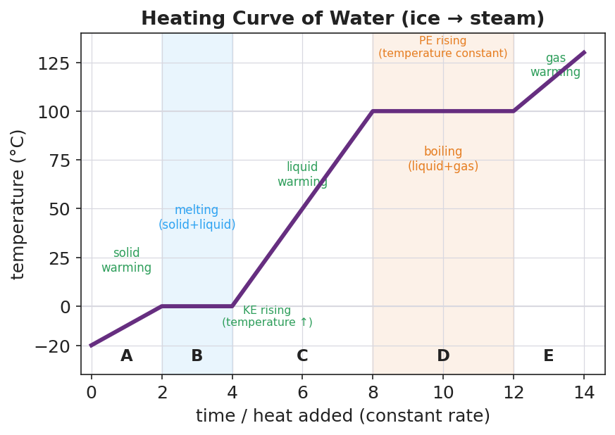
Temperature-vs-time heating curve for water heated at a constant rate from ice to steam, showing five segments A–E: a rising solid-warming segment, a flat melting plateau at 0 °C, a rising liquid-warming segment, a flat boiling plateau at 100 °C, and a rising gas-warming segment. Sloped segments are labeled ‘KE rising’ and the two flat plateaus are labeled ‘PE rising’. The y-axis is temperature in degrees Celsius; the x-axis is time / heat added at a constant rate.
From the figure above, fill in the blanks:
- The two flat plateaus are at _______ °C (melting) and _______ °C (boiling).
- On every sloped segment, the __________ energy of the particles is rising, which is why the __________ goes up.
- On every flat segment, the __________ energy is rising while the temperature stays __________.
The key rule:
Heat added on a slope → faster particles → temperature changes (kinetic energy). Heat added on a plateau → particles pulled apart → phase changes (potential energy).

Worked Example
Scenario: A heating curve of water shows a flat plateau at 100 °C (segment D). The burner adds energy at a constant rate the entire time the plateau lasts. Explain what is happening to the energy and to the water.
Step 1 — Is the temperature changing?
The plateau is __________ (flat / sloped), so the temperature is __________ (changing / constant).
Step 2 — What does constant temperature tell you about kinetic energy?
Temperature measures the average __________ energy. Since the temperature is constant, the average kinetic energy is __________.
Step 3 — If the kinetic energy is not changing, where is the added energy going?
The added energy is raising the __________ energy — it is pulling the liquid molecules apart to form __________ (a gas).
Step 4 — Name the phase change:
Segment D is __________ (the phase change from __________ to __________).
Step 5 — Because / But / So
The thermometer stays at 100 °C while water boils because _______________________________________________, but _______________________________________________, so _______________________________________________.
Check your reasoning: “because” should say the energy goes into potential energy / the phase change; “but” should say temperature only measures kinetic energy; “so” should say the temperature stays constant even though heat keeps flowing in.

Summary
Complete the Because / But / So sentence:
A heating curve has a flat plateau during a phase change because __________________________________________, but __________________________________________, so __________________________________________.
Reminder:
- Sloped segment = temperature changing = kinetic energy changing (no phase change).
- Flat plateau = temperature constant = potential energy changing = phase change.
- Energy is always conserved: every joule added either speeds particles up (kinetic) or pulls them apart (potential).
Key reference: - Pure water: melting/freezing point = 0 °C; boiling/condensation point = 100 °C. - Temperature is a measure of the average kinetic energy of particles.

