Heating & Cooling Curves — Student Worksheet
Unit: Heat and Energy — Lesson 01 Name: _______________________ Date: __________ Period: ____

Phenomenon
A pot of water is boiling hard on a stove turned all the way up to maximum. A thermometer in the water reads 100 °C. You leave it boiling for five more minutes — the burner is still on full power, steam is pouring off the top. Energy is clearly still flowing into the pot the whole time. And yet, for the entire five minutes, the thermometer does not move. It stays locked at 100 °C.
Driving question: Why does the temperature of boiling water stay at 100 °C no matter how much heat you add?

Notice & Wonder
I notice… | I wonder…
Turn & Talk #1: The burner keeps adding energy, but the temperature is not rising. Where could that energy be going if it is not making the water hotter? Try to name a specific destination — not just “it disappears.”

Initial Model
You are going to heat a sample from ice all the way to steam, recording the temperature every 30 seconds as energy is added at a steady rate.
Record your data here (add rows as needed). Important: keep recording even when the temperature stops changing — those flat moments are the most important data.
Time (s) | Temperature (°C)
0
30
60
90
120
150
180
210
240
Now graph your data: plot temperature (y-axis) vs. time (x-axis) and connect the points. Then describe the shape in words:
- Where does the line go UP (temperature rising)? _______________________________________________
- Where does the line go FLAT (temperature constant)? _______________________________________________
- How many flat parts are there? _______________

Investigation
Compare your graph to the reference heating curve below. The five segments are labeled A through E.
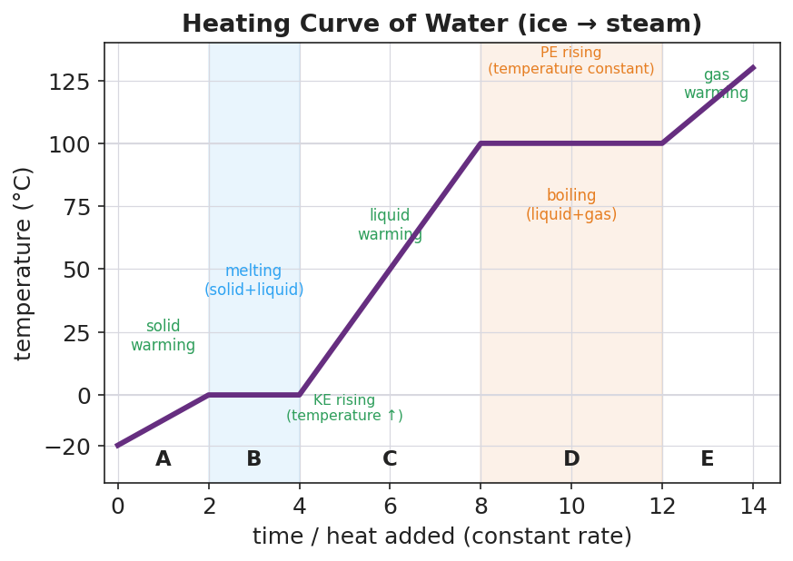
Temperature-vs-time heating curve for water heated at a constant rate from ice to steam. The purple line rises through five labeled segments A–E. Segment A: solid ice warming below 0 °C (sloped). Segment B: a flat plateau at 0 °C shaded blue, labeled ‘melting (solid+liquid)’. Segment C: liquid water warming from 0 °C to 100 °C (sloped). Segment D: a longer flat plateau at 100 °C shaded orange, labeled ‘boiling (liquid+gas)’. Segment E: gas/steam warming above 100 °C (sloped). Sloped segments are annotated ‘KE rising’ and the plateaus are annotated ‘PE rising’. The y-axis is temperature in degrees Celsius; the x-axis is time / heat added.

Part 1 — Label the five segments
For each segment, describe what is happening to the water and name the phase(s) of water present.
Segment | What is happening? | Phase(s) present
A (rising, below 0 °C)
B (flat, at 0 °C)
C (rising, 0–100 °C)
D (flat, at 100 °C)
E (rising, above 100 °C)

Part 2 — Find the two phase changes
- Circle the two flat plateaus on the figure above.
- Which phase change is happening on plateau B? _______________
- Which phase change is happening on plateau D? _______________
- At what temperature does each phase change happen?
- Plateau B: _______ °C Plateau D: _______ °C

Part 3 — Sort the energy
For each segment, decide whether the temperature is changing. If the temperature is changing, the particles are speeding up — kinetic energy is rising. If the temperature is constant, the energy is going into pulling particles apart — potential energy is rising.
Segment | Is temperature changing? | Which energy is rising — kinetic or potential?
A
B
C
D
E
Key question: During segment D, the burner is still adding energy but the temperature stays at 100 °C. Where is that energy going? (This is the answer to our phenomenon.)

Make It Make Sense
Use the heating curve of water to answer each item. Show your reasoning.
1. A student says, “On the flat parts of the graph, no energy is being added — that’s why the temperature isn’t changing.” Is the student correct? Explain what is really happening to the energy on a flat plateau.

2. Look at segment C (liquid water warming from 0 °C to 100 °C). Is the kinetic energy of the particles increasing, decreasing, or staying the same? How do you know from the graph?

3. Two students heat identical beakers of ice. Student 1 uses a low burner setting; Student 2 turns the burner to maximum. Both graph the boiling plateau (segment D). Predict: will the two plateaus be at the same temperature? Will they be the same length (time)? Explain.

Vocabulary in Action
Use each term in a sentence about today’s heating-curve investigation. Do not copy the definition — describe something you actually observed on the graph or in the data.
- kinetic energy: _______________________________________________ _______________________________________________
- potential energy: _______________________________________________ _______________________________________________
- phase change: _______________________________________________ _______________________________________________

Revise Your Model
Return to your Initial Model graph. Add vocabulary labels:
- Write “KE rising” along each sloped segment (A, C, E).
- Write “PE rising — phase change” along each flat plateau (B, D), and label them melting and boiling.
- Draw an arrow to the plateau that answers our phenomenon (the one at 100 °C) and write one word for where the energy goes: _______________
Then finish this Because / But / So sentence:
While water boils, the temperature stays at 100 °C because __________________________________________, but __________________________________________, so __________________________________________.

Exit Ticket
A different liquid substance is cooled at a constant rate. Its cooling curve shows the temperature dropping, then holding flat at 80 °C for a while, then dropping again.
- What is happening to the substance during the flat plateau at 80 °C, and what is this temperature called?

- Along the sloped part before the plateau (temperature dropping), is the particles’ kinetic energy increasing or decreasing? Explain in one sentence.

- During the flat plateau, energy is still flowing out of the substance, yet the temperature does not drop. In one sentence, explain why, using the words potential energy and phase change.

