Heat Calculations — Student Notes
Unit: Heat & Energy — Lesson 02 Name: _______________________ Date: __________ Period: ____

Learning Targets
By the end of today’s 42 minutes I can:
- Calculate the heat absorbed or released when a sample changes temperature using q = mcΔT, and name the unit of each variable.
- Calculate the heat for melting/freezing using q = mH_f and for boiling/condensing using q = mH_v.
- Apply the sign convention: energy flowing into a sample is positive; energy flowing out is negative; in a calorimeter, q_lost = −q_gained.
- Explain, using Energy and Matter, why the same energy input warms sand far more than water — because water has a much larger specific heat capacity.

Key Vocabulary
- specific heat capacity (c) — _______________________________________________ _______________________________________________
- heat of fusion (H_f) — _______________________________________________ _______________________________________________
- heat of vaporization (H_v) — _______________________________________________ _______________________________________________

Guided Notes
The big idea — Energy and Matter: Energy is __________, not destroyed. When a hot object meets a cooler one in a closed container, energy flows from __________ to __________ until they reach the same temperature. The heat lost by the hot object __________ the heat gained by the cool one: q_lost = −q_gained.
The three heat equations:
Situation | Equation | What stays the same
Temperature is changing (no phase change) | q = m × c × ΔT | the phase (still solid, liquid, or gas)
Melting or freezing at the melting point | q = m × H_f | the __________ (stays at the melting point)
Boiling or condensing at the boiling point | q = m × H_v | the __________ (stays at the boiling point)
How to choose the equation: First ask — is the temperature changing? - If yes → use q = __________ (you will have a ΔT). - If no (a phase change at constant temperature) → melting? use q = __________ · boiling? use q = __________ (no ΔT, no c).
Computing ΔT: ΔT = T___________ − T___________ (always final minus initial)
The sign convention (required by PS3-1): - Energy flowing into a sample (it warms up or melts) → q is __________ - Energy flowing out of a sample (it cools down or freezes) → q is __________
Reference Table B values for water: - specific heat c = ______ J/g·°C - heat of fusion H_f = ______ J/g - heat of vaporization H_v = ______ J/g (much __________ than H_f)
The Hochman appositive definition:
Specific heat capacity — _________________________ — is the value of c in the equation q = mcΔT.
The figure — why water resists heating:
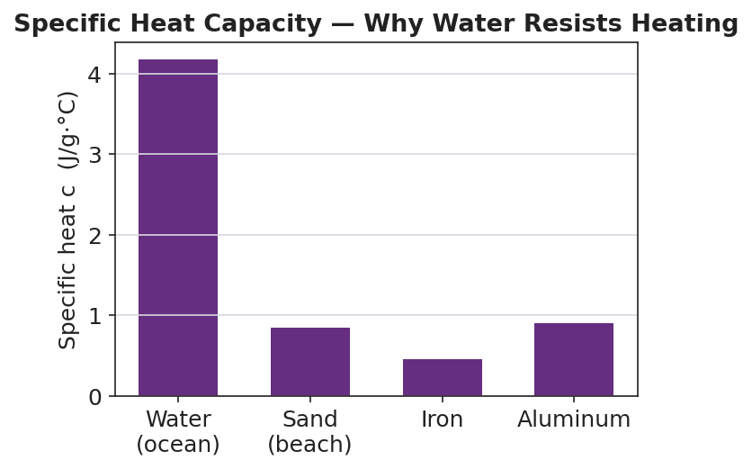
Bar chart titled ‘Specific Heat Capacity — Why Water Resists Heating’ showing the specific heat c in J/g·°C for four materials: water (ocean) at about 4.18, sand (beach) at about 0.84, iron at about 0.45, and aluminum at about 0.90; the water bar towers about five times taller than the sand bar; the y-axis is labeled ‘Specific heat c (J/g·°C)’ and the x-axis labels each material.
From the figure above, fill in the blanks:
- Material with the highest specific heat: ___________ (___ J/g·°C)
- Material with the lowest specific heat: ___________ (___ J/g·°C)
- For the same energy and mass, the material with the lower specific heat warms up __________ (more / less), which is why sand burns your feet but the ocean stays cool.

Worked Example
Scenario: How much heat is absorbed when 200. g of water is heated from 30.0 °C to 80.0 °C?
Step 1 — Decide which equation. Is the temperature changing? ______ → Use q = __________.
Step 2 — Compute ΔT (final − initial):
ΔT = ______ − ______ = ______ °C
Step 3 — List the values:
m = ______ g c = ______ J/g·°C ΔT = ______ °C
Step 4 — Substitute and solve:
q = m × c × ΔT = ( ______ )( ______ )( ______ ) = ____________ J
Step 5 — Sign: The water got __________ (warmer / cooler), so energy flowed __________ (in / out), so q is __________ (positive / negative).
Step 6 — Appositive sentence:
The specific heat capacity of water — ___ J/g·°C — is the value of c that made q = ___________ J for this sample.
Step 7 — Because / But / So
I used q = mcΔT instead of q = mH_v because _______________________________________________, but if the water had been boiling at 100 °C the temperature would not change, _______________________________________________, so _______________________________________________.
Check your reasoning: “because” should say the temperature was changing; “but” should describe what happens during a phase change; “so” should name the equation you would switch to.

Summary
Complete the appositive sentence:
Specific heat capacity — _________________________ — is the value of c in the equation q = mcΔT.
Complete the Because / But / So sentence:
At the beach, the sand gets hotter than the ocean under the same Sun because __________________________________________, but __________________________________________, so __________________________________________.
Reminder — choosing the equation: If the temperature changes, use q = mcΔT (you need a ΔT). If a phase change happens at constant temperature, use q = mH_f (melting/freezing) or q = mH_v (boiling/condensing) — no ΔT, no c.
Key reference (from the 2025 NYS Reference Tables, Tables B and T): q = mcΔT · q = mH_f · q = mH_v For water: c = 4.18 J/g·°C · H_f = 334 J/g · H_v = 2260 J/g Sign: energy in = positive, energy out = negative; in a calorimeter q_lost = −q_gained

