Heat Calculations — Student Worksheet
Unit: Heat & Energy — Lesson 02 Name: _______________________ Date: __________ Period: ____

Phenomenon
It is the same sunny afternoon at the beach. The Sun shines the same on every part of the shore. Walk barefoot across the dry sand and it is scorching — you hop from foot to foot. Take three steps into the ocean and the water is cool, almost cold. Same Sun, same hours of daylight, same energy landing on each surface — yet the sand burns and the water stays cool. After sunset, it flips: the sand cools off fast while the ocean holds its warmth.
Driving question: How much energy does it take to change the temperature of a sample — and why does the same energy heat some materials far more than others?

Notice & Wonder
I notice… | I wonder…
Turn & Talk #1: Your teacher is projecting a bar chart of specific heat values. Water’s value (4.18 J/g·°C) is about five times the sand’s (0.84 J/g·°C). In one sentence: if the Sun delivers the same energy to equal masses of sand and water, which one heats up more, and by roughly how many times?

Initial Model
Before your teacher names the equation, use this relationship you build from data: q = m × c × ΔT, where c = 4.18 J/g·°C for water and ΔT = final temperature − initial temperature.
Problem: How much energy is needed to heat 50.0 g of water from 20.0 °C to 70.0 °C?
Step 1 — Find ΔT (final − initial): ΔT = ______ − ______ = ______ °C
Step 2 — List your values: m = ______ g c = ______ J/g·°C ΔT = ______ °C
Step 3 — Substitute and solve:
q = m × c × ΔT = ( ______ )( ______ )( ______ ) = ____________ J
- Is q positive or negative here? ______ Why? _______________________________________________
- Check your units: which units cancel, and what unit is left for q? _______________________________________________

Investigation

Part 1 — ABCs: Find the pattern before the formula
A hot plate delivers measured energy to water samples. Study the table — do not use a formula yet.
Sample | Mass of water (g) | Energy added (J) | Temperature change ΔT (°C)
1 | 100 | 4180 | 10
2 | 200 | 4180 | 5
3 | 100 | 8360 | 20
- Compare Sample 1 and Sample 2 (same energy). When the mass doubles, what happens to ΔT? _______________________________________________
- Compare Sample 1 and Sample 3 (same mass). When the energy doubles, what happens to ΔT? _______________________________________________
- For Sample 1, divide: 4180 ÷ (100 × 10) = ______. Check it on Sample 3: 8360 ÷ (100 × 20) = ______. What constant do you get both times? ______
- Write a relationship connecting energy (q), mass (m), specific heat (c), and temperature change (ΔT):
q = _______________________________________________

Part 2 — Heat calculations (three equations)
Use Reference Table B values: c(water) = 4.18 J/g·°C · H_f = 334 J/g · H_v = 2260 J/g. Decision rule: temperature changing → q = mcΔT · melting/freezing → q = mH_f · boiling/condensing → q = mH_v.
Problem A — Heating (q = mcΔT): How much heat is absorbed when 120. g of water is heated from 25.0 °C to 100. °C?
Equation: __________ ΔT = ______ − ______ = ______ °C q = ( ______ )( ______ )( ______ ) = ____________ J
Problem B — Melting (q = mH_f): How much heat is needed to melt 45.0 g of ice at 0 °C into water at 0 °C?
Equation: __________ q = ( ______ )( ______ ) = ____________ J
Problem C — Boiling (q = mH_v): How much heat is needed to boil 30.0 g of water at 100 °C into steam at 100 °C?
Equation: __________ q = ( ______ )( ______ ) = ____________ J
- Problems B and C have no ΔT and no c. Why not? _______________________________________________

Part 3 — Reading the bar chart
Look at figures/specific_heat_capacities.png:
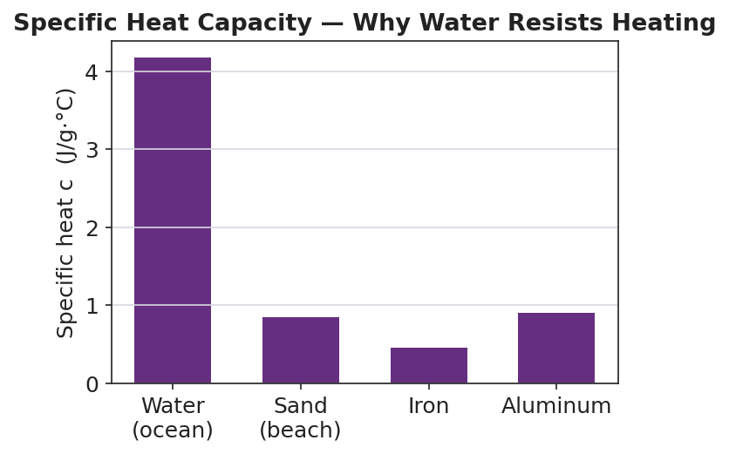
Bar chart titled ‘Specific Heat Capacity — Why Water Resists Heating’ showing the specific heat c in J/g·°C for four materials: water (ocean) at about 4.18, sand (beach) at about 0.84, iron at about 0.45, and aluminum at about 0.90; the water bar towers about five times taller than the sand bar; the y-axis is labeled ‘Specific heat c (J/g·°C)’ and the x-axis labels each material.
- Which material has the highest specific heat? ______ Which has the lowest? ______
- A metal park bench heats up fast in the sun and burns you. Use the chart to explain why metal heats faster than water for the same sunlight.

Make It Make Sense
For each problem below, choose the right equation, substitute, and solve. These are the same problems you practiced in the Investigation — confirm your work here. Use c(water) = 4.18 J/g·°C, H_f = 334 J/g, H_v = 2260 J/g.
1. Heating: How much heat is absorbed when 120. g of water is heated from 25.0 °C to 100. °C?
Equation: __________ ΔT = ______ °C q = ( ______ )( ______ )( ______ ) = ____________ J
2. Melting: How much heat is needed to melt 45.0 g of ice at 0 °C into water at 0 °C?
Equation: __________ q = ( ______ )( ______ ) = ____________ J
3. Boiling: How much heat is needed to boil 30.0 g of water at 100 °C into steam at 100 °C?
Equation: __________ q = ( ______ )( ______ ) = ____________ J

Vocabulary in Action
Use each term in a sentence about today’s investigation. Do not copy the definition — describe something you actually calculated or observed.
- specific heat capacity: _______________________________________________ _______________________________________________
- heat of fusion: _______________________________________________ _______________________________________________
- heat of vaporization: _______________________________________________ _______________________________________________

Revise Your Model
Return to your Initial Model (50.0 g of water, 20 → 70 °C). Add vocabulary labels:
- Draw a box around the value c (4.18). Label it “specific heat capacity.”
- Circle ΔT. Label it “final − initial.”
- Mark whether q is positive or negative, and write why: ______ because _______________________________________________
- Write a revised appositive sentence for the result you calculated:
The specific heat capacity of water — _________________________ — is the value of c that made q = ___________ J for this sample.
Then finish this Because / But / So sentence:
At the beach, the sand gets much hotter than the ocean under the same Sun because __________________________________________, but __________________________________________, so __________________________________________.

Exit Ticket
(a) How much heat is absorbed when 80.0 g of copper (c = 0.385 J/g·°C) is heated from 25.0 °C to 75.0 °C? Show the formula and substitution.
Equation: __________ ΔT = ______ − ______ = ______ °C q = ( ______ )( ______ )( ______ ) = ____________ J
(b) How much heat is needed to boil 25.0 g of water at 100 °C into steam at 100 °C? (H_v = 2260 J/g.) Show the formula and substitution.
Equation: __________ q = ( ______ )( ______ ) = ____________ J
(c) In one sentence, explain the sign convention: when a sample cools down, is its q positive or negative, and why?

