Photosynthesis — Energy Storage in Bonds — Student Notes
Unit: Heat and Energy — Lesson 03 Name: _______________________ Date: __________ Period: ____

Learning Targets
By the end of today’s 42 minutes I can:
- State the equation for photosynthesis (6 CO₂ + 6 H₂O → C₆H₁₂O₆ + 6 O₂) and identify the inputs and outputs.
- Use an energy diagram to show that the products (sugar + O₂) store more chemical potential energy than the reactants (CO₂ + H₂O), and name light as the energy source for the difference.
- Define chemical potential energy, photosynthesis, and conservation of energy and use each in a sentence.
- Explain, using Energy and Matter (flows and conservation), how the Sun’s energy is stored in sugar and later released when the sugar is burned or eaten.

Key Vocabulary
- chemical potential energy — _______________________________________________ _______________________________________________
- photosynthesis — _______________________________________________ _______________________________________________
- conservation of energy — _______________________________________________ _______________________________________________

Guided Notes
The big idea — Energy and Matter (flows and conservation): During photosynthesis, ______________ energy from the Sun flows into a plant and is stored as ______________ energy in the bonds of sugar. The atoms are not created or destroyed — they are only ______________. Later, when the sugar is burned or eaten, that stored energy is ______________ (not created), so energy is ______________.
The photosynthesis equation:
$$6 {\text{CO}}_{2}+6 {\text{H}}_{2}\text{O}\overset{\text{light}}{→}{\text{C}}_{6}{\text{H}}_{12}{\text{O}}_{6}+6 {\text{O}}_{2}$$
- Inputs (reactants): ______________ and ______________ — these store ______________ (low / high) energy.
- Outputs (products): ______________ and ______________ — these store ______________ (low / high) energy.
- Energy source that powers the reaction: ______________
The atoms balance (matter is conserved):
Element | Left (reactants) | Right (products)
C | 6 | 6
H | 12 | 12
O | 18 | 18
Because every atom on the left reappears on the right, no atoms are created or destroyed. So the thing that changed between reactants and products is not the atoms — it is the ______________ stored in their bonds.
The energy diagram — fill in the labels:
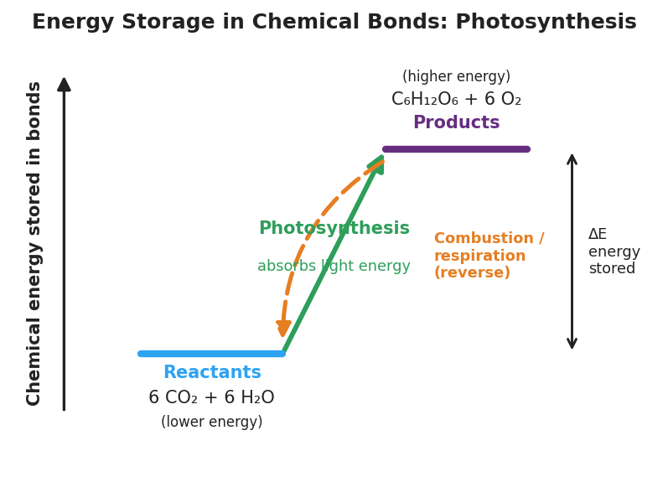
Energy-level diagram titled ‘Energy Storage in Chemical Bonds: Photosynthesis’. A low blue platform on the left is labeled ‘Reactants — 6 CO₂ + 6 H₂O (lower energy)’. A high purple platform on the right is labeled ‘Products — C₆H₁₂O₆ + 6 O₂ (higher energy)’. A solid green upward arrow labeled ‘Photosynthesis — absorbs light energy’ goes from the low reactant level up to the high product level. A dashed orange downward arrow labeled ‘Combustion / respiration (reverse)’ goes back down from products to reactants. A double-headed bracket on the right marks the energy difference ‘ΔE energy stored’.
From the figure above, fill in the blanks:
- The set of substances on the low energy level is: ______________ (the reactants).
- The set of substances on the high energy level is: ______________ (the products).
- The green up-arrow is ______________; it adds ______________ energy.
- The orange down-arrow is the reverse (burning or respiration); it ______________ energy.
- The bracket labeled ΔE is the ______________ stored in the bonds — it comes from ______________.
The energy chain (memorize this path):
Sun → ______________ energy → ______________ energy stored in sugar bonds → ______________ released when sugar is burned or eaten

Worked Example
Scenario: A campfire log gives off heat and light as it burns. The log used to be a living tree. Trace and explain the energy.
Step 1 — Where did the energy in the fire come from?
The energy released by the fire is ______________ energy that was stored in the bonds of the wood (mostly sugars/cellulose the tree built).
Step 2 — How did the energy get into the wood in the first place?
The tree ran ______________: it used ______________ energy from the Sun to build high-energy sugar from low-energy CO₂ and H₂O. The Sun’s energy was stored in the bonds.
Step 3 — Which direction on the energy diagram is burning?
Burning runs the reaction in ______________ (forward / reverse). On the diagram it moves from the ______________ level to the ______________ level, which means energy is ______________ (stored / released).
Step 4 — Is energy created or destroyed at any step?
No. By the law of ______________, the energy is only transferred and changed in form: light → chemical → heat and light. The total energy stays the ______________.
Step 5 — Because / But / So
The campfire releases heat and light because _______________________________________________, but _______________________________________________, so _______________________________________________.
Check your reasoning: “because” should name the stored chemical energy and where it came from (the Sun, via photosynthesis); “but” should note that the atoms were only rearranged, never created; “so” should state that burning releases the stored sunlight, with energy conserved.

Summary
Complete the Because / But / So sentence:
The products of photosynthesis (sugar + O₂) store more energy than the reactants (CO₂ + H₂O) because __________________________________________, but __________________________________________, so __________________________________________.
Reminder: A plant gets its atoms from air (CO₂) and water; it gets its energy from sunlight. Photosynthesis does not make energy — it stores the Sun’s energy in chemical bonds. Burning or eating the sugar later releases that exact energy. Energy is always conserved.
Key reference: Photosynthesis: 6 CO₂ + 6 H₂O → C₆H₁₂O₆ + 6 O₂ (light energy in, stored in bonds) Reverse (respiration / combustion): C₆H₁₂O₆ + 6 O₂ → 6 CO₂ + 6 H₂O (energy released)

