Photosynthesis — Energy Storage in Bonds — Student Worksheet
Unit: Heat and Energy — Lesson 03 Name: _______________________ Date: __________ Period: ____

Phenomenon
A green plant sits on a windowsill, motionless, for weeks. It is not plugged into anything — just air, water, and light. Yet it grows new leaves out of almost nothing. If you dried one of those leaves and set it on fire, it would release heat and light. That heat had to come from somewhere. The plant “charged up” the leaf with energy — and burning it pays the energy back out.
Driving question: How does a plant “capture” sunlight as chemical energy you can later eat?

Notice & Wonder
I notice… | I wonder…
Turn & Talk #1: Look at the energy diagram your teacher is projecting. The green arrow (photosynthesis) goes up and the orange arrow (burning) goes down. In one sentence: what is the difference between climbing up the diagram and sliding down it, in terms of energy going in versus coming out?

Initial Model
Before your teacher names the process, work out the atom bookkeeping for photosynthesis:
$$6 {\text{CO}}_{2}+6 {\text{H}}_{2}\text{O}→{\text{C}}_{6}{\text{H}}_{12}{\text{O}}_{6}+6 {\text{O}}_{2}$$
Count the atoms of each element on each side. Fill in the table:
Element | Atoms on the LEFT (reactants) | Atoms on the RIGHT (products) | Balanced?
C (carbon)
H (hydrogen)
O (oxygen)
- Does the equation balance? _______________
- If every atom on the left shows up again on the right, what does that tell you about the atoms — are any created or destroyed?

- The atoms are the same on both sides. So if something is different between the reactants and the products, it cannot be the atoms. What do you think changed?

Investigation

Part 1 — ABCs: Build the energy diagram (predict before you’re told)
At your group’s board, you have cards for the reactants (6 CO₂ + 6 H₂O) and the products (C₆H₁₂O₆ + 6 O₂). Draw a two-level energy diagram and decide which set goes on the HIGH level and which goes on the LOW level.
- Which set did your group place on the high energy level? _______________
- Write the one reason that settled it for your group:

- Hint to check yourself: which substance is the fuel — the thing that burns and releases heat? A fuel stores energy you can release, so the fuel must sit on the ____________ level.

Part 2 — Trace the energy
Use the diagram below and your board work.
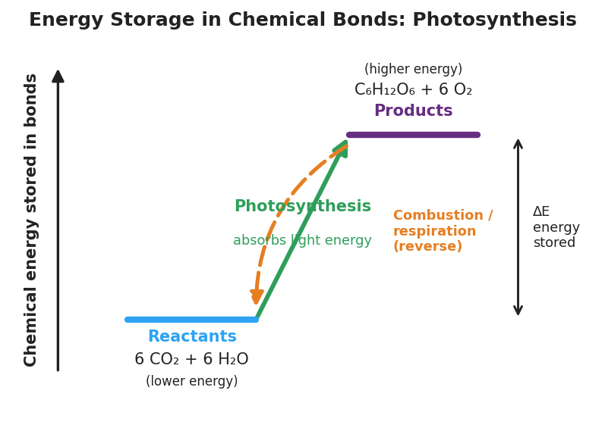
Energy-level diagram titled ‘Energy Storage in Chemical Bonds: Photosynthesis’. A low blue platform on the left is labeled ‘Reactants — 6 CO₂ + 6 H₂O (lower energy)’. A high purple platform on the right is labeled ‘Products — C₆H₁₂O₆ + 6 O₂ (higher energy)’. A solid green upward arrow labeled ‘Photosynthesis — absorbs light energy’ goes from the low reactant level up to the high product level. A dashed orange downward arrow labeled ‘Combustion / respiration (reverse)’ goes back down from products to reactants. A double-headed bracket on the right marks the energy difference ‘ΔE energy stored’.
- The source. What supplies the energy that lets the reaction climb up the diagram (the photosynthesis arrow)?

- The store. Once the plant has climbed to the high level, where is that energy now physically held? (What part of the sugar molecule is storing it?)

- The release. Name two ways the stored energy can be released by running the reaction in reverse (down the diagram):

- The whole chain. Fill in the energy path from start to finish:
Sun → ______________ → ______________ stored in the bonds of sugar → ______________ (when the sugar is burned or eaten)

Make It Make Sense
For each scenario, decide where the energy is stored or released and explain using the energy diagram. These use the leaf and salad — the examples from class.
- A dried leaf is set on fire and releases heat and light, even though it was never plugged into anything.
  - Where did the energy in the fire come from originally? _______________________________________________
  - Was the energy created by the fire, or released from storage? _______________________________________________
  - On the energy diagram, is burning the leaf moving up or down? _______________________________________________
- You eat a salad. Hours later you have energy to walk to class. The lettuce just sat in a sunny field for weeks.
  - What did the plant store in the lettuce while it sat in the field? _______________________________________________
  - What was the original source of that stored energy? _______________________________________________
  - When your body releases that energy, are you running the photosynthesis reaction forward or in reverse? _______________________________________________
- Two sides of the same equation: the reactants are 6 CO₂ + 6 H₂O and the products are C₆H₁₂O₆ + 6 O₂. They contain the exact same atoms.
  - Which side stores more chemical potential energy? _______________________________________________
  - If the atoms are identical on both sides, what makes one side store more energy than the other? _______________________________________________
  - Where did the extra energy in the higher side come from? _______________________________________________

Vocabulary in Action
Use each term in a sentence about today’s phenomenon or investigation. Do not just copy the definition — use the word to describe something you observed, drew, or reasoned about.
- chemical potential energy: _______________________________________________ _______________________________________________
- photosynthesis: _______________________________________________ _______________________________________________
- conservation of energy: _______________________________________________ _______________________________________________

Revise Your Model
Return to the energy diagram your group built. Add these labels:
- On the high level, write “high chemical potential energy.” On the low level, write “low chemical potential energy.”
- On the up-arrow write “light energy in.” On the down-arrow write “energy released.”
- Write the one-line energy chain along the bottom of your diagram: Sun → light energy → chemical potential energy in bonds → heat/motion.
Then finish this Because / But / So sentence:
A dried leaf releases heat and light when it burns because __________________________________________, but __________________________________________, so __________________________________________.

Exit Ticket
(a) In the reaction 6 CO₂ + 6 H₂O → C₆H₁₂O₆ + 6 O₂, which side stores more chemical potential energy — the reactants or the products? Explain how you know in one sentence.

(b) What supplies the energy that photosynthesis stores? Where does it ultimately come from?

(c) A marshmallow roasting over a campfire releases heat. Trace that heat energy backward, step by step, all the way to its original source.

