Real vs. Ideal Gases — Student Worksheet
Unit: Gas Laws — Lesson 01 Name: _______________________ Date: __________ Period: ____

Phenomenon
A bunch of helium balloons is tied to a chair at a party. In the warm evening they ride high and round against the ceiling. Overnight the heat shuts off and the room turns cold. In the morning the same balloons are smaller, wrinkled, and sinking toward the floor. Nobody untied them and the room is sealed — but by morning they have shrunk and sunk.
Driving question: Under what conditions does a fixed amount of gas behave in a simple, predictable way — and when does that simple picture start to break down?

Notice & Wonder
I notice… | I wonder…
Turn & Talk #1: In both the balloons and your teacher’s crushing-can demo, nothing was added or removed — the only change was that the gas got colder. In one sentence, what is happening to the particles inside the gas as it cools?

Initial Model
Before your teacher explains anything, draw the gas particles inside one warm balloon and the same gas inside the same balloon after it has cooled overnight.
Warm balloon (evening) | Cooled balloon (morning)
In your drawings, show: how fast the particles move (use arrows), how spread out they are, and how often they hit the walls.
Prediction: Why is the cooled balloon smaller? (Write one sentence.)

Investigation

Part 1 — ACTIVE LEARNING: Predict, observe, explain
Activity A — Crushing can (teacher demo). Before your teacher flips the can, commit a prediction in writing.
- My prediction: Will the can change? How? Why?

- What actually happened:

- Was my prediction right? ▢ Yes ▢ No ▢ Partly. What surprised me: _______________________________________________
Activity B — Inverted graduated cylinder (you do this). Trap a gas sample under an inverted cylinder by water displacement. Predict the volume direction before you change the temperature, then measure.
- My prediction: When I cool the trapped gas, the volume will get ▢ bigger ▢ smaller ▢ stay the same, because _______________________________________________
Condition | Trapped volume (mL) | What the particles are doing
Warm (hand / room)
Cold (ice bath)

Part 2 — Reading the pressure–volume relationship
Look at figures/pressure_volume_curve.png:
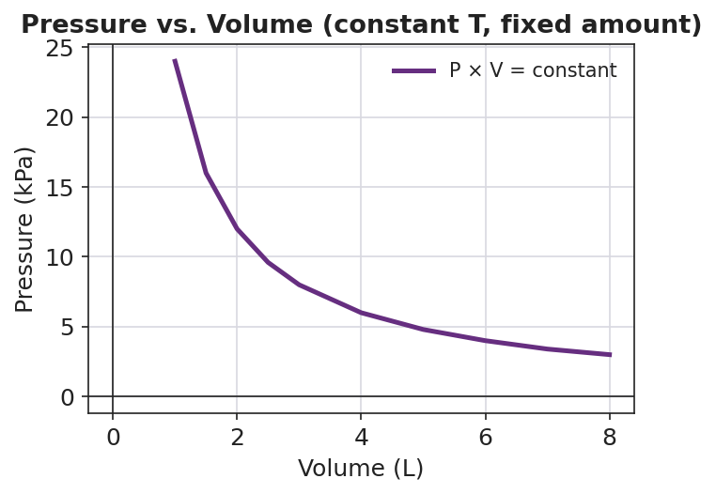
Line graph titled ‘Pressure vs. Volume (constant T, fixed amount)’: a smooth curve falling from upper-left to lower-right, showing pressure in kPa decreasing as volume in liters increases; the curve is steep at small volumes and flattens at large volumes; at every point the product of pressure and volume is the same constant value, showing the inverse pressure–volume relationship of an ideal gas at fixed temperature.
- As the volume increases, the pressure _______________ (increases / decreases).
- Pick any two points on the curve and multiply pressure × volume for each. What do you notice about the two products?

- Why would squeezing a fixed amount of gas into a smaller volume raise its pressure? (Think about the particles and the walls.)

Make It Make Sense
For each situation below, decide whether the gas is behaving more like or less like an ideal gas, and explain in terms of the particles. (Reminder: a gas is most ideal at low pressure and high temperature.)
- A weather balloon drifts high in the warm upper atmosphere where the surrounding pressure is very low.
  - More like / less like an ideal gas: _______________________________________________
  - Why, in terms of the particles? _______________________________________________

- A scuba diver’s gas is squeezed into a tank at very high pressure at room temperature.
  - More like / less like an ideal gas: _______________________________________________
  - Why, in terms of the particles? _______________________________________________

- A sample of carbon dioxide is cooled to a very low temperature inside a sealed container.
  - More like / less like an ideal gas: _______________________________________________
  - Why, in terms of the particles? _______________________________________________

Vocabulary in Action
Use each term in a sentence about today’s phenomenon or investigation. Do not just copy the definition — use the word to describe something you observed or did.
- ideal gas: _______________________________________________ _______________________________________________
- real gas: _______________________________________________ _______________________________________________
- model: _______________________________________________ _______________________________________________

Revise Your Model
Return to your Initial Model (the warm-vs-cooled balloon drawings).
- Add a label noting that you were assuming an ideal gas. Write the assumption you were making about the particles: _______________________________________________
- Add a note: under what extreme condition would that assumption start to fail for the helium? _______________________________________________
Then finish this Because / But / So sentence:
The overnight helium balloons shrink and sink as the room cools because __________________________________________, but __________________________________________, so __________________________________________.

Exit Ticket
Two sealed steel tanks hold the same amount of nitrogen gas. Tank X is at high temperature and low pressure (particles spread far apart). Tank Y is at low temperature and high pressure (particles crowded close together).
- In which tank does the nitrogen behave most like an ideal gas? Explain your choice in terms of the particles.
Tank _____ — because: _______________________________________________ _______________________________________________
- Name the three assumptions the ideal gas model makes about gas particles.

- In one sentence, use the word model to explain why the ideal gas is useful even though no real gas is perfectly ideal.

