Kinetic Molecular Theory — Student Notes
Unit: Gas Laws — Lesson 02 Name: _______________________ Date: __________ Period: ____

Learning Targets
By the end of today’s 42 minutes I can:
- State the main postulates of the kinetic molecular theory in my own words.
- Explain that the temperature of a gas (in kelvin) measures the average kinetic energy of its particles.
- Explain that pressure is caused by gas particles colliding with the walls of their container.
- Use the kinetic molecular theory to explain a real phenomenon — like why a sealed bag of chips puffs up on a mountain.

Key Vocabulary
- kinetic molecular theory — _______________________________________________ _______________________________________________
- temperature — _______________________________________________ _______________________________________________
- pressure — _______________________________________________ _______________________________________________

Guided Notes
The big idea — Cause and Effect: A gas is a swarm of tiny particles in constant motion. A change at the __________ scale (faster motion, more collisions) causes a change you can measure (higher __________, a puffed-up bag).
The postulates of the kinetic molecular theory (fill in the blanks):
- A gas is made of many tiny __________ that are very small compared to the space between them — a gas is mostly empty __________.
- The particles are in constant, __________ motion, moving in straight lines until they collide.
- Collisions between particles (and with the walls) are __________ — no kinetic energy is lost.
- The average kinetic energy of the particles depends only on the __________ (in kelvin).
What temperature really measures:
Temperature (in kelvin) is a measure of the average __________ __________ of the particles. Higher temperature → particles move __________. At 0 K (absolute zero), particle motion __________.
What causes pressure:
Pressure is the force of particle __________ on the walls of the container, per unit area. More collisions, or harder collisions, means __________ pressure.
The figure — same particles, faster motion at higher temperature:
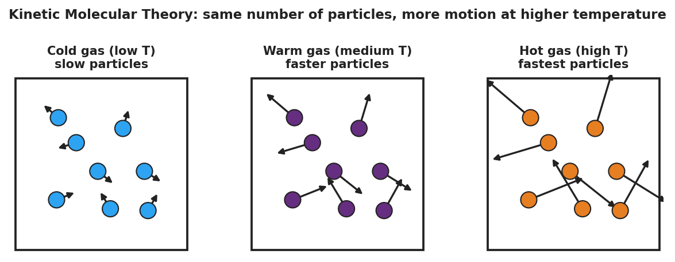
Three side-by-side boxes, each with the same eight gas particles. The left box (cold, low temperature) has short motion arrows; the middle box (warm) has medium arrows; the right box (hot, high temperature) has long arrows. The title reads: same number of particles, more motion at higher temperature.
From the figure, fill in the blanks:
- The number of particles in each box is the __________ (count them).
- The thing that changes from box to box is how __________ the particles move.
- The box with the longest arrows is the __________ gas (highest temperature).
The temperature–energy graph:
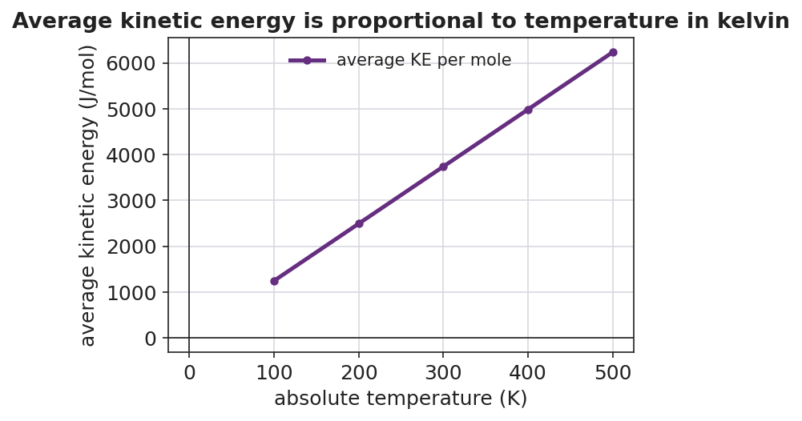
A line graph showing average kinetic energy (J/mol) on the y-axis versus absolute temperature in kelvin on the x-axis. A straight purple line passes through the origin and rises steadily.
- The line goes through the origin (0, 0), which means at 0 K the particles have __________ energy.
- The line is straight, so average kinetic energy is __________ proportional to the kelvin temperature.
- This is why every gas law uses __________, not Celsius.
The Hochman appositive definition:
The kinetic molecular theory — _________________________ — explains pressure and temperature in terms of _________________________.

Worked Example
Scenario: A rigid steel tank of air sits in the sun and heats up from 290 K to 320 K. The tank cannot expand. Use KMT to explain what happens to the pressure.
Step 1 — What changed? The __________ of the gas increased (290 K → 320 K). No particles were added or removed.
Step 2 — What does higher temperature do to the particles?
Higher temperature means higher average __________ __________, so the particles move __________.
Step 3 — What happens at the walls?
Faster particles collide with the tank walls __________ often and with __________ energy.
Step 4 — The tank cannot expand, so what is the only thing that can change?
The __________ inside the tank goes up.
Step 5 — Appositive sentence:
The pressure rose because the kinetic molecular theory — a model of a gas as moving particles — predicts that hotter particles _______________________________________________.
Step 6 — Because / But / So
Heating the sealed tank raises its pressure because _______________________________________________, but _______________________________________________, so _______________________________________________.
Check your reasoning: “because” should name the faster particle motion; “but” should note that the rigid tank cannot expand; “so” should state that the pressure must rise instead.

Summary
Complete the appositive sentence:
The kinetic molecular theory — _________________________ — explains gas pressure as _________________________.
Complete the Because / But / So sentence:
A sealed bag of chips puffs up on a mountain because __________________________________________, but __________________________________________, so __________________________________________.
Reminder: A gas is mostly empty space filled with tiny, fast-moving particles. Temperature tells you how fast they move (their average kinetic energy); pressure tells you how their collisions push on the container walls. Both always use the kelvin scale in gas-law work.

