Pressure–Volume Relationship (Boyle’s Law) — Student Notes
Unit: Gas Laws — Lesson 03 Name: _______________________ Date: __________ Period: ____

Learning Targets
By the end of today’s 42 minutes I can:
- Describe how the gas pressure of a trapped gas changes as its volume changes at constant temperature (volume down → pressure ____).
- State Boyle’s Law in words and as the equation P₁V₁ = P₂V₂.
- Solve for an unknown pressure or volume using P₁V₁ = P₂V₂, carrying correct units.
- Explain, using Scale, Proportion, and Quantity and the particle model, why pressure and volume are an inverse proportion.

Key Vocabulary
- Boyle’s Law — _______________________________________________ _______________________________________________
- inverse proportion — _______________________________________________ _______________________________________________
- gas pressure — _______________________________________________ _______________________________________________

Guided Notes
The big idea — Scale, Proportion, and Quantity: At constant temperature and a fixed amount of gas, pressure and volume are ______________ proportional. When volume goes __________, pressure goes __________. Their product, P × V, stays ______________ .
Boyle’s Law — how it works:
- In words: for a fixed amount of gas at constant temperature, pressure and volume are __________ proportional.
- As an equation: __________ = __________ (read: “pressure-one times volume-one equals pressure-two times volume-two”).
- The product P × V is the same __________ a change and __________ a change.
Why it happens (the particle model): Gas pressure comes from particles __________ with the container walls. When you shrink the volume, the same number of particles is packed into __________ space, so they hit the walls __________ often per second — and more collisions per area means __________ pressure.
The proportion rule: If you multiply the volume by a factor, the pressure is __________ by the same factor.
- Halve the volume (× ½) → pressure __________ (× 2).
- Triple the volume (× 3) → pressure is __________ (× ⅓).
The figure — pressure vs. volume at constant temperature:
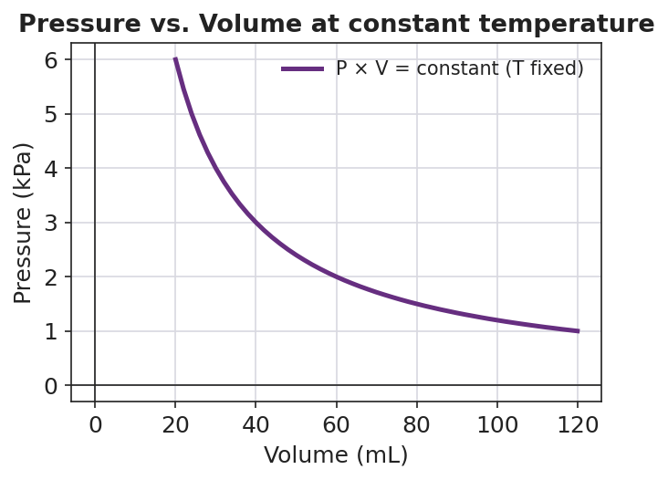
Line graph titled ‘Pressure vs. Volume at constant temperature’ showing a smooth downward-curving line: pressure in kilopascals on the y-axis (from 0 to 6) falls steeply as volume in milliliters on the x-axis (from 20 to 120) increases; the curve passes through (20 mL, 6 kPa), (40 mL, 3 kPa), (60 mL, 2 kPa), and (120 mL, 1 kPa); the legend labels the line ‘P × V = constant (T fixed)’, indicating an inverse proportion where the product of pressure and volume stays the same at every point.
From the figure above, fill in the blanks:
- At 20 mL the pressure is ____ kPa; at 40 mL it is ____ kPa. When the volume doubled, the pressure was __________ .
- Pick the point at 60 mL: P = ____ kPa. P × V = ____ .
- The curve is a smooth bend (not a straight line) because the relationship is __________ , so as volume grows, pressure keeps falling but never reaches __________ .

Worked Example
Scenario: A trapped gas occupies 50.0 mL at 100. kPa. At constant temperature, the plunger is pushed in until the volume is 25.0 mL. Find the new pressure.
Step 1 — Write down what you know:
P₁ = ____ kPa V₁ = ____ mL V₂ = ____ mL P₂ = ?
Step 2 — Write Boyle’s Law:
____________ = ____________
Step 3 — Substitute the known values:
( ____ kPa )( ____ mL ) = P₂ ( ____ mL )
Step 4 — Solve for P₂:
P₂ = ( ____ × ____ ) ÷ ____ = ____________ kPa
Step 5 — Proportional check: The volume was cut in __________ , so the pressure should __________ . Does your answer agree? __________
Step 6 — Because / But / So
The pressure doubled when the volume was halved because _______________________________________________, but _______________________________________________, so _______________________________________________.
Check your reasoning: “because” should explain the particle collisions; “but” should name what stayed constant (temperature and amount); “so” should state that P × V stays constant — Boyle’s Law.

Summary
Complete the sentence:
Boyle’s Law states that, at constant temperature, the __________ and __________ of a fixed amount of gas are __________ proportional, so P₁V₁ = __________ .
Complete the Because / But / So sentence:
When you compress a trapped gas at constant temperature, its pressure rises because __________________________________________, but __________________________________________, so __________________________________________.
Reminder: Boyle’s Law holds only when temperature and the amount of gas stay constant. The equation conserves the product P × V — you multiply pressure by volume on each side, you do not add them.
Key reference: Boyle’s Law: P₁V₁ = P₂V₂ (constant T, constant amount of gas) Inverse proportion: volume × factor → pressure ÷ same factor → product unchanged

