Pressure–Volume Relationship (Boyle’s Law) — Student Worksheet
Unit: Gas Laws — Lesson 03 Name: _______________________ Date: __________ Period: ____

Phenomenon
You seal the tip of a syringe full of air with your finger, then push the plunger in. It moves at first, then fights back — the harder you push, the harder it pushes back, and you can never reach the bottom. Pull the plunger out against the seal, and it resists the other way and springs back when you let go. The amount of air never changed; no air went in or out. Yet the trapped gas behaves like a spring.
Driving question: Why does a syringe get harder to push as you compress the air inside?

Notice & Wonder
I notice… | I wonder…
Turn & Talk #1: As you push the plunger in, the volume of the trapped air goes down. In one sentence, what happens to the pressure — and how do you know from what you felt?

Initial Model
Before your teacher names any rule: draw the air particles inside the syringe in two pictures — one with the plunger pulled out (large volume) and one with the plunger pushed in (small volume). Use the same number of dots in both boxes.
Plunger OUT — large volume | Plunger IN — small volume
(draw the particles) | (draw the particles)
- In which box do the particles hit the walls more often? _______________
- Based on your drawing, when the volume gets smaller, the pressure should get _______________ (larger / smaller).
- What two things must stay the same for this to be a fair comparison? _______________________________________________

Investigation

Part 1 — BTC: collect the data, find the rule
Working at your group’s vertical surface, change the volume of the trapped gas (by hand on the syringe and by dragging the wall in the PhET Gas Properties simulation, holding temperature and particle count fixed). Record the pressure at each volume. Then look for a pattern.
Volume (mL) | Pressure (kPa) | Volume × Pressure
120
60
40
30
20
- As the volume goes down, the pressure goes _______________ .
- Look at the last column. What stays (about) the same every time? _______________
- Write the rule your group found, in your own words:

Part 2 — Read the P–V curve
Look at figures/pressure_volume_curve.png:
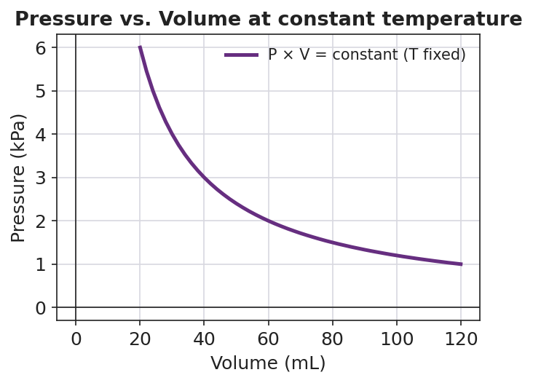
Line graph titled ‘Pressure vs. Volume at constant temperature’ showing a smooth downward-curving line: pressure in kilopascals on the y-axis (from 0 to 6) falls steeply as volume in milliliters on the x-axis (from 20 to 120) increases; the curve passes through (20 mL, 6 kPa), (40 mL, 3 kPa), (60 mL, 2 kPa), and (120 mL, 1 kPa); the legend labels the line ‘P × V = constant (T fixed)’, indicating an inverse proportion where the product of pressure and volume stays the same at every point.
- Pick two points on the curve. Read the volume and pressure at each, and multiply.
Point 1: V = ____ mL, P = ____ kPa → P × V = ____ Point 2: V = ____ mL, P = ____ kPa → P × V = ____
- What do you notice about the two products? _______________________________________________
- Why is the curve a smooth bend instead of a straight line? _______________________________________________

Make It Make Sense
Use Boyle’s Law, P₁V₁ = P₂V₂, for each problem. Show your substitution and your answer with units. (These are the practice problems you will confirm against the Answer Key.)
1. A trapped gas occupies 50.0 mL at 100. kPa. At constant temperature it is compressed to 25.0 mL. Find the new pressure.
P₁V₁ = P₂V₂ → ( ____ )( ____ ) = P₂( ____ ) P₂ = _______________ kPa
2. A gas occupies 4.0 L at 2.0 atm. At constant temperature its volume increases to 8.0 L. Find the new pressure.
P₁V₁ = P₂V₂ → ( ____ )( ____ ) = P₂( ____ ) P₂ = _______________ atm
3. A gas is at 90. kPa in a 6.0 L container. At constant temperature it is compressed until the pressure reaches 270 kPa. Find the new volume.
P₁V₁ = P₂V₂ → ( ____ )( ____ ) = ( ____ )V₂ V₂ = _______________ L

Vocabulary in Action
Use each term in a sentence about today’s investigation. Do not copy the definition — describe something you actually did, felt, or observed.
- Boyle’s Law: _______________________________________________ _______________________________________________
- inverse proportion: _______________________________________________ _______________________________________________
- gas pressure: _______________________________________________ _______________________________________________

Revise Your Model
Return to your Initial Model (the two particle drawings). Add vocabulary labels:
- Label the small-volume box with what happens to the gas pressure and why (collisions): _______________________________________________
- Write the result as an inverse proportion: when volume is multiplied by ____, pressure is _______________ by the same factor, so P × V stays _______________ .
Then finish this Because / But / So sentence:
When you squeeze a sealed syringe to half its volume, the pressure doubles because __________________________________________, but __________________________________________, so __________________________________________.

Exit Ticket
(a) A gas occupies 8.0 L at 1.5 atm. At constant temperature it is compressed to 3.0 L. Use P₁V₁ = P₂V₂ to find the new pressure. Show your work.
P₁V₁ = P₂V₂ → ( ____ )( ____ ) = P₂( ____ ) P₂ = _______________ atm
(b) A gas is at 200. kPa in a 2.0 L container. At constant temperature the pressure drops to 50. kPa. Find the new volume. Show your work.
P₁V₁ = P₂V₂ → ( ____ )( ____ ) = ( ____ )V₂ V₂ = _______________ L
(c) In one sentence, use the particle model to explain why decreasing a gas’s volume increases its pressure.

