Temperature–Volume & Temperature–Pressure Relationships — Student Notes
Unit: Gas Laws — Lesson 04 Name: _______________________ Date: __________ Period: ____

Learning Targets
By the end of today’s 42 minutes I can:
- Describe the direct relationship between the temperature and volume of a fixed gas at constant pressure, and between temperature and pressure at constant volume.
- Convert a Celsius temperature to the Kelvin scale (K = °C + 273) and explain why gas calculations require it.
- Extrapolate a graph to locate absolute zero at −273 °C (0 K).
- Solve T–V problems with V₁/T₁ = V₂/T₂ and T–P problems with P₁/T₁ = P₂/T₂, using Kelvin temperatures.

Key Vocabulary
- absolute zero — _______________________________________________ _______________________________________________
- Kelvin scale — _______________________________________________ _______________________________________________
- direct relationship — _______________________________________________ _______________________________________________

Guided Notes
The big idea — Scale, Proportion, and Quantity: For a fixed amount of gas, volume and pressure each have a __________ relationship with temperature — but only when temperature is measured on the __________ scale. On that scale, doubling the temperature __________ the volume (constant pressure) or __________ the pressure (constant volume).
Two relationships:
Hold this constant | These vary together | Proportion to use | Example
Pressure | temperature ↔ __________ | V₁ / T₁ = V₂ / T₂ | balloon in liquid nitrogen
Volume | temperature ↔ __________ | P₁ / T₁ = P₂ / T₂ | tire on a cold morning
Converting to Kelvin (the non-negotiable first step):
K = °C + ______
- 0 °C = ______ K
- 100 °C = ______ K
- 25 °C (room temperature) = ______ K
- −273 °C = ______ K ← this is absolute zero
Why Celsius fails and Kelvin works: The ratio V ÷ T is only constant when T starts at __________. If you use Celsius, you can divide by __________ (at 0 °C) or by a __________ number (below freezing), and the ratios will not match.
The figure — volume vs. temperature for a fixed gas at constant pressure:
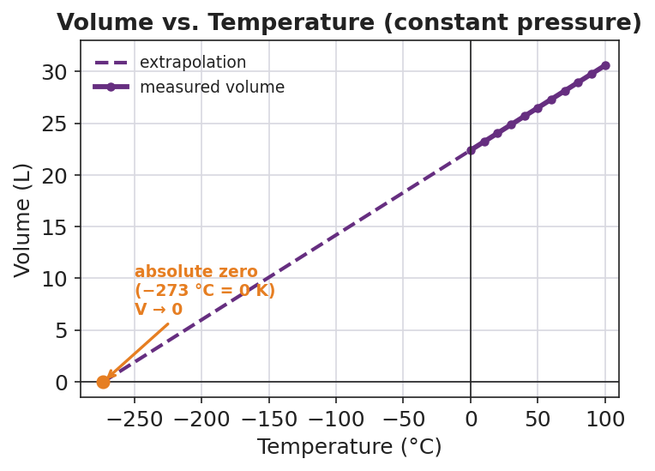
Line graph titled ‘Volume vs. Temperature (constant pressure)’ for a fixed sample of gas. A solid purple line of data points runs from 0 °C (about 22.4 L) up to 100 °C (about 30.6 L); a dashed purple line extends the straight trend down and to the left, crossing zero volume at −273 °C. An orange point and label at (−273 °C, 0 L) reads ‘absolute zero (−273 °C = 0 K), V → 0’. The x-axis is Temperature in degrees Celsius and the y-axis is Volume in liters.
From the figure above, fill in the blanks:
- The line is __________ (straight / curved), which is the shape of a __________ relationship.
- Extending the dashed line, volume reaches zero at __________ °C — this temperature is called __________.
- At 0 °C the gas still has volume (about ____ L), which shows that 0 °C is __________ (the coldest possible / not the coldest possible) temperature.

Worked Example
Scenario: A balloon holds 6.0 L of air at 27 °C. It is warmed to 327 °C at constant pressure. Find the new volume.
Step 1 — Identify what is constant and choose the proportion:
Pressure is constant, so use: ____________________
Step 2 — Convert both temperatures to Kelvin (K = °C + 273):
T₁ = 27 + 273 = ______ K T₂ = 327 + 273 = ______ K
Step 3 — Set up the proportion with the known values:
6.0 / ______ = V₂ / ______
Step 4 — Solve for V₂:
V₂ = 6.0 × (______ / ______) = ______ L
Step 5 — Check the proportional reasoning:
The Kelvin temperature went from 300 K to 600 K — it __________ (doubled / halved). So the volume should __________ (double / halve). Does your answer agree? ______
Step 6 — Because / But / So
The volume increased when the gas was heated because _______________________________________________, but _______________________________________________, so _______________________________________________.
Check your reasoning: “because” should name the direct relationship and the Kelvin temperature change; “but” should note that no gas was added; “so” should state the new volume.

Summary
Complete the rule:
For a fixed amount of gas, volume and pressure each have a __________ relationship with __________ temperature. Always convert: K = °C + ______, because the proportion only works on the scale that starts at __________ (____ °C = ____ K).
Complete the Because / But / So sentence:
A tire’s pressure drops on a cold morning even though no air escaped because __________________________________________, but __________________________________________, so __________________________________________.
Reminder: The very first step of every gas-law problem is to convert temperature to Kelvin. A negative or zero temperature inside your proportion is a warning that you forgot to add 273.
Key reference (from the 2025 NYS Reference Tables): Kelvin conversion: K = °C + 273 Absolute zero: −273 °C = 0 K T–V (constant P): V₁/T₁ = V₂/T₂ · T–P (constant V): P₁/T₁ = P₂/T₂

