Combined Gas Law — Student Notes
Unit: Gas Laws — Lesson 05 Name: _______________________ Date: __________ Period: ____

Learning Targets
By the end of today’s 42 minutes I can:
- State the combined gas law, P₁V₁/T₁ = P₂V₂/T₂, and explain that it merges Boyle’s, Charles’s, and Gay-Lussac’s laws into one equation.
- Convert all temperatures to Kelvin (K = °C + 273) and write down STP (273 K, 101.3 kPa) when a problem says a gas is “at STP.”
- Rearrange the combined gas law to solve for any one unknown (V₂, P₂, or T₂) and carry the correct units.
- Explain, using Scale, Proportion, and Quantity, why volume increases with absolute temperature but decreases with pressure.

Key Vocabulary
- combined gas law — _______________________________________________ _______________________________________________
- absolute temperature — _______________________________________________ _______________________________________________
- STP — _______________________________________________ _______________________________________________

Guided Notes
The big idea — Scale, Proportion, and Quantity: For a fixed amount of gas, volume is __________ proportional to absolute temperature and __________ proportional to pressure. When you change two of the three variables, the third must adjust so that the quantity P·V/T stays __________.
The combined gas law:
P₁V₁/T₁ = P₂V₂/T₂
State 1 is the gas’s __________ condition; state 2 is its __________ condition.
Three laws in one. The combined gas law contains the three earlier gas laws as special cases:
- Hold temperature constant → the T’s cancel → P₁V₁ = P₂V₂ (__________ law)
- Hold pressure constant → V₁/T₁ = V₂/T₂ (__________ law)
- Hold volume constant → P₁/T₁ = P₂/T₂ (__________ law)
Two non-negotiable rules:
- Temperature must be in __________ . Convert: K = °C + ______.
- P₁ and P₂ must use the __________ unit (and V₁, V₂ the same unit). The units then cancel.
STP — the free reference state. When a problem says a gas is “at STP,” write down:
- P = __________ kPa
- T = __________ K
The Hochman appositive definition:
The combined gas law — _________________________ — relates the pressure, volume, and temperature of a fixed gas sample.
The figure — the inverse pressure–volume relationship (constant temperature):
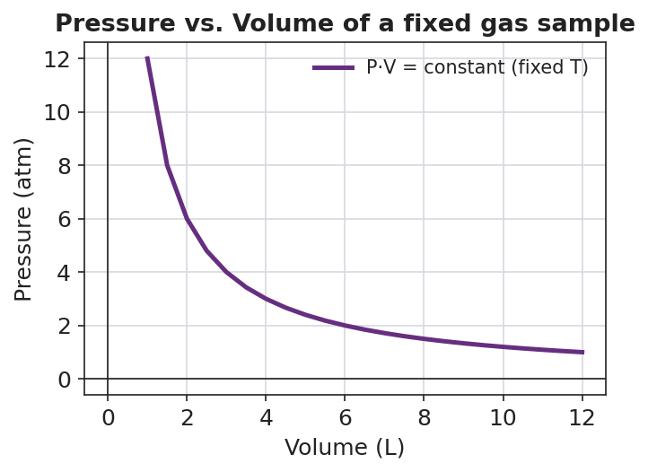
Line graph titled ‘Pressure vs. Volume of a fixed gas sample’ showing an inverse (hyperbolic) curve for a fixed gas sample at constant temperature; pressure on the y-axis in atm falls steeply from about 12 atm at 1 L toward about 1 atm at 12 L; the product P·V stays constant; the x-axis is labeled ‘Volume (L)’ and the y-axis ‘Pressure (atm)’.
From the figure above, fill in the blanks:
- As volume increases, pressure __________.
- This curve shows the special case of the combined gas law where __________ is held constant.
- The relationship shown here (P up, V down) is described as __________ proportional.

Worked Example
Scenario: A gas occupies 2.0 L at STP. Its pressure is doubled to 202.6 kPa and its temperature is doubled to 546 K. Find the new volume V₂.
Step 1 — Write down the knowns and the unknown.
State 1 (at STP): P₁ = __________ kPa, V₁ = __________ L, T₁ = __________ K
State 2: P₂ = 202.6 kPa, V₂ = ?, T₂ = 546 K
Step 2 — Confirm temperatures are in Kelvin. Both T₁ and T₂ are already in __________ . ✓
Step 3 — Write the combined gas law and rearrange for V₂.
P₁V₁/T₁ = P₂V₂/T₂ → V₂ = (P₁ × V₁ × T₂) ÷ (T₁ × P₂)
Step 4 — Substitute.
V₂ = (101.3 × 2.0 × 546) ÷ (273 × 202.6)
Step 5 — Solve.
V₂ = __________ ÷ __________ = __________ L
Step 6 — Sanity check. The pressure doubled (would halve the volume) but the temperature also doubled (would double the volume). The two effects __________ each other, so the volume stays __________.
Step 7 — Appositive sentence.
The combined gas law — ___________________________ — let me solve for the new volume by keeping P·V/T constant.
Step 8 — Because / But / So
The volume did not change in this problem because _______________________________________________, but _______________________________________________, so _______________________________________________.
Check your reasoning: “because” should name what doubling the pressure does; “but” should name what doubling the temperature does; “so” should state that the effects cancel and V₂ = V₁.

Summary
Complete the appositive sentence:
The combined gas law — _________________________ — relates the pressure, volume, and temperature of a fixed gas sample.
Complete the Because / But / So sentence:
A weather balloon rises into colder, lower-pressure air and gets bigger anyway because __________________________________________, but __________________________________________, so __________________________________________.
Reminder: Always convert temperature to Kelvin before substituting, and write down STP = 273 K, 101.3 kPa whenever a problem says “at STP.” Volume goes up with absolute temperature and down with pressure.
Key reference (from the 2025 NYS Reference Tables): STP (Reference Table A): 273 K and 101.3 kPa Kelvin conversion: K = °C + 273 Combined gas law: P₁V₁/T₁ = P₂V₂/T₂

