Evolution of the Atomic Model — Student Notes
Unit: Atomic Concepts — Lesson 01 Name: _______________________ Date: __________ Period: ____

Learning Targets
By the end of today’s 42 minutes I can:
- Express atomic-scale sizes in scientific notation and state how many orders of magnitude separate an atom from things I can see.
- Interpret the gold-foil deflection pattern as evidence and reason from it to the structure of the atom (a small, dense, positive nucleus; electrons outside; mostly empty space).
- Sequence the five atomic models (Dalton → Thomson → Rutherford → Bohr → wave-mechanical) and name the evidence that forced each revision.
- Explain, using Stability and Change, why scientists revise a model instead of treating it as permanent truth.

Key Vocabulary
- nucleus — _______________________________________________ _______________________________________________
- electron — _______________________________________________ _______________________________________________
- model — _______________________________________________ _______________________________________________

Guided Notes
The big idea — Stability and Change: A scientific model is a __________ explanation of how something works. It stays in use as long as it explains the __________. When new evidence appears that the old model __________ explain, scientists __________ the model. The model is not permanent truth — it changes when evidence demands it.
The problem: an atom is too small to see.
- A human hair is about 10⁻⁴ m wide; a single atom is about 10⁻¹⁰ m wide — about __________ powers of ten smaller (roughly a million times smaller).
- No light microscope can photograph an atom, because an atom is smaller than the __________ of visible light.
- So scientists learned about the atom using __________ evidence — they fired particles at atoms and studied the pattern of what bounced back.
The Rutherford gold-foil experiment — reading the evidence:
What the alpha particles did | How often | What it proves
Passed straight through | the vast majority | the atom is mostly __________
Bounced almost straight back | very rare | there is a tiny, dense, __________ -charged core
The structure of the atom (the modern, nuclear model):
- The __________ is the tiny, dense core. It contains the positive __________ and the neutral __________.
- The negative __________ are found outside the nucleus, in the mostly-empty space.
The figure — five models, each revised by new evidence:
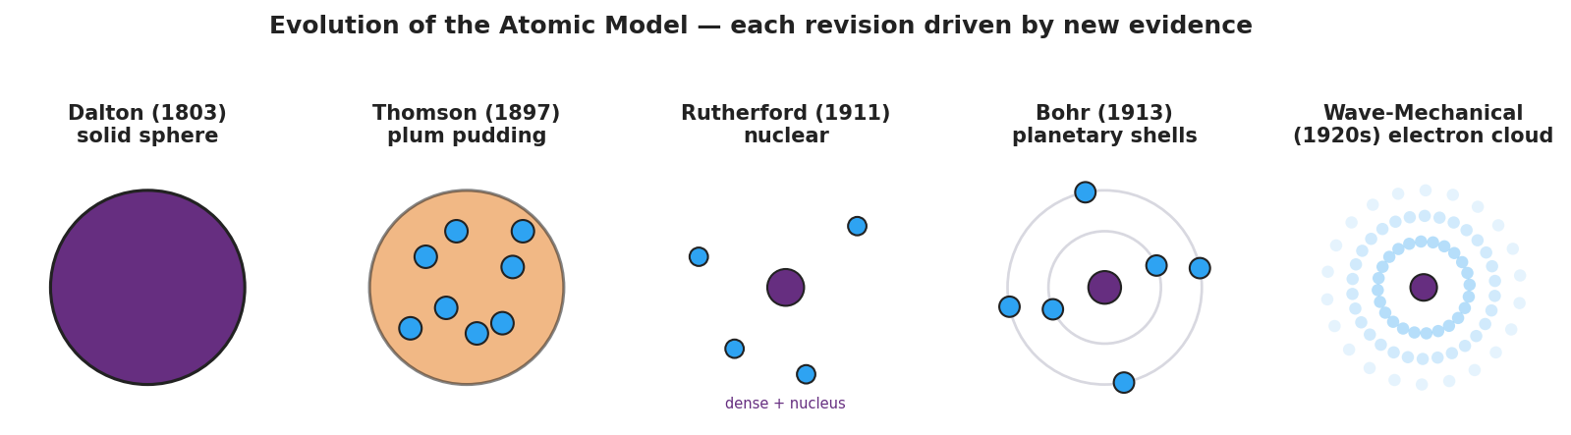
Five-panel timeline of the atomic model from Dalton’s solid sphere (1803) to the wave-mechanical electron cloud (1920s), with a banner reading “each revision driven by new evidence.”
Fill in the evidence that forced each revision:
- Dalton → Thomson: the discovery of the __________ showed the atom is divisible (it has parts inside).
- Thomson → Rutherford: the gold-foil __________ proved the positive charge is concentrated, not spread out.
- Rutherford → Bohr → Wave-mechanical: later evidence showed electrons are not in fixed circular orbits but occupy regions of __________ (an electron cloud).

Worked Example
Scenario: A pair of students runs the gold-foil simulation. Out of 1000 alpha particles fired at the gold foil, about 985 pass straight through, about 14 deflect at an angle, and exactly 1 bounces almost straight back. They must reason from this evidence to the structure of the atom.
Step 1 — Interpret the “most pass straight through” result:
985 of 1000 passed through untouched. This means the atom is mostly _______________________________________________.
Step 2 — Interpret the rare “bounce straight back” result:
A fast, positive particle bounces back only if it hits something small, dense, and _______________ -charged. So the atom must contain a _______________.
Step 3 — Name the structure:
The tiny dense core is the _______________. It holds the _______________ (positive) and _______________ (neutral). The _______________ are outside it.
Step 4 — Which model does this data produce? Circle one: Dalton / Thomson / Rutherford (nuclear) / Bohr
Step 5 — Because / But / So:
The plum-pudding model had to be replaced because _______________________________________________, but _______________________________________________, so _______________________________________________.
Check your reasoning: “because” should name the surprising evidence (the bounce-backs); “but” should explain why pudding could never produce it; “so” should state the new structure (a concentrated nucleus).

Summary
Complete the Because / But / So sentence:
Scientists keep revising the atomic model because __________________________________________, but __________________________________________, so __________________________________________.
Key idea to remember: Scientists cannot photograph an atom, so they build models from indirect evidence. Each model — Dalton, Thomson, Rutherford, Bohr, wave-mechanical — explained more evidence than the one before it. The modern atom is a tiny nucleus of protons and neutrons surrounded by electrons in mostly-empty space.
Key reference (from the 2025 NYS Reference Tables): Atom diameter ≈ 1 × 10⁻¹⁰ m · Nucleus diameter ≈ 1 × 10⁻¹⁴ m The nucleus holds the protons (charge 1+) and neutrons (charge 0); electrons (charge 1−) lie outside it.

