Determining Number of Subatomic Particles — Student Notes
Unit: Atomic Concepts — Lesson 02 Name: _______________________ Date: __________ Period: ____

Learning Targets
By the end of today’s 42 minutes I can:
- Read the atomic number (Z) and mass number (A) of an element and state that the atomic number equals the number of protons.
- Calculate the number of neutrons using neutrons = mass number − atomic number (A − Z).
- Determine the number of electrons in a neutral atom (electrons = protons) and in an ion (electrons = protons − charge).
- Explain, using Patterns, why the number of protons — not neutrons or electrons — fixes the identity of an element.

Key Vocabulary
- atomic number — _______________________________________________ _______________________________________________
- mass number — _______________________________________________ _______________________________________________
- isotope — _______________________________________________ _______________________________________________

Guided Notes
The big idea — Patterns: The Periodic Table is ordered by __________ count. The atomic number rises by exactly __________ from one element to the next. Neutron count and electron count can __________ without changing the element, but the proton count __________.
The three formulas (use these for every atom or ion):
Particle | Formula | Where the numbers come from
Protons | = __________ | atomic number (Periodic Table)
Neutrons | = mass number − __________ | A − Z
Electrons (neutral) | = __________ | same as protons
Electrons (ion) | = protons − __________ | adjust for the charge
Reading the symbol notation:
In a symbol like ³⁹K, the small upper-left number (39) is the __________ number, and the element symbol tells you the __________ number from the Periodic Table.
In an ion like ²⁴Mg²⁺, the +2 is the __________. A positive charge means the atom __________ electrons; a negative charge means the atom __________ electrons.
The Hochman appositive definition:
The atomic number — _________________________ — is what determines _________________________.
The figure — a carbon-12 atom built from its particles:
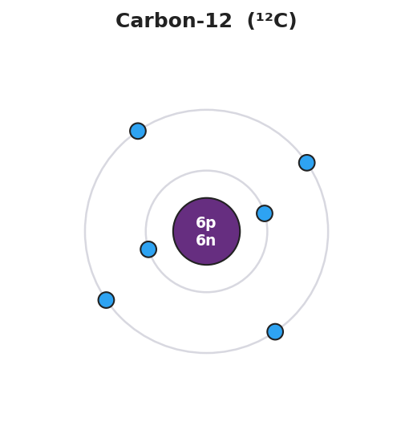
Bohr model of a carbon-12 atom: a central nucleus labeled 6p 6n surrounded by two electron shells, with 2 electrons in the inner shell and 4 electrons in the outer shell, totaling 6 electrons for a neutral atom.
From the figure above, fill in the blanks:
- Protons in the nucleus: ___ Neutrons in the nucleus: ___ Electrons around it: ___
- Atomic number of this atom: ___ → therefore the element is: ___________
- Mass number of this atom (protons + neutrons): ___

Worked Example
Scenario: Determine the protons, neutrons, and electrons in a magnesium-24 ion, written ²⁴Mg²⁺.
Step 1 — Read the atomic number from the Periodic Table:
Mg atomic number (Z) = ___ → protons = ___
Step 2 — Read the mass number from the symbol:
Mass number (A) = ___
Step 3 — Find the neutrons (A − Z):
Neutrons = ___ − ___ = ___
Step 4 — Find the electrons (protons − charge):
The charge is +2, which means the atom lost ___ electrons.
Electrons = protons − charge = ___ − 2 = ___
Step 5 — Appositive sentence:
The atomic number of magnesium — ___ — tells us this ion still has ___ protons, so it is still magnesium even though it lost two electrons.
Step 6 — Because / But / So
A magnesium ion (Mg²⁺) is still magnesium because _______________________________________________, but _______________________________________________, so _______________________________________________.
Check your reasoning: “because” should name the unchanged proton count; “but” should name what did change (the electrons / charge); “so” should state that the element is unchanged.

Summary
Complete the appositive sentence:
The atomic number — _________________________ — is what determines _________________________.
Complete the Because / But / So sentence:
Adding one proton to a carbon atom turns it into nitrogen because __________________________________________, but __________________________________________, so __________________________________________.
Reminder: Protons come straight from the atomic number. Neutrons = mass number − atomic number. Electrons = protons (neutral) or protons − charge (ion). Only the proton count sets the element’s identity.
Key reference (from the 2025 NYS Reference Tables): Atomic number and atomic mass: Periodic Table (Reference Table S) Particles: proton (+1, in nucleus) · neutron (0, in nucleus) · electron (−1, around nucleus)

