Determining Number of Subatomic Particles — Student Worksheet
Unit: Atomic Concepts — Lesson 02 Name: _______________________ Date: __________ Period: ____

Phenomenon
Carbon comes in different “versions.” Carbon-12 has 6 neutrons, carbon-13 has 7, and carbon-14 has 8 — carbon-14 is even radioactive and is the isotope scientists use to date ancient bones and artifacts. Yet every one of them is still carbon. A sodium atom (Na) and a sodium ion (Na⁺) are also still both sodium, even though the ion has lost an electron. But make one different kind of change — add a single proton to a carbon atom — and it stops being carbon entirely. It becomes nitrogen, a completely different element.
Driving question: Why is the identity of an element fixed by its number of protons alone — and not by its neutrons or electrons?

Notice & Wonder
I notice… | I wonder…
Turn & Talk #1: Carbon-12 and carbon-14 are both carbon, but they have different numbers of neutrons. In one sentence: what number is the same for both of them — the number that never changed, no matter which carbon you looked at?

Initial Model
Before your teacher names the process: here is fluorine on the Periodic Table. Its atomic number is 9 and its mass number is 19. Using only those two numbers, work out the particles in a neutral fluorine atom. Show how you got the neutrons.
Quantity | Show your work | Value
Protons | = atomic number
Neutrons | = mass number − atomic number (19 − 9)
Electrons | = protons (neutral atom)
- How many protons does fluorine have? _______________
- How did you find the number of neutrons? _______________________________________________
- Why does a neutral atom have the same number of electrons as protons? _______________________________________________

Investigation

Part 1 — ABCs: Build an Atom (simulation or counters)
Use the Build an Atom simulation (or counters with the Bohr-model template). Build each atom, then record what happens to the element name when you change one kind of particle.
Step | What you do | Element name now | Did the element change? (yes/no)
1 | Build an atom with 6 protons
2 | Add 1 neutron (keep 6 protons)
3 | Add another neutron (still 6 protons)
4 | Remove 1 electron (still 6 protons)
5 | Go back to 6 protons, then add 1 proton (now 7)
Key question: Which single change — and only which change — caused the element name to switch to a new element?

Part 2 — Counting particles from a symbol
Determine protons, neutrons, and electrons for each species. Use the Periodic Table. Show the neutron subtraction (mass number − atomic number).
Species A: ³⁹K (potassium-39, neutral atom)
Quantity | How to find it | Value
Protons | = atomic number
Neutrons | = mass number − atomic number (39 − ___)
Electrons | = protons (neutral)
Species B: ²⁴Mg²⁺ (magnesium-24 ion, charge +2)
Quantity | How to find it | Value
Protons | = atomic number
Neutrons | = mass number − atomic number (24 − ___)
Electrons | = protons − charge (___ − 2)
Species C: ³⁵Cl⁻ (chloride ion, charge −1)
Quantity | How to find it | Value
Protons | = atomic number
Neutrons | = mass number − atomic number (35 − ___)
Electrons | = protons − charge (___ − (−1))
Look at your three species. Which quantity — protons, neutrons, or electrons — stayed equal to the atomic number every single time, no matter the isotope or the charge?

Make It Make Sense
For each species below, determine the number of protons, neutrons, and electrons. Show your complete table. These are the same species you counted in the Investigation — confirm your work here.
1. ³⁹K (potassium-39, neutral)
Quantity | How to find it | Value
Protons | = atomic number
Neutrons | = mass number − atomic number
Electrons | = protons (neutral)
2. ²⁴Mg²⁺ (magnesium-24, charge +2)
Quantity | How to find it | Value
Protons | = atomic number
Neutrons | = mass number − atomic number
Electrons | = protons − charge
3. ³⁵Cl⁻ (chloride, charge −1)
Quantity | How to find it | Value
Protons | = atomic number
Neutrons | = mass number − atomic number
Electrons | = protons − charge
The figure below shows how a neutral carbon-12 atom is put together — 6 protons and 6 neutrons in the nucleus, with 6 electrons in shells around it. Use it as a model for how protons, neutrons, and electrons fit into any atom.
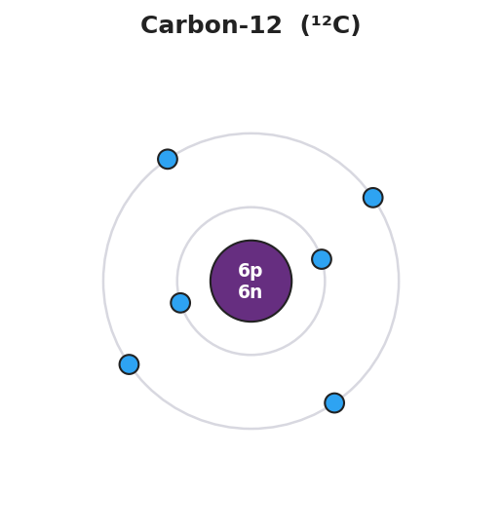
Bohr model of a carbon-12 atom: a central nucleus labeled 6p 6n surrounded by two electron shells, with 2 electrons in the inner shell and 4 electrons in the outer shell, totaling 6 electrons for a neutral atom.

Vocabulary in Action
Use each term in a sentence about today’s investigation. Do not copy the definition — describe something you actually did or observed.
- atomic number: _______________________________________________ _______________________________________________
- mass number: _______________________________________________ _______________________________________________
- isotope: _______________________________________________ _______________________________________________

Revise Your Model
Return to your Initial Model (the fluorine table). Add vocabulary labels:
- Circle the 9 and label it “atomic number = protons.”
- Underline the 19 and label it “mass number = protons + neutrons.”
- Write a revised appositive sentence for fluorine:
The atomic number of fluorine — ___ — tells us a fluorine atom has ___ protons, which is what makes it fluorine and not any other element.
Then finish this Because / But / So sentence:
Carbon-12 and carbon-14 are both still carbon because __________________________________________, but __________________________________________, so __________________________________________.

Exit Ticket
(a) Oxygen-18 (¹⁸O) is a neutral atom. Determine the protons, neutrons, and electrons. Show the neutron subtraction.
Quantity | How to find it | Value
Protons | = atomic number
Neutrons | = mass number − atomic number
Electrons | = protons (neutral)
(b) An aluminum ion is written Al³⁺ with mass number 27. Determine the protons, neutrons, and electrons.
Quantity | How to find it | Value
Protons | = atomic number
Neutrons | = mass number − atomic number
Electrons | = protons − charge
(c) In one sentence, explain why adding one proton to a fluorine atom would change it into a different element.

