Isotopes & Average Atomic Mass — Student Notes
Unit: Atomic Concepts — Lesson 04 Name: _______________________ Date: __________ Period: ____

Learning Targets
By the end of today’s 42 minutes I can:
- Define an isotope as atoms of the same element (same protons) with different numbers of neutrons.
- Write and read isotope notation (carbon-12, carbon-14) and give the proton, neutron, and electron counts of each.
- Explain, without calculating, that the average atomic mass on the Periodic Table is a weighted average that leans toward the most abundant isotope.
- Use Stability and Change to explain why an unstable isotope (carbon-14) makes radiocarbon dating of a turtle shell possible.

Key Vocabulary
- isotope — _______________________________________________ _______________________________________________
- mass number — _______________________________________________ _______________________________________________
- average atomic mass — _______________________________________________ _______________________________________________

Guided Notes
The big idea — Stability and Change: The number of __________ in an atom never changes for a given element — that is the atom’s stable identity (its atomic number). What can change is the number of __________, which changes the atom’s __________ number and, for some atoms, the __________ of the nucleus.
What makes two atoms isotopes?
Feature | Carbon-12 | Carbon-14 | Same or different?
Protons | 6 | 6
Electrons | 6 | 6
Neutrons | 6 | 8
Mass number | 12 | 14
So: isotopes have the same number of __________ (so they are the same element) but a different number of __________ (so they have different mass).
The two carbon isotopes that matter for dating:
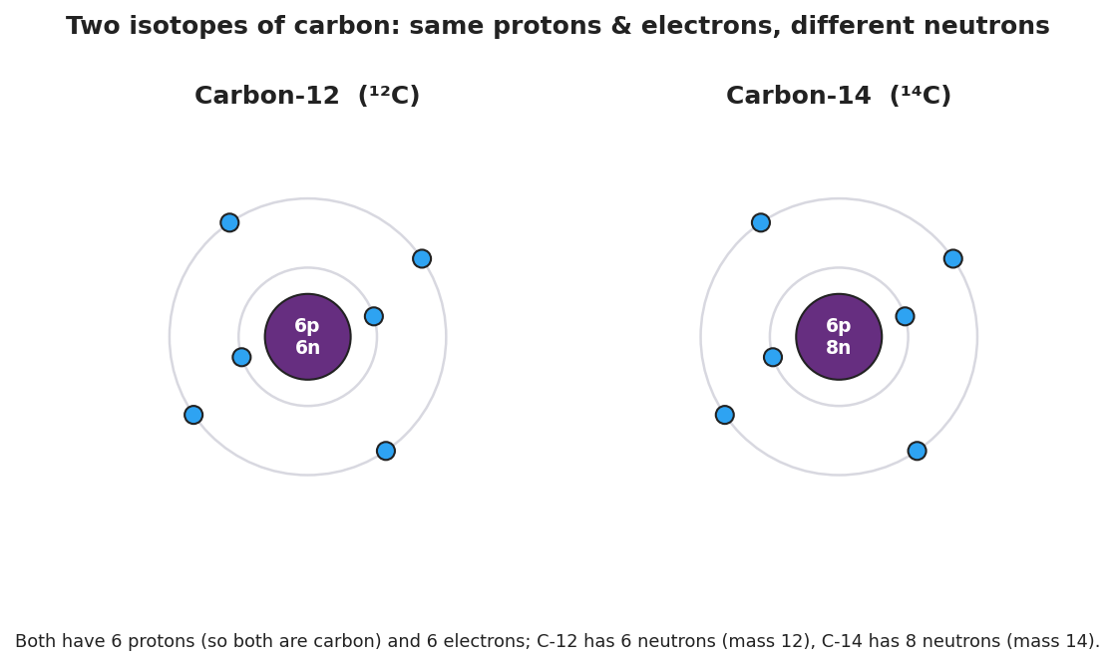
Two Bohr-model diagrams side by side, both carbon. Carbon-12 (left) has a nucleus of 6 protons and 6 neutrons with 6 electrons; Carbon-14 (right) has 6 protons and 8 neutrons with the same 6 electrons. Both are carbon; they differ only in neutron count and mass number.
- Carbon-12 is __________ (it never decays) — it is almost all of the carbon in nature.
- Carbon-14 is __________ (it decays at a fixed rate) — only a trace amount, and it is the “clock” used in radiocarbon dating.
Average atomic mass — what the Periodic Table really lists:
The Periodic Table lists one number for each element’s mass, even though an element can have several isotopes. That number is the average atomic mass — a __________ average across all the naturally occurring isotopes.
- It is not a plain average — it is __________ by how __________ each isotope is.
- It always leans toward the __________ abundant isotope.
Reading the lean (you do NOT compute this):
Element | Average atomic mass | Closer to… | More abundant isotope
Carbon | 12.011 | 12
Chlorine | 35.5 |  | chlorine-35
Boron | 10.81

Worked Example
Scenario: A scientist examines two atoms found in a sample.
- Atom A: 8 protons, 8 neutrons, 8 electrons
- Atom B: 8 protons, 10 neutrons, 8 electrons
Step 1 — Identify the element. Use the Periodic Table: what element has 8 protons?
Element: ___________
Step 2 — Are they isotopes? Compare the proton counts and the neutron counts.
- Protons: A = , B = → same or different? ___________
- Neutrons: A = , B = → same or different? ___________
- Conclusion: A and B ___________ isotopes, because ___________________________________________.
Step 3 — Write each mass number (protons + neutrons):
- Atom A mass number = ___ + ___ = ___ (written as oxygen-___)
- Atom B mass number = ___ + ___ = ___ (written as oxygen-___)
Step 4 — Reason about the average (no calculation). Oxygen’s average atomic mass on the Periodic Table is about 16.00, very close to 16.
- Which isotope of oxygen must be the most abundant? ___________
- How do you know? _______________________________________________
Step 5 — Because / But / So:
Atom A and Atom B are the same element because _______________________________________________, but _______________________________________________, so _______________________________________________.
Check your reasoning: “because” should name what’s the same (protons); “but” should name what’s different (neutrons → mass number); “so” should state that they are isotopes of the same element.

Summary
Complete the sentence:
An isotope is an atom with the same number of __________ as another atom of the element but a different number of __________.
Complete the Because / But / So sentence about the turtle:
Radiocarbon dating works on the turtle shell because __________________________________________, but __________________________________________, so __________________________________________.
Reminder: The average atomic mass on the Periodic Table is a weighted average — it leans toward the most abundant isotope. No single atom actually has the average mass; each real atom is a whole-numbered isotope.
Key reference (from the 2025 NYS Reference Tables): Atomic number (= proton count) and average atomic mass: Periodic Table. Mass number = protons + neutrons (a whole number, one per isotope).

