Isotopes & Average Atomic Mass — Student Worksheet
Unit: Atomic Concepts — Lesson 04 Name: _______________________ Date: __________ Period: ____

Phenomenon
Scientists recover an ancient turtle shell from a coastal marsh dig. They cannot read a date off the shell, but by measuring the carbon-14 inside it they can tell when the turtle died — and, by comparing shells from sites up and down the coast, when an ancient turtle population migrated. While the turtle was alive and eating, its shell held the same tiny fraction of carbon-14 as the world around it. The moment it died, no new carbon-14 came in, and the carbon-14 already there began ticking down at a fixed, known rate. Measure what’s left, and you can read the clock backward.
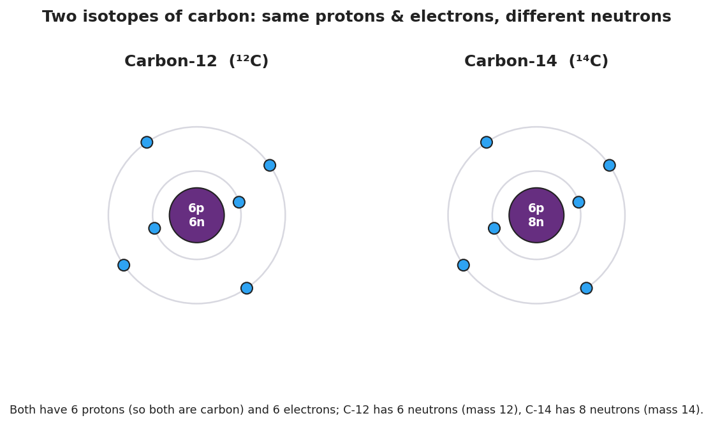
Two Bohr-model diagrams side by side, both carbon. Carbon-12 (left) has a nucleus of 6 protons and 6 neutrons with 6 electrons in two shells; Carbon-14 (right) has a nucleus of 6 protons and 8 neutrons with the same 6 electrons. Both are carbon because both have 6 protons; they differ only in neutrons and therefore in mass number.
Driving question: How can the kind of carbon atom in a turtle shell tell scientists when that turtle lived and migrated?

Notice & Wonder
I notice… | I wonder…
Turn & Talk #1: Both diagrams above are carbon — same 6 protons, same 6 electrons. The only difference is the number of neutrons. In one sentence, would the turtle’s body treat these two kinds of carbon differently, or the same? Why?

Initial Model
Your group has a cup of pennium — a fictional element. There are two kinds: a heavy kind (pre-1982 pennies) and a light kind (post-1982 pennies). They are the same “element” but different masses. Your cup is mostly the heavy kind.
You will not calculate a number. Predict, then explain:
The average mass of a pennium in your cup will land (circle one):
- closer to the heavy mass
- closer to the light mass
- exactly in the middle
My reasoning (one sentence): _______________________________________________ _______________________________________________

Investigation

Part 1 — ABCs: Sort, count, and weigh your pennium
Sort your cup into the two kinds. Count each pile. Then weigh one of each kind (or use the masses your teacher gives you).
Kind of pennium | Count (how many) | Mass of ONE (g)
Heavy (pre-1982)
Light (post-1982)
- Which kind is more abundant (you have more of) in your cup? _______________
- If you grabbed one pennium at random, would you more likely grab the heavy or the light kind? _______________
- Does your prediction from the Initial Model still hold? Which mass does the average lean toward, and why?

Part 2 — From pennium to real carbon
Look at the abundance of carbon’s isotopes:
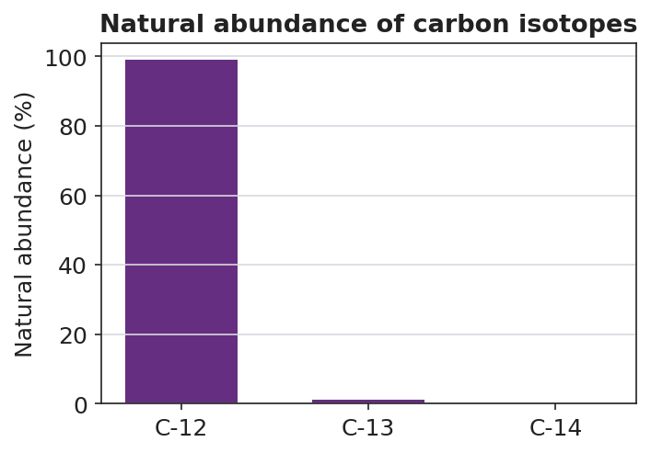
Bar chart ‘Natural abundance of carbon isotopes’ showing C-12 at about 98.9 percent (by far the tallest bar), C-13 at about 1.1 percent (very short), and C-14 as a trace amount essentially at the baseline. The y-axis is natural abundance in percent.
- Which isotope is almost all of the carbon in nature? _______________
- On the Periodic Table, carbon’s average atomic mass is about 12.011. Is that closer to 12 or to 13? _______________
- Use the chart to explain why carbon’s average atomic mass is so close to 12.

Part 3 — Reasoning about chlorine (no calculator needed)
On the Periodic Table, chlorine’s average atomic mass is about 35.5. Chlorine has two main isotopes: chlorine-35 and chlorine-37.
- Is 35.5 closer to 35 or to 37? _______________
- Which isotope must be more abundant, and how do you know — without calculating?

Make It Make Sense
1. Are they isotopes? Two atoms are described below.
- Atom X: 5 protons, 5 neutrons, 5 electrons
- Atom Y: 5 protons, 6 neutrons, 5 electrons
- What element are these? (Use the Periodic Table — what has 5 protons?) _______________
- Are X and Y isotopes of the same element? Explain using proton and neutron counts.

- Write each one’s mass number: Atom X = _______ Atom Y = _______
2. Boron’s average atomic mass. Boron (the element above) has isotopes boron-10 and boron-11. The Periodic Table lists boron’s average atomic mass as about 10.81.
- Is 10.81 closer to 10 or to 11? _______________
- Which isotope of boron is more abundant? How does the average tell you?

3. One average, many atoms. Carbon’s average atomic mass is 12.011.
- Does any single carbon atom actually weigh 12.011 u? (yes / no) _______________
- Explain your answer using the word isotope and the word abundant.

Vocabulary in Action
Use each term in a sentence about today’s phenomenon or investigation. Do not copy the definition — use the word to describe something you observed or did.
- isotope: _______________________________________________ _______________________________________________
- mass number: _______________________________________________ _______________________________________________
- average atomic mass: _______________________________________________ _______________________________________________

Revise Your Model
Return to your Initial Model (the pennium prediction). Add vocabulary labels:
- Label the two kinds of pennium as “two ___________ of pennium.”
- Label each kind’s mass with the term that means protons + neutrons: ___________
- Label the predicted cup average with the Periodic-Table term it stands for: ___________
Then finish this Because / But / So sentence about the turtle:
Carbon-12 and carbon-14 are both carbon because __________________________________________, but __________________________________________, so __________________________________________.

Exit Ticket
- Two atoms are described below.
- Atom 1: 17 protons, 18 neutrons
- Atom 2: 17 protons, 20 neutrons
Are they isotopes of the same element? Name the element, and write each isotope’s mass number.
Element: _______________ Atom 1 mass number: _______ Atom 2 mass number: _______ Isotopes? (yes / no) and why: _______________________________________________
- Chlorine’s average atomic mass on the Periodic Table is about 35.5. Its two isotopes are chlorine-35 and chlorine-37. Which isotope is more abundant, and how do you know — without calculating?

- In one sentence, explain why radiocarbon dating of the turtle shell depends on an unstable isotope. Try to use the words stable and unstable, or the word decay.

