Ions: Why Sodium Reacts but Sodium Ion Sits Still — Student Notes
Unit: Atomic Concepts — Lesson 05 Name: _______________________ Date: __________ Period: ____

Learning Targets
By the end of today’s 42 minutes I can:
- Define an ion as a charged atom and explain that the charge comes from a mismatch between protons and electrons.
- Draw the formation of a cation and an anion by removing or adding the correct number of electrons and stating the resulting charge.
- Predict, from an element’s group number alone, whether it forms a cation or an anion and the magnitude of its charge.
- Explain, using Patterns, why elements in the same group form ions of the same charge.

Key Vocabulary
- ion — _______________________________________________ _______________________________________________
- cation — _______________________________________________ _______________________________________________
- anion — _______________________________________________ _______________________________________________

Guided Notes
The big idea — Patterns: Ion charge is not random. It repeats predictably down each __________ of the periodic table. The group number sets the number of __________ electrons, and that sets the stable ion an atom forms.
What is an ion?
- The nucleus (protons and neutrons) __________ change when an ion forms. Only __________ are lost or gained.
- If protons and electrons balance → the atom is __________ (no charge).
- If an atom loses electrons → more protons than electrons → overall charge is __________ → called a __________.
- If an atom gains electrons → more electrons than protons → overall charge is __________ → called an __________.
Why do atoms form ions? Atoms gain or lose electrons to reach a full, __________ outer shell (8 electrons, or 2 for the smallest atoms). Atoms take the __________ path: lose a few, or gain a few — whichever is fewer.
The figure — sodium becomes a cation:
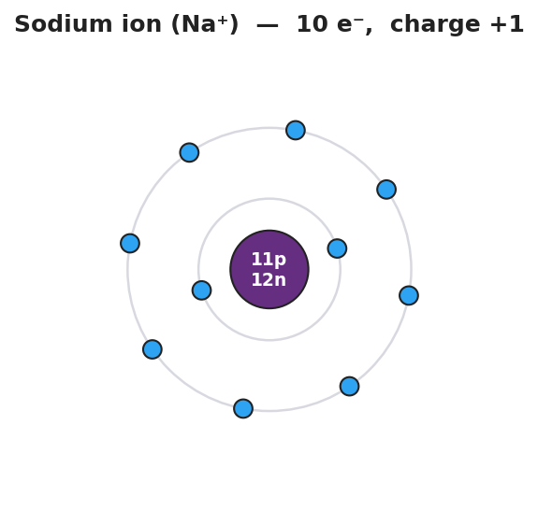
Bohr shell diagram of a sodium ion: a central purple nucleus labeled 11p 12n surrounded by two electron shells holding 2 and 8 electrons for a total of 10 electrons; the lone outer electron of neutral sodium is gone and the outer shell is now full; titled ‘Sodium ion (Na⁺) — 10 e⁻, charge +1’.
From the figure: sodium had 11 protons and 11 electrons (neutral). After losing 1 electron it has 11 protons and ___ electrons → overall charge ___ → symbol ___.
Predicting the ion from the group number:
Group | Type of element | Valence e⁻ | Lose or gain? | Ion charge
1 | metal | 1 | lose 1 | ___
2 | metal | 2 | lose 2 | ___
16 | nonmetal | 6 | gain 2 | ___
17 | nonmetal | 7 | gain 1 | ___
18 | noble gas | 8 (full) | neither | __________
Pattern rule: Metals on the left __________ electrons → __________ ions (cations). Nonmetals on the right __________ electrons → __________ ions (anions). Same group → same __________.
The Hochman appositive definition:
An ion — _________________________ — forms when an atom reaches a stable full outer shell.

Worked Example
Scenario: Predict the ion that chlorine (Cl) forms, and explain why.
Step 1 — Find the group and valence electrons:
Chlorine is in Group . Valence electrons = .
Step 2 — Decide the shortest path to a full outer shell (8):
Chlorine has 7 valence electrons. To reach 8, it is easier to __________ 1 electron than to lose 7.
Step 3 — Count protons and electrons after the change:
 | Protons | Electrons | Overall charge
Cl atom | 17 | 17 | 0
Cl after gaining 1 | 17 | ___ | ___
Step 4 — Write the ion:
Chlorine gains 1 electron and forms the ion ___ — a (cation / anion): __________.
Step 5 — Appositive sentence:
The chloride ion (Cl⁻) — _________________________ — has one more electron than proton.
Step 6 — Because / But / So
Chlorine gains an electron rather than losing seven because _______________________________________________, but _______________________________________________, so _______________________________________________.
Check your reasoning: “because” should name the shortest path to a full shell; “but” should name what gaining a negative electron does to the charge; “so” should state the final ion (Cl⁻, an anion).

Summary
Complete the appositive sentence:
An ion — _________________________ — forms when an atom reaches a stable full outer shell.
Complete the Because / But / So sentence:
Sodium metal reacts violently with water, but sodium ion in salt does not, because __________________________________________, but __________________________________________, so __________________________________________.
Reminder — the sign rule: Lose electrons → positive (cation). Gain electrons → negative (anion). The charge is opposite to the direction you might first guess, because electrons themselves are negative.
Key reference (from the 2025 NYS Reference Tables): Periodic Table — group number gives the valence-electron count, which predicts the ion charge. Group 1 → 1+; Group 2 → 2+; Group 16 → 2−; Group 17 → 1−; Group 18 → no ion.

