Electron Configuration: Excited & Ground States — Student Notes
Unit: Atomic Concepts — Lesson 06 Name: _______________________ Date: __________ Period: ____

Learning Targets
By the end of today’s 42 minutes I can:
- Read the ground-state electron configuration of an element from the NYS Chemistry Reference Tables (for example, sodium = 2-8-1).
- Decide whether a configuration is a ground state or an excited state by checking that the digits add up to the atomic number and that the lower shells are filled first.
- Write a valid excited-state configuration for a named neutral atom.
- Explain, using Energy and Matter, why an excited electron falling back to the ground state releases a photon, and why each element produces its own color.

Key Vocabulary
- ground state — _______________________________________________ _______________________________________________
- excited state — _______________________________________________ _______________________________________________
- photon — _______________________________________________ _______________________________________________

Guided Notes
The big idea — Energy and Matter: When an atom absorbs energy, an electron jumps __________ to a higher shell. The atom is now in an __________ state. When the electron falls back __________, it releases that energy as a particle of light called a __________. The size of the energy gap sets the __________ of the light.
How electrons fill shells (for the elements we use):
Shell | Maximum electrons it can hold
Shell 1 | ____
Shell 2 | ____
Shell 3 | ____
In the ground state, the __________ shells fill completely before any electron goes higher.
Two checks for any configuration:
- Do the digits add up to the __________ (the atomic number, for a neutral atom)?
- Are the lower shells filled first (ground state), or is there a gap below an occupied higher shell (excited state)?
Reading the reference tables: The electron configuration printed under each element on the NYS Chemistry Reference Tables is always the __________ state.
The figure — same atom, two arrangements of sodium:
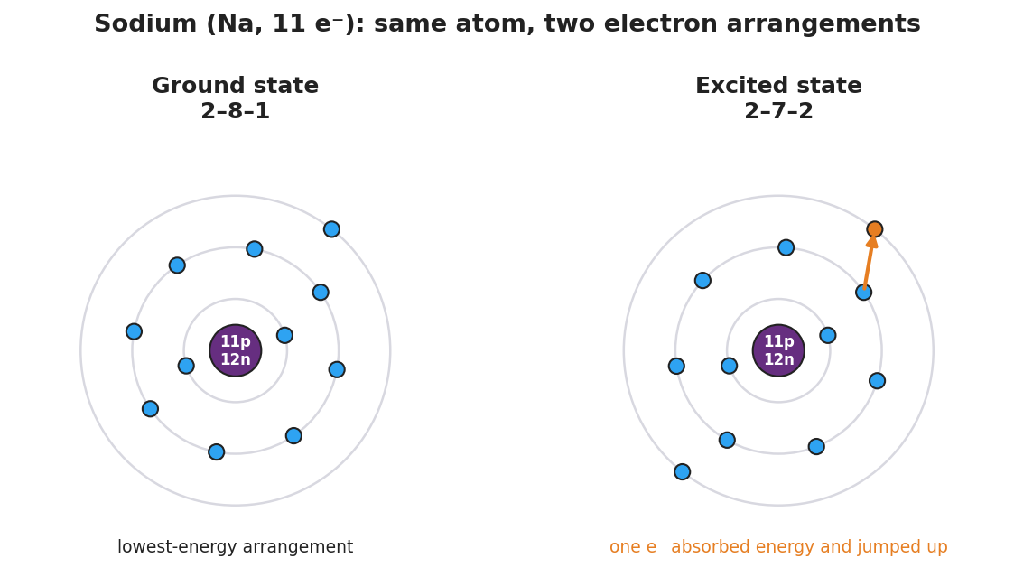
Side-by-side Bohr-model comparison of a sodium atom (11 protons, 12 neutrons). Left panel labeled “Ground state 2–8–1”; right panel labeled “Excited state 2–7–2” with one electron highlighted in orange on the outer shell and an arrow showing it jumped up after absorbing energy.
From the figure, fill in the blanks:
- Both panels are the element __________ because the electrons add up to ____ in each.
- The ground-state configuration is __________ (lowest shells filled first).
- The excited-state configuration is __________ (one electron jumped up, leaving a gap in shell ___).

Worked Example
Scenario: Decide whether each configuration of sodium (Na, 11 electrons) is a ground state, a valid excited state, or impossible.
Step 1 — How many electrons should sodium have?
Atomic number of sodium = ____ , so a neutral sodium atom has ____ electrons.
Step 2 — Check each card with the two rules.
Configuration | Sum of digits | Sum = 11? | Lowest shells filled first? | Verdict
2-8-1 | ____
2-7-2 | ____
2-9 | ____
Step 3 — Put it in words.
- 2-8-1 is the __________ state because __________________________________.
- 2-7-2 is a valid __________ state because the digits still add to 11, but shell 2 has only ___ electrons while shell 3 is occupied — an electron __________ up.
- 2-9 is __________ because shell 2 cannot hold ___ electrons (its limit is ___).
Step 4 — Because / But / So
A sodium configuration of 2-7-2 is an excited state because _______________________________________________, but _______________________________________________, so _______________________________________________.
Check your reasoning: “because” should name the gap in the lower shell; “but” should state what the ground state would look like; “so” should name which state 2-7-2 is.

Summary
Complete the sentence:
The configuration printed on the reference tables is the __________ state; when an atom absorbs energy, an electron jumps to a higher shell, putting the atom in an __________ state; when the electron falls back, the atom releases a __________ of light.
Complete the Because / But / So sentence:
A sodium flame always glows the same yellow-orange color because __________________________________________, but __________________________________________, so __________________________________________.
Reminder: An excited state is the same atom as the ground state — same number of electrons, same atomic number — just rearranged to a higher energy. Changing the total number of electrons gives a different element or an ion, not an excited state.
Key reference (from the 2025 NYS Chemistry Reference Tables): Electron configurations (ground state) and atomic numbers: Periodic Table. Shell capacities used here: shell 1 = 2, shell 2 = 8, shell 3 = 8.

