Bright-Line Spectra — Student Notes
Unit: Atomic Concepts — Lesson 07 Name: _______________________ Date: __________ Period: ____

Learning Targets
By the end of today’s 42 minutes I can:
- Tell apart a continuous spectrum (a full rainbow, every wavelength) from a bright-line spectrum (a few discrete colored lines on black).
- Observe a gas-discharge tube through a spectroscope and sketch its line pattern.
- Identify an unknown element by matching its bright-line spectrum to reference spectra, citing specific lines.
- Explain, using energy levels and electron transitions, why a bright-line spectrum shows separate lines instead of a continuous rainbow.

Key Vocabulary
- bright-line spectrum (emission spectrum) — _______________________________________________ _______________________________________________
- energy level — _______________________________________________ _______________________________________________
- electron transition — _______________________________________________ _______________________________________________

Guided Notes
The big idea — Patterns: Each element gives off a fixed, repeatable set of light wavelengths. The unique pattern of lines is a __________ that lets us identify the element — even in a star we can never __________.
Two kinds of spectra:
Type | What it looks like | What produces it
Continuous spectrum | a full __________ , every color present | a hot, dense glowing source (filament, Sun’s surface)
Bright-line (emission) spectrum | a few __________ colored lines on a black background | a thin, excited gas of a single element
Why discrete lines? — the energy-level model:
- Inside an atom, an electron can only have certain allowed __________ levels (the shells from the Bohr model). It can never have an energy in between two levels.
- When an electron drops from a __________ level to a __________ level, the atom releases the leftover energy as light of one specific __________ .
- Because only certain levels exist, only certain drops are possible — so only certain colors appear. That is why a spectrum is separate __________, not a smooth rainbow.
Color and energy (no calculation needed):
- A bigger energy drop releases light toward the __________ end of the spectrum (higher energy).
- A smaller energy drop releases light toward the __________ end of the spectrum (lower energy).
The figure — comparing spectra:
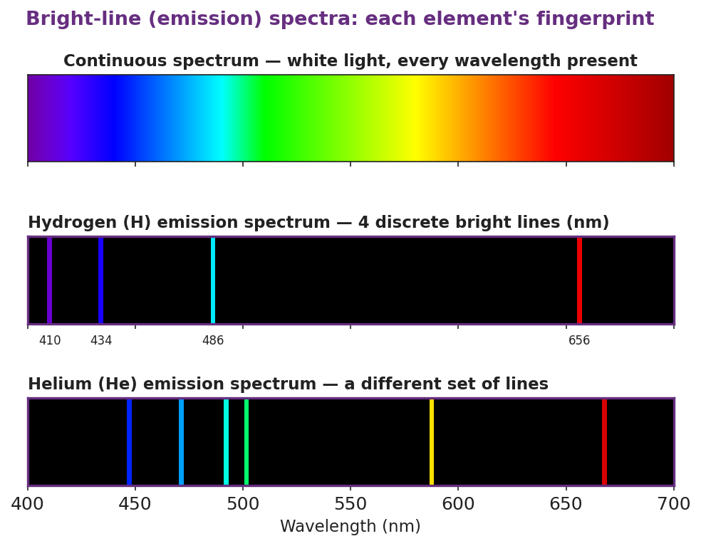
Three stacked spectrum panels titled ‘Bright-line (emission) spectra: each element’s fingerprint.’ The top panel is a continuous rainbow band from 400 to 700 nm. The middle panel, on black, shows hydrogen as four discrete bright lines at 410 nm violet, 434 nm blue-violet, 486 nm blue-green, and 656 nm red. The bottom panel, on black, shows helium as a different set of about six lines, demonstrating that each element has a unique fingerprint.
From the figure above, fill in the blanks:
- Number of visible hydrogen lines: ___________
- Hydrogen’s red line is at ___________ nm; its violet line is at ___________ nm.
- Does helium have the same pattern as hydrogen? ___________ This shows each element has a unique ___________.
The Hochman appositive definition (say it, then write it):
A bright-line spectrum — _________________________ — is unique to each element.

Worked Example
Scenario: You view a mystery gas tube through a spectroscope. It shows four lines: a red line far to one side, a blue-green line near the middle, and two lines close together at the violet end. You compare it to your reference spectra.
Step 1 — Count the lines: The mystery tube has ___________ visible lines.
Step 2 — Compare to references. Hydrogen has exactly 4 lines (656 nm red, 486 nm blue-green, 434 and 410 nm violet). Helium has more lines, including a strong yellow line.
Does the mystery tube have a strong yellow line? ___________ So it is not ___________.
Step 3 — Match line by line:
Mystery line (color/position) | Matches hydrogen line?
red, far side | 656 nm — yes / no
blue-green, middle | 486 nm — yes / no
two violet lines, close together | 434 + 410 nm — yes / no
Step 4 — Identify: The mystery tube is ___________.
Step 5 — Explain the lines: Each of those four lines is produced by an ___________ ___________ — an electron dropping from a higher ___________ level to a lower one, releasing light of one specific color.
Step 6 — Because / But / So
The mystery tube must be hydrogen because _______________________________________________, but _______________________________________________, so _______________________________________________.
Check your reasoning: “because” should name the matching lines; “but” should name a line a competitor (like helium) has that the mystery tube lacks; “so” should state the identification.

Summary
Complete the appositive sentence:
A bright-line spectrum — _________________________ — appears as separate colored lines because _________________________.
Complete the Because / But / So sentence:
Astronomers can identify the elements in a star they will never visit because __________________________________________, but __________________________________________, so __________________________________________.
Reminder: Light comes out (a bright line appears) when an electron drops down from a higher energy level to a lower one. Energy going in lifts the electron up; the bright line is the energy coming back out as light.
Key reference (Atomic Concepts unit): Electron energy levels = the shells of the Bohr model. Only certain levels are allowed, so only certain transitions — and therefore only certain colors — are possible for each element.

