Bright-Line Spectra — Student Worksheet
Unit: Atomic Concepts — Lesson 07 Name: _______________________ Date: __________ Period: ____

Phenomenon
A star is trillions of kilometers away, and no spacecraft will ever land on one to collect a sample. Yet astronomers say with confidence that the Sun is about three-quarters hydrogen and one-quarter helium. In class, your teacher lights a tube of hydrogen gas. With your eyes it glows a single pinkish-purple color. But look at that same glow through a spectroscope and the one color shatters into four sharp colored lines on a black background — and nothing in between. Switch to helium and you get a completely different set of lines. Each gas has its own pattern, like a barcode. Starlight carries that same barcode across the galaxy.
Driving question: How can we identify what something is made of using only the light it gives off?

Notice & Wonder
I notice… | I wonder…
Turn & Talk #1: The full rainbow (continuous spectrum) contains every color. The hydrogen panel shows only four lines on a black background — most of the rainbow is missing. In one sentence: what does it mean that the gas gives off only a few specific colors and leaves the rest out?

Initial Model
You will view several gas-discharge tubes through a spectroscope. For each tube, sketch the lines exactly where you see them — color and rough position across the strip. Leave the spaces between lines black — the gaps are part of the data. Do not write the mystery tube’s name until you have compared it to the known tubes.
Known tube 1 — Hydrogen:
400 nm ◀ ────────────────────────────── ▶ 700 nm
(sketch the lines you see)
Known tube 2 — Helium:
400 nm ◀ ────────────────────────────── ▶ 700 nm
(sketch the lines you see)
Known tube 3 — Neon:
400 nm ◀ ────────────────────────────── ▶ 700 nm
(sketch the lines you see)
Mystery tube — identity hidden:
400 nm ◀ ────────────────────────────── ▶ 700 nm
(sketch the lines you see)
My identification of the mystery tube: _______________
The specific lines that convinced me (which lines match? which rule an element out?):

Investigation

Part 1 — Compare to the reference figure
Look at figures/bright_line_spectra.png:
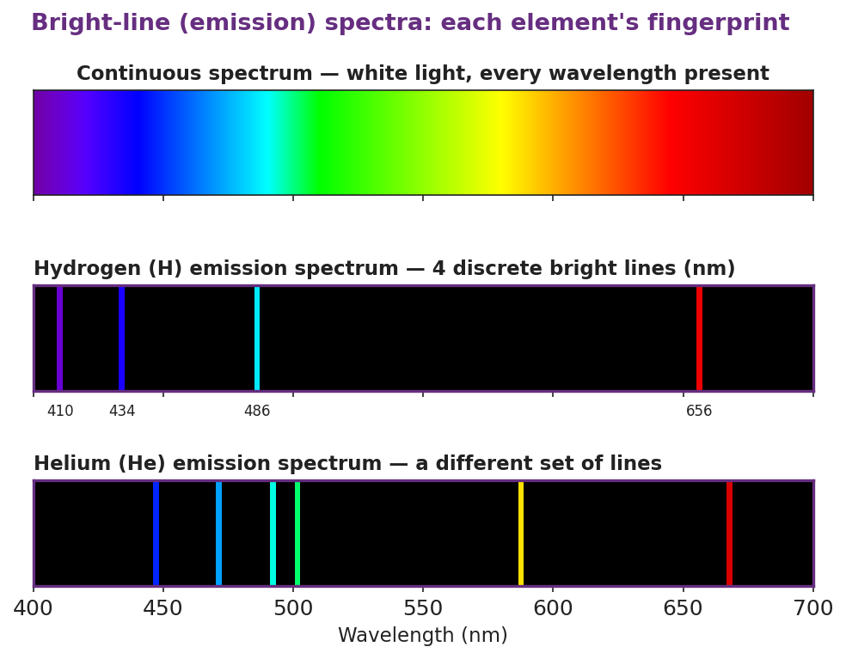
Three stacked spectrum panels titled ‘Bright-line (emission) spectra: each element’s fingerprint.’ The top panel is a continuous rainbow band from 400 to 700 nm labeled white light, every wavelength present. The middle panel, on a black background, shows the hydrogen emission spectrum as four discrete bright lines labeled 410 nm violet, 434 nm blue-violet, 486 nm blue-green, and 656 nm red. The bottom panel, also on black, shows the helium emission spectrum as a different set of about six lines including blue, cyan, green, yellow, and red, with a wavelength axis in nanometers.
- How many bright lines does hydrogen have in the visible range? _______________
- At which wavelength is hydrogen’s red line? _______________ nm
- Does helium have more lines than hydrogen, fewer, or the same number? _______________
- Name one line helium has that hydrogen does not have (give its approximate color or position):

Part 2 — Element-identification challenge
Your teacher gives you reference spectra (hydrogen, helium, neon, sodium, mercury) and one or two unknown spectrum strips. For each unknown, identify the element and cite at least two specific lines that justify the match. A line that one reference has and another does not have is the strongest evidence.
Unknown #1
- My identification: _______________
- Line 1 that matches: _______________________________________________
- Line 2 that matches (or a line that rules out a competitor): _______________________________________________
Unknown #2
- My identification: _______________
- Line 1 that matches: _______________________________________________
- Line 2 that matches (or a line that rules out a competitor): _______________________________________________
Key question: If two reference elements both have a red line, why is the red line alone not enough to identify an unknown? What kind of line would be enough?

Make It Make Sense
For each item, use the reference figure and your investigation to reason it out.
- A gas tube gives off only a few discrete colored lines, not a smooth rainbow. What does this tell you about the energies an electron is allowed to have inside that atom?
  - What the discrete lines tell us: _______________________________________________
  - If the electron could have any energy instead, the spectrum would look like: _______________________________________________
- Hydrogen’s violet line is at 410 nm and its red line is at 656 nm. Violet light is higher energy than red light.
  - Which line came from the electron making the bigger energy drop? _______________
  - Explain your reasoning: _______________________________________________
- Two unlabeled tubes are on the desk. Tube X shows four lines that match hydrogen exactly. Tube Y shows a single dominant yellow line.
  - Tube X is: _______________ How do you know? _______________________________________________
  - Tube Y is most likely: _______________ (hint: think of the color of many streetlights)
  - What single line feature identified Tube Y? _______________________________________________

Vocabulary in Action
Use each term in a sentence about today’s investigation. Do not copy the definition — describe something you actually observed or did.
- bright-line spectrum (emission spectrum): _______________________________________________ _______________________________________________
- energy level: _______________________________________________ _______________________________________________
- electron transition: _______________________________________________ _______________________________________________

Revise Your Model
Return to your Initial Model (your sketches and mystery-tube identification). Add vocabulary labels:
- Write “bright-line spectrum” over your set of sketches.
- Next to the matched mystery element, add a note: “Each line = one ___________ transition between ___________ levels.”
- Finish this Because / But / So sentence:
Hydrogen gives off only four specific colors of light, not a full rainbow, because __________________________________________, but __________________________________________, so __________________________________________.

Exit Ticket
- An unknown gas tube shows one extremely bright yellow-orange line and very few other lines. Reference A (neon) shows many evenly spread red-orange lines. Reference B (sodium) shows one dominant yellow-orange line.
The unknown element is: _______________
The specific feature that justifies my choice: _______________________________________________ _______________________________________________
- In one sentence, explain why a bright-line spectrum appears as separate lines instead of a continuous rainbow. Use the idea of energy levels.

