Emission Spectrum & the Electromagnetic Spectrum — Student Notes
Unit: Atomic Concepts — Lesson 08 Name: _______________________ Date: __________ Period: ____

Learning Targets
By the end of today’s 42 minutes I can:
- Order the regions of the electromagnetic spectrum (radio → gamma) by wavelength, frequency, and energy.
- State the relationship between wavelength, frequency, and energy: as wavelength decreases, frequency and energy increase.
- Explain, using Energy and Matter, why high-energy radiation (UV, X-ray, gamma) can damage tissue while low-energy radiation (radio, microwave) cannot.
- Interpret an emission spectrum as evidence that electrons occupy fixed energy levels.

Key Vocabulary
- electromagnetic spectrum — _______________________________________________ _______________________________________________
- wavelength — _______________________________________________ _______________________________________________
- frequency — _______________________________________________ _______________________________________________

Guided Notes
The big idea — Energy and Matter: All electromagnetic radiation carries __________. When radiation is absorbed by matter, that energy is __________ to the matter. The __________ a wave carries (set by its frequency) decides whether it can break chemical bonds and damage cells.
The electromagnetic spectrum — one family of waves:
The whole band — radio, microwave, infrared, visible, ultraviolet, X-ray, gamma — is all the same kind of thing: electromagnetic radiation traveling at the speed of light. The regions differ only in three properties:
Property | Low-energy end (radio) | High-energy end (gamma)
Wavelength | __________ (long / short) | __________ (long / short)
Frequency | __________ (high / low) | __________ (high / low)
Energy | __________ (high / low) | __________ (high / low)
The relationship to memorize:
As wavelength gets shorter, frequency gets __________ and energy gets __________. (Wavelength moves opposite to frequency and energy.)
The figure — the electromagnetic spectrum:
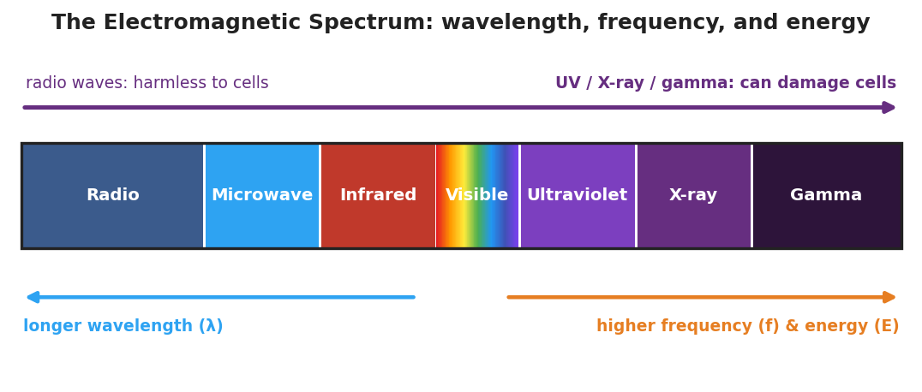
A horizontal band of the electromagnetic spectrum divided into seven labeled regions from left to right: Radio, Microwave, Infrared, Visible (a rainbow gradient), Ultraviolet, X-ray, and Gamma. A blue arrow beneath the left half points left, labeled ‘longer wavelength.’ An orange arrow beneath the right half points right, labeled ‘higher frequency and energy.’
From the figure, fill in the blanks:
- Region with the longest wavelength: ___________
- Region with the highest energy: ___________
- The “danger to living tissue” line falls between ___________ and ___________.
Why UV is dangerous but radio is not:
Radio waves have a __________ wavelength and __________ energy — not enough to break chemical bonds, so they pass through harmlessly. Ultraviolet light has a __________ wavelength and __________ energy — enough to break the bonds in DNA and skin cells, which is what causes a __________.
The emission spectrum — evidence for energy levels:
When an atom is given energy, its electrons jump to a __________ energy level. They cannot stay there, so they fall back. When an electron falls, the atom gives off a __________ (a particle of light) of one specific energy — and therefore one specific __________.
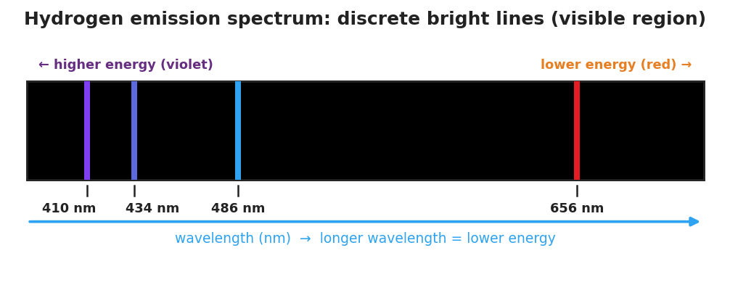
A black band representing the hydrogen emission spectrum, showing four discrete colored vertical lines labeled by wavelength: red at 656 nm, blue at 486 nm, blue-violet at 434 nm, and violet at 410 nm.
- An emission spectrum is a set of __________ bright lines, NOT a continuous rainbow.
- The lines are discrete because electrons can only occupy __________ energy levels, so only certain drops (and certain colors) are allowed.
- Each element gives a __________ set of lines — a fingerprint of its energy levels.

Worked Example
Scenario: Compare two waves in the hydrogen emission spectrum — the red line at 656 nm and the violet line at 410 nm — and decide which carries more energy.
Step 1 — Compare the wavelengths:
Red line wavelength = ___ nm Violet line wavelength = ___ nm
Which is shorter? ___________
Step 2 — Apply the relationship (shorter wavelength → higher frequency → higher energy):
The __________ line has the shorter wavelength, so it has the higher frequency and the __________ energy.
Step 3 — Connect to electron drops:
A higher-energy photon comes from a __________ (larger / smaller) drop between energy levels. So the violet line came from a __________ electron drop than the red line.
Step 4 — Appositive sentence:
The violet line — the hydrogen line with the shortest visible wavelength (410 nm) — carries _______________ because _______________.
Step 5 — Because / But / So:
The violet line carries more energy than the red line because _______________________________________________, but _______________________________________________, so _______________________________________________.
Check your reasoning: “because” should name the shorter wavelength; “but” should acknowledge that both are just light from hydrogen; “so” should state that the violet line came from a larger electron drop and carries more energy.

Summary
Complete the appositive sentence:
The electromagnetic spectrum — _________________________ — runs from low-energy radio waves to high-energy gamma rays.
Complete the Because / But / So sentence:
Ultraviolet light can damage your skin but radio waves cannot, because __________________________________________, but __________________________________________, so __________________________________________.
Reminder: For all electromagnetic radiation, wavelength and energy move in opposite directions. Shorter wavelength = higher frequency = higher energy = more able to damage matter.
Key reference (from the 2025 NYS Reference Tables): Speed of light: c = f × λ (frequency × wavelength), constant for all EM waves Energy of a photon increases with frequency (E = hf)

