Emission Spectrum & the Electromagnetic Spectrum — Student Worksheet
Unit: Atomic Concepts — Lesson 08 Name: _______________________ Date: __________ Period: ____

Phenomenon
You can stand right next to a radio antenna all day and feel nothing — radio waves are passing through you constantly. But fifteen minutes in strong midday sun gives you a sunburn, and a few seconds of direct gamma radiation would be deadly. All three — radio waves, the ultraviolet (UV) light in sunlight, and gamma rays — are the same kind of thing: electromagnetic radiation, waves of energy traveling at the speed of light. Yet one is harmless and the others are dangerous.
A glowing neon sign or a hydrogen discharge tube gives off light of one specific color. That color is a fingerprint: it tells you which atom is inside and how its electrons are arranged.
Driving question: All electromagnetic waves are the same kind of thing — so why is UV light dangerous to your skin while radio waves pass through you harmlessly?

Notice & Wonder
I notice… | I wonder…
Turn & Talk #1: On the spectrum band your teacher is projecting, radio is at the far left and gamma is at the far right. Microwaves cook food; gamma rays are used to kill cancer cells. In one sentence, what does a wave’s position on the band tell you about how much energy it carries — and why that matters for your body?

Initial Model
Before your teacher names the relationship, use your sorted cards to put the seven EM regions in order from longest wavelength (lowest energy) to shortest wavelength (highest energy). Then label each region’s energy as low, medium, or high, and circle the boundary where waves start to become dangerous to living tissue.
Order (1 = longest wavelength) | EM region | Energy (low / medium / high)
1
2
3
4
5
6
7
- Where did you draw the “danger line” — between which two regions? _______________________________________________
- As wavelength gets shorter, what happens to the energy? _______________________________________________

Investigation

Part 1 — ABCs: Sort the spectrum by energy
Before checking anything, arrange the seven EM regions from lowest energy to highest energy using the everyday examples on your cards. Use the clue of how careful you have to be around each one.
EM region | Everyday example | My energy rank (1 = lowest, 7 = highest)
Radio | FM radio / Wi-Fi
Microwave | microwave oven / phone signal
Infrared | TV remote / heat from a fire
Visible | the colors your eyes see
Ultraviolet | sunburn / tanning bed
X-ray | dental or bone X-ray
Gamma | cancer radiation therapy
After you check against the spectrum band, what surprised you about your ordering? _______________________________________________

Part 2 — Read the EM spectrum band
Look at figures/em_spectrum_band.png:
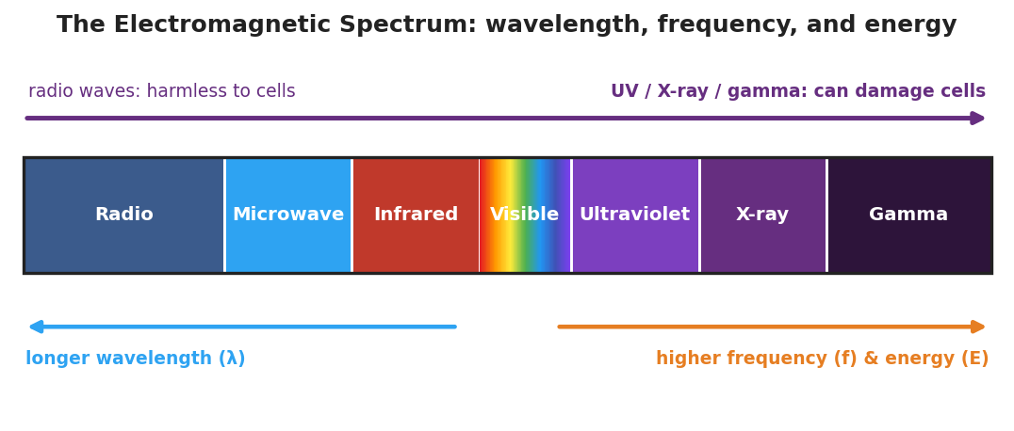
A horizontal band of the electromagnetic spectrum divided into seven labeled regions from left to right: Radio, Microwave, Infrared, Visible (a rainbow gradient), Ultraviolet, X-ray, and Gamma. A blue arrow beneath the left half points left, labeled ‘longer wavelength.’ An orange arrow beneath the right half points right, labeled ‘higher frequency and energy.’
- Which region has the longest wavelength? _______________
- Which region has the highest energy? _______________
- On the band, do wavelength and energy increase in the same direction or opposite directions? _______________

Part 3 — Emission Spectra simulator
Use the Light Emission Spectra simulator (or the discharge tubes and diffraction glasses). For each element, record what you observe.
Element | Continuous rainbow OR discrete lines? | How many distinct bright lines?
Hydrogen
Helium
Neon
Mercury
Now look closely at the hydrogen spectrum and compare to the reference below:
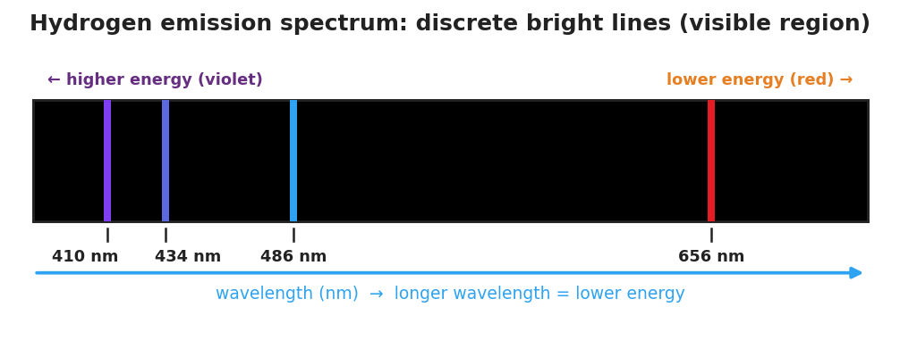
A black band representing the hydrogen emission spectrum, showing four discrete colored vertical lines labeled by wavelength: red at 656 nm, blue at 486 nm, blue-violet at 434 nm, and violet at 410 nm. An arrow beneath points right, labeled ‘wavelength — longer wavelength means lower energy.’
- Does hydrogen produce a continuous rainbow or separate lines with black gaps? _______________
- Of the four hydrogen lines, which has the shortest wavelength? _______________
- Which hydrogen line carries the most energy, and how do you know? _______________________________________________

Make It Make Sense
For each comparison below, decide which wave has the higher energy, and explain your reasoning using wavelength. These use different examples than the Investigation — apply the rule.
- Microwaves vs. X-rays. A microwave oven uses microwaves; a dentist’s machine uses X-rays.
  - Which has the shorter wavelength? _______________
  - Which carries more energy per wave? _______________
  - Why does the dentist put a lead apron on you for X-rays but not for microwaves? _______________________________________________
- Hydrogen’s red line (656 nm) vs. violet line (410 nm).
  - Which has the shorter wavelength? _______________
  - Which carries more energy? _______________
  - In terms of electrons dropping between energy levels, why is the violet line higher in energy? _______________________________________________
- A published claim to evaluate: A website states, “Wi-Fi routers emit radiation, so they must damage the DNA in your cells like the sun’s UV does.” Use the energy relationship to evaluate this claim.
  - Wi-Fi uses radio/microwave radiation. Is its wavelength longer or shorter than UV? _______________
  - Does it carry more or less energy per wave than UV? _______________
  - Is the claim valid? Explain in one sentence. _______________________________________________

Vocabulary in Action
Use each term in a sentence about today’s investigation. Do not copy the definition — describe something you actually observed or did.
- electromagnetic spectrum: _______________________________________________ _______________________________________________
- wavelength: _______________________________________________ _______________________________________________
- frequency: _______________________________________________ _______________________________________________

Revise Your Model
Return to your Initial Model (the ordered EM regions). Add vocabulary labels:
- At the long-wavelength end, write: “long wavelength → low frequency → ___ energy.”
- At the short-wavelength end, write: “short wavelength → high frequency → ___ energy.”
- Write a revised appositive sentence for the spectrum:
The electromagnetic spectrum — _________________________ — runs from low-energy ___________ waves to high-energy ___________ rays.
Then finish this Because / But / So sentence:
Radio waves pass through your body harmlessly, but ultraviolet light can damage your skin, because __________________________________________, but __________________________________________, so __________________________________________.

Exit Ticket
(a) Two regions of the EM spectrum: infrared and gamma. Which one carries more energy per wave? Explain your answer using wavelength.

(b) Wave A has a wavelength of 700 nm. Wave B has a wavelength of 200 nm. Which wave has the higher frequency, and which carries more energy? How do you know?
Higher frequency: Wave ___ — Higher energy: Wave How I know: ____________________________________________
(c) In one sentence, explain — in terms of energy — why ultraviolet light can damage your skin but radio waves cannot, even though both are electromagnetic radiation.

