Radioactivity — Student Notes
Unit: Nuclear Chemistry — Lesson 01 Name: _______________________ Date: __________ Period: ____

Learning Targets
By the end of today’s 42 minutes I can:
- Identify alpha (⁴₂He), beta (⁰₋₁e, an electron), positron (⁰₊₁e), and gamma (⁰₀γ) emissions by symbol, charge, and mass.
- Rank alpha, beta, and gamma by penetrating power and match each to what stops it (paper, aluminum, lead).
- Write and balance a nuclear decay equation so that mass number (A) and atomic number (Z) are conserved, and name the daughter element by its new proton number.
- Explain, using Energy and Matter (conservation), why an unstable nucleus decays on its own.

Key Vocabulary
- radioactive decay — _______________________________________________ _______________________________________________
- nuclear radiation — _______________________________________________ _______________________________________________
- parent / daughter nuclide — _______________________________________________ _______________________________________________

Guided Notes
The big idea — Energy and Matter (conservation): An unstable nucleus changes itself to become more stable. It is __________ — it happens on its own, with no outside trigger (heat, light, or chemicals do not cause it). When it decays it releases a __________ and energy. Across the decay arrow, the total __________ number (top) and total __________ number (bottom) are conserved — nothing is created or destroyed.
The element’s name tag: An element’s identity is set by its number of __________. If the proton number changes during decay, the atom becomes a __________ element.
The three types of nuclear radiation:
Type | Symbol | Mass number | Charge | Stopped by | Penetrating power
Alpha | ⁴₂He |  |  | paper
Beta (electron) | ⁰₋₁e |  |  | aluminum
Positron (beta-plus) | ⁰₊₁e |  |  | aluminum
Gamma | ⁰₀γ |  |  | thick lead
Rule of thumb: the more mass and charge a particle carries, the less it penetrates. So penetrating power increases: alpha ___ beta ___ gamma. (Fill in < or >.)
The penetrating-power model:
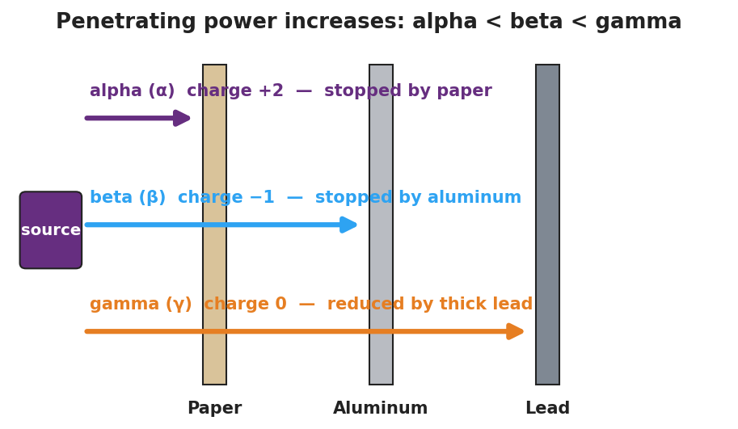
Penetrating-power diagram: a source emits three rays at three barriers — paper, aluminum, lead. Alpha is stopped by paper; beta passes paper but is stopped by aluminum; gamma passes both and reaches the lead.
From the figure, fill in the blanks:
- The ray stopped by a sheet of paper is: ____________
- The ray that even thick lead only reduces is: ____________
- The ray stopped by a few mm of aluminum is: ____________
How each emission changes the nucleus (fill in how the atomic number Z shifts):
- Alpha decay: Z goes __________ by 2 (loses 2 protons).
- Beta-minus decay: a neutron becomes a proton + emitted electron, so Z goes __________ by 1.
- Positron decay: a proton becomes a neutron + emitted positron, so Z goes __________ by 1.
- Gamma decay: Z stays __________ (only energy leaves; same element).
How to balance a nuclear equation (use this every time):
- Write the parent nuclide on the left and the emitted particle on the right.
- Make the top numbers (mass) add up the same on both sides.
- Make the bottom numbers (charge / atomic number) add up the same on both sides.
- Use the bottom number of the daughter + the Periodic Table to name the __________ element.
The decay curve (population view):
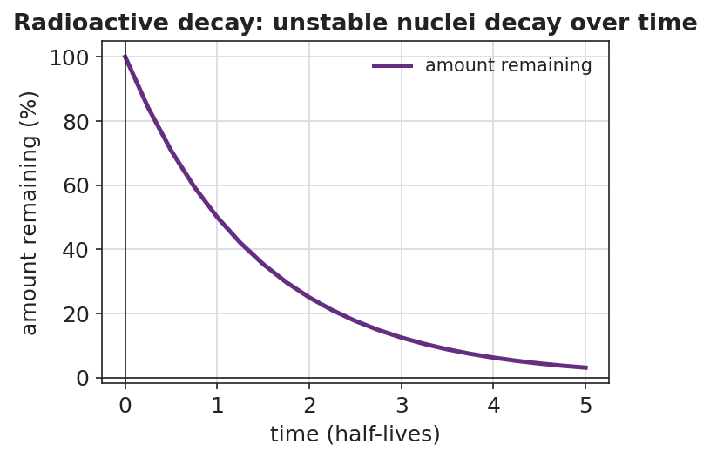
Radioactive decay curve: a line falls from 100 percent at time zero to 50 percent at one half-life, 25 percent at two half-lives, approaching but never reaching zero. X-axis: time in half-lives; y-axis: amount remaining in percent.
- Each decay event removes one __________ nucleus and creates one __________ nucleus.
- Does the amount of parent ever reach exactly zero according to the curve? __________

Worked Example
Scenario: Carbon-14 (¹⁴₆C) undergoes beta-minus decay. Find the daughter nuclide and write the balanced equation.
Step 1 — Write what you know:
¹⁴₆C → ____________ + ⁰₋₁e
Parent: mass number A = ___ , atomic number Z = ___ . Emitted particle: ⁰₋₁e (mass ___ , charge ___ ).
Step 2 — Balance the mass numbers (top):
Daughter mass = parent mass − particle mass = 14 − ___ = ____________
Step 3 — Balance the atomic numbers (bottom):
Daughter charge = parent charge − particle charge = 6 − ( ___ ) = ____________
(Careful with the sign: subtracting −1 means the daughter’s atomic number goes up by 1.)
Step 4 — Name the daughter element:
The daughter has ____ protons. From the Periodic Table, that element is ____________ .
Step 5 — Write the balanced equation:
¹⁴₆C → ____________ + ⁰₋₁e
Step 6 — Conservation check:
- Top: ____ + 0 = 14? ____
- Bottom: ____ + (−1) = 6? ____
Step 7 — Because / But / So
A beta-minus emission raises the atomic number even though a negative electron leaves the nucleus because _______________________________________________, but _______________________________________________, so _______________________________________________.
Check your reasoning: “because” should explain that a neutron converts into a proton + the emitted electron; “but” should note the electron carries away the −1 charge; “so” should state that Z rises by 1 and the daughter is a new element.

Summary
Complete the sentence:
Radioactive decay is __________ — it happens with no outside trigger. In every decay equation, the total __________ number and total __________ number are conserved across the arrow, and the daughter is a new element whenever the __________ number changes.
Complete the Because / But / So sentence:
A uranium-238 nucleus emits an alpha particle and becomes thorium-234 because __________________________________________, but __________________________________________, so __________________________________________.
Reminder — the four emissions at a glance:
Emission | Symbol | What changes
Alpha | ⁴₂He | A − 4, Z − 2 (new element)
Beta-minus | ⁰₋₁e | A same, Z + 1 (new element)
Positron | ⁰₊₁e | A same, Z − 1 (new element)
Gamma | ⁰₀γ | A same, Z same (only energy leaves)
Key reference (from the 2025 NYS Reference Tables): Symbols used in nuclear chemistry: Reference Table O. Atomic numbers: Periodic Table.

