Transmutation Reactions — Student Notes
Unit: Nuclear Chemistry — Lesson 02 Name: _______________________ Date: __________ Period: ____

Learning Targets
By the end of today’s 42 minutes I can:
- Define transmutation and tell the difference between natural and artificial transmutation.
- Balance a nuclear equation by conserving the total mass number (top) and the total atomic number (bottom).
- Build and compare models of fission (one nucleus splits) and fusion (two nuclei merge) and explain why both release energy.
- Explain, using Energy and Matter, why nuclear processes release roughly 10⁵–10⁶ times more energy than chemical reactions.

Key Vocabulary
- transmutation — _______________________________________________ _______________________________________________
- natural transmutation — _______________________________________________ _______________________________________________
- artificial transmutation — _______________________________________________ _______________________________________________

Guided Notes
The big idea — Energy and Matter: In every nuclear change, the total __________ number and total __________ number are conserved (matter is rearranged, not created or destroyed), while a large amount of __________ is released from the nucleus.
Two conservation rules for balancing nuclear equations:
- The sum of the mass numbers (the __________ numbers) must be equal on both sides of the arrow.
- The sum of the atomic numbers (the __________ numbers) must be equal on both sides of the arrow.
A neutron, ¹₀n, has mass number ___ and atomic number . A beta particle, ⁰₋₁e, has mass number and atomic number . An alpha particle, ⁴₂He, has mass number and atomic number ___.
Two directions a nucleus can change:
Process | What happens to the nuclei | Example
Fission | one __________ nucleus splits into __________ fragments | U-235 + neutron → Ba + Kr + neutrons
Fusion | two __________ nuclei merge into __________ larger nucleus | H-2 + H-3 → He-4 + neutron
Both fission and fusion __________ energy.
Natural vs. artificial transmutation:
- Natural transmutation happens __________ (on its own) — spontaneous radioactive decay. No outside particle is needed.
- Artificial transmutation is forced by __________ the nucleus with a particle (for example, the neutron that starts U-235 fission).
Is it a type of fission?
- Alpha emission is a type of fission, because a __________ (⁴₂He) splits off the nucleus.
- Beta emission is not fission — a __________ inside the nucleus converts into a proton; nothing splits off.
- Gamma emission is not fission — only __________ leaves the nucleus; the mass number and atomic number do not change.
The Hochman appositive definition:
Transmutation — _________________________ — always conserves the total mass number and the total atomic number.
The figure — fission vs. fusion:
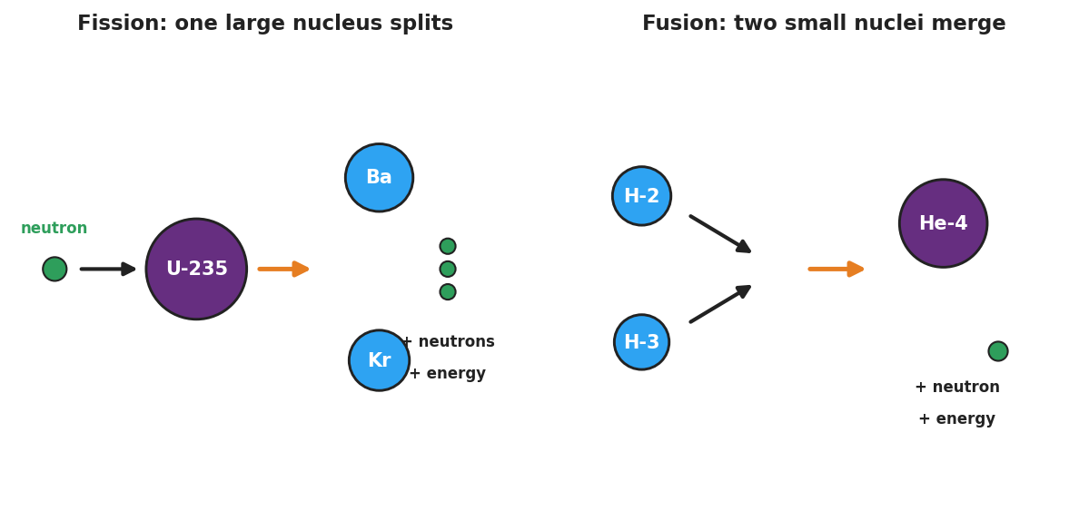
Two-panel schematic. Left panel labeled ‘Fission: one large nucleus splits’ shows a green neutron striking a large purple U-235 nucleus, an orange arrow, and the products: two smaller blue nuclei labeled Ba and Kr plus three released neutrons and the note ‘+ neutrons + energy.’ Right panel labeled ‘Fusion: two small nuclei merge’ shows two small blue nuclei labeled H-2 and H-3, arrows converging, and the product: one larger purple He-4 nucleus plus a released neutron and the note ‘+ neutron + energy.’
From the figure: in fission, one nucleus becomes ____ nuclei. In fusion, ____ nuclei become one nucleus.

Worked Example
Scenario: Find the missing nucleus in the alpha decay of uranium-238.
²³⁸₉₂U → ___ + ⁴₂He
Step 1 — Write down what you know. The alpha particle ⁴₂He has mass number ___ and atomic number ___.
Step 2 — Balance the mass numbers (top).
Left top = 238. Right known top = 4 (from He). Missing top = 238 − 4 = ___________
Step 3 — Balance the atomic numbers (bottom).
Left bottom = 92. Right known bottom = 2 (from He). Missing bottom = 92 − 2 = ___________
Step 4 — Identify the element. Atomic number ___ on the Periodic Table is the element __________ (symbol ___).
Step 5 — Write the balanced equation:
²³⁸₉₂U → __________ + ⁴₂He
Step 6 — Classify it. This decay happens spontaneously, so it is __________ transmutation. Because a fragment (the alpha particle) splits off, alpha decay is a type of __________.
Step 7 — Because / But / So
The atomic number of the product is lower than uranium’s because _______________________________________________, but _______________________________________________, so _______________________________________________.
Check your reasoning: “because” should explain that the alpha particle carried away 2 protons; “but” should note that the total proton count is still conserved across the whole equation; “so” should state the new element’s identity.

Summary
Complete the appositive sentence:
Transmutation — _________________________ — always conserves the total _________________ and the total _________________.
Complete the Because / But / So sentence:
A nuclear reaction releases far more energy than a chemical reaction because __________________________________________, but __________________________________________, so __________________________________________.
Reminder: To balance any nuclear equation, make the top numbers (mass) match on both sides AND the bottom numbers (atomic number) match on both sides. Nothing is created or destroyed — particles are rearranged and energy is released.
Key reference (from the 2025 NYS Reference Tables): Table O — Symbols Used in Nuclear Chemistry (alpha ⁴₂He, beta ⁰₋₁e, neutron ¹₀n, positron ⁰₊₁e, gamma γ) Table N — Selected Radioisotopes (decay modes and half-lives) Periodic Table — atomic numbers for identifying the product element

