Transmutation Reactions — Student Worksheet
Unit: Nuclear Chemistry — Lesson 02 Name: _______________________ Date: __________ Period: ____

Phenomenon
The Sun has been shining for about 4.6 billion years — and no fuel truck ever refills it. On Earth, a nuclear power plant lights up a whole city, and a single fuel pellet the size of a fingertip holds about as much energy as a ton of coal. But the Sun and the power plant run on opposite nuclear processes. The Sun fuses small hydrogen nuclei into larger helium nuclei. The power plant splits large uranium nuclei into smaller fragments. Building up and breaking down — yet both release staggering amounts of energy.
Driving question: How can building nuclei up (fusion) and breaking nuclei down (fission) both release enormous amounts of energy — and how do we keep track of every particle while a nucleus changes?

Notice & Wonder
I notice… | I wonder…
Turn & Talk #1: Look at the two-panel figure your teacher is projecting (fission on the left, fusion on the right). The number of nuclei and their size change across the arrow. But something stays the same. In one sentence, name something that does not change from the left side of the arrow to the right side.

Initial Model
Below is the fission of uranium-235 written as a nuclear equation, with one number missing. Each symbol is written as (mass number on top, atomic number on bottom).
²³⁵₉₂U + ¹₀n → ¹⁴¹₅₆Ba + ⁹²₃₆Kr + ___ ¹₀n
Use two rules to find the missing number of neutrons:
- Mass numbers (top) must balance. Add the top numbers on the left: 235 + 1 = ______. Add the known top numbers on the right: 141 + 92 = ______. How many more mass units are needed on the right? ______ → that is the number of neutrons in the blank.
- Atomic numbers (bottom) must balance. Add the bottom numbers on the left: 92 + 0 = ______. Add the bottom numbers on the right: 56 + 36 = ______. Do they already match? ______ (Remember: a neutron has atomic number 0.)
- The missing number of neutrons is: ______

Investigation

Part 1 — ABCs: Build the models and count
Before naming any rules, build each process with your nucleon tokens (one color = proton, another = neutron) and count. Fill in the table.
Process | Protons before | Protons after | Neutrons before | Neutrons after | Conserved? (yes/no)
Fission: U-235 + n → Ba + Kr + neutrons
Fusion: H-2 + H-3 → He-4 + neutron
What pattern do you notice about the totals before and after the arrow?

Part 2 — Balance the nuclear equations
For each equation, find the missing particle. Use the Periodic Table for atomic numbers. Fill in the ledger (top = mass number, bottom = atomic number), then write the missing particle.
Equation A — alpha decay of uranium-238:
²³⁸₉₂U → ___ + ⁴₂He
 | Mass number (top) | Atomic number (bottom)
Left total
Known right (⁴₂He)
Missing particle
Missing particle (symbol and element name): _______________
Equation B — beta decay of carbon-14:
¹⁴₆C → ___ + ⁰₋₁e
 | Mass number (top) | Atomic number (bottom)
Left total
Known right (⁰₋₁e)
Missing particle
Missing particle (symbol and element name): _______________
Did the atomic number go up or down? _______________ Why?

Equation C — fusion (the D–T reaction, like the Sun):
²₁H + ³₁H → ⁴₂He + ___
 | Mass number (top) | Atomic number (bottom)
Left total
Known right (⁴₂He)
Missing particle
Missing particle (symbol and name): _______________

Part 3 — Reading the energy-scale chart
Look at the figure your teacher is projecting:
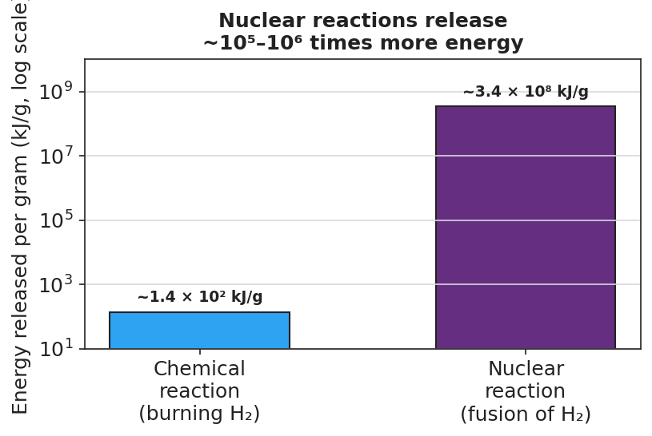
Bar chart on a logarithmic y-axis comparing energy released per gram of fuel. The left blue bar, labeled ‘Chemical reaction (burning H2),’ reaches about 1.4 times 10 squared kilojoules per gram. The right purple bar, labeled ‘Nuclear reaction (fusion of H2),’ reaches about 3.4 times 10 to the eighth kilojoules per gram — roughly a million times taller. The title reads ‘Nuclear reactions release ~10^5 to 10^6 times more energy.’
- Roughly how many times more energy does the nuclear reaction release than the chemical reaction (per gram)? _______________
- Use the chart to explain why a fingertip-sized fuel pellet can hold as much energy as a ton of coal.

Make It Make Sense
For each item below, balance the nuclear equation and answer the question. These are the same reactions you modeled in the Investigation — confirm your work here.
1. Alpha decay of uranium-238. Find the missing nucleus.
²³⁸₉₂U → ___ + ⁴₂He
 | Mass number (top) | Atomic number (bottom)
Missing particle
Symbol and element name: _______________ Is this natural or artificial transmutation? _______________
2. Beta decay of carbon-14. Find the missing nucleus.
¹⁴₆C → ___ + ⁰₋₁e
 | Mass number (top) | Atomic number (bottom)
Missing particle
Symbol and element name: _______________ Did the atomic number go up or down? _______________
3. Fusion (D–T reaction). Find the missing particle.
²₁H + ³₁H → ⁴₂He + ___
 | Mass number (top) | Atomic number (bottom)
Missing particle
Symbol and name: _______________ Did two nuclei merge into one, or did one split into two? _______________

Vocabulary in Action
Use each term in a sentence about today’s investigation. Do not copy the definition — describe something you actually did, built, or balanced.
- transmutation: _______________________________________________ _______________________________________________
- natural transmutation: _______________________________________________ _______________________________________________
- artificial transmutation: _______________________________________________ _______________________________________________

Revise Your Model
Return to your Initial Model (the U-235 fission equation). Add vocabulary labels:
- Label the equation as natural or artificial transmutation: _______________ (Hint: a neutron is fired at the nucleus to start it.)
- Draw a box around the two totals that are conserved. Write them here: mass number ____ = ____ ; atomic number ____ = ____
- Write a revised appositive sentence for the process:
Transmutation — _______________________________________________ — always conserves the total _______________ and the total _______________.
Then finish this Because / But / So sentence:
A fingertip-sized nuclear fuel pellet releases about as much energy as a ton of coal because __________________________________________, but __________________________________________, so __________________________________________.

Exit Ticket
(a) Balance this alpha-decay equation for polonium-210. Find the missing nucleus and name the element.
²¹⁰₈₄Po → ___ + ⁴₂He
 | Mass number (top) | Atomic number (bottom)
Missing particle
Symbol and element name: _______________
(b) One of these equations is fusion and one is fission. Label each, and justify your choice by what happens to the size of the nuclei.
Equation 1: ⁶₃Li + ²₁H → 2 ⁴₂He
Equation 2: ²³⁹₉₄Pu + ¹₀n → ¹³⁴₅₄Xe + ¹⁰³₄₀Zr + 3 ¹₀n
Equation 1 is ________________ because _______________________________________________
Equation 2 is ________________ because _______________________________________________
(c) In one appositive sentence (use dashes), explain why a nuclear reaction releases far more energy than a chemical reaction.

