Half-Life — Student Notes
Unit: Nuclear Chemistry — Lesson 03 Name: _______________________ Date: __________ Period: ____

Learning Targets
By the end of today’s 42 minutes I can:
- Define half-life as the fixed time required for one half of a radioactive sample to decay.
- Determine the fraction remaining after a whole number of half-lives using (1/2) raised to the number of half-lives.
- Calculate the number of half-lives elapsed and the total time elapsed, using the half-life value from Reference Table N.
- Explain, using the Patterns CCC, why the same fraction of a sample decays in each half-life regardless of the starting amount — and why this lets us date an artifact.

Key Vocabulary
- half-life — _______________________________________________ _______________________________________________
- radioactive decay — _______________________________________________ _______________________________________________
- radioisotope — _______________________________________________ _______________________________________________

Guided Notes
The big idea — Patterns: Radioactive decay follows a fixed pattern. In each half-life, exactly __________ of the remaining sample decays. The amount keeps being cut in __________ and never quite reaches __________. The fraction lost each half-life is the same no matter how __________ sample you start with.
The three relationships (memorize the connections):
- number of half-lives = total time ÷ __________
- fraction remaining = ( __________ ) raised to the number of half-lives
- total time = number of half-lives × __________
The halving ladder — fill in the fraction remaining after each half-life:
Number of half-lives (n) | Fraction remaining | As a power of 1/2
0 | 1 (the whole sample) | (1/2)⁰
1 | __________ | (1/2)¹
2 | __________ | (1/2)²
3 | __________ | (1/2)³
4 | __________ | (1/2)⁴
Where to find half-life values: __________________ in the 2025 NYS Chemistry Reference Tables. Each radioisotope has its OWN half-life that never changes.
The figure — the decay curve:
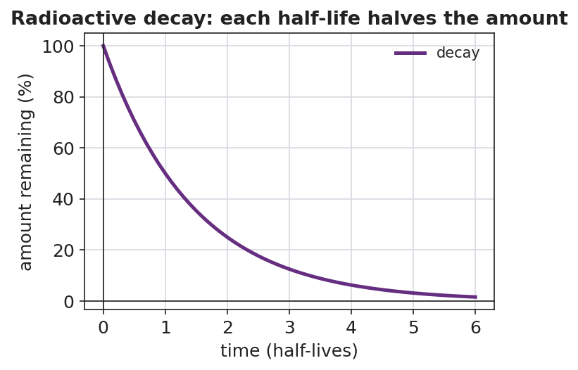
Line graph titled ‘Radioactive decay: each half-life halves the amount.’ The x-axis is ‘time (half-lives)’ from 0 to 6 and the y-axis is ‘amount remaining (%)’ from 0 to 100. A smooth purple curve starts at 100% and falls through 50% at 1 half-life, 25% at 2 half-lives, and 12.5% at 3 half-lives, approaching but never reaching zero.
From the figure above, fill in the blanks:
- After 1 half-life, the amount remaining is ___ %.
- After 3 half-lives, the amount remaining is ___ %.
- The curve gets closer and closer to zero but never __________ it, which means a sample never fully __________.
The Because / But / So frame (decay as a clock):
A scientist can date an artifact because the half-life is __________, but they only measure the fraction __________, so the fraction tells them the number of half-lives and therefore the __________.

Worked Example
Scenario: A lab finds that a wooden artifact has 1/4 of the carbon-14 of a fresh sample. Carbon-14 has a half-life of 5,730 years. How old is the artifact?
Step 1 — Match the fraction remaining to a number of half-lives:
Fraction remaining = 1/4. Write 1/4 as a power of one-half: 1/4 = (1/2)^___
So the number of half-lives = ___
Step 2 — Look up the half-life on Reference Table N:
Half-life of carbon-14 = __________ years
Step 3 — Find the total time elapsed:
total time = number of half-lives × half-life
total time = ___ × __________ years = __________ years
Step 4 — State the answer in a sentence:
The artifact is about __________ years old, because its carbon-14 has been cut in half ___ times.
Step 5 — Because / But / So
The artifact has 1/4 of its original carbon-14 because _______________________________________________, but _______________________________________________, so _______________________________________________.
Check your reasoning: “because” should explain why 1/4 means 2 half-lives; “but” should note that we only see the fraction left, not the original amount; “so” should give the age in years.

Summary
Complete the rule:
After n half-lives, the fraction of a radioactive sample remaining is __________.
Complete the Because / But / So sentence:
A big sample and a tiny sample of the same radioisotope both lose the same FRACTION in one half-life because __________________________________________, but __________________________________________, so __________________________________________.
Reminder: The number of half-lives is the exponent on 1/2 — NOT the denominator of the fraction. 1/4 = (1/2)² → 2 half-lives (not 4). 1/8 = (1/2)³ → 3 half-lives (not 8). Count how many times the sample was cut in half.
Key reference (from the 2025 NYS Reference Tables): Half-life values: Reference Table N (Selected Radioisotopes) Carbon-14 half-life: 5,730 years | Iodine-131 half-life: ≈ 8 days

