Benefits & Risks of Nuclear Chemistry — Student Notes
Unit: Nuclear Chemistry — Lesson 04 Name: _______________________ Date: __________ Period: ____

Learning Targets
By the end of today’s 42 minutes I can:
- Distinguish a benefit from a risk in a published claim about nuclear technology, and explain the dose→effect reasoning behind each.
- Evaluate a claim’s validity (does the evidence support it?) and reliability (is the source trustworthy and repeatable?).
- Use dose-comparison data to put a radiation risk in quantitative perspective instead of reacting to the word “nuclear.”
- Build an evidence-based risk–benefit analysis and weigh a counter-claim, using Cause and Effect.

Key Vocabulary
- risk–benefit analysis — _______________________________________________ _______________________________________________
- validity — _______________________________________________ _______________________________________________
- reliability — _______________________________________________ _______________________________________________

Guided Notes
The big idea — Cause and Effect (it’s all about dose): The same ionizing radiation can image a tumor, cure a tumor, or cause one. The difference is the __________ (how much), the __________ (how targeted), and whether it is __________ (contained). So “is nuclear good or bad?” is the wrong question — the right question is under what dose and control?
Benefits and risks of nuclear chemistry — fill in examples from the case studies:
Area | A BENEFIT | A RISK | What dose/control decides
Medical (imaging & treatment)
Power generation
Weapons
Putting risk in perspective — the dose chart (mSv):
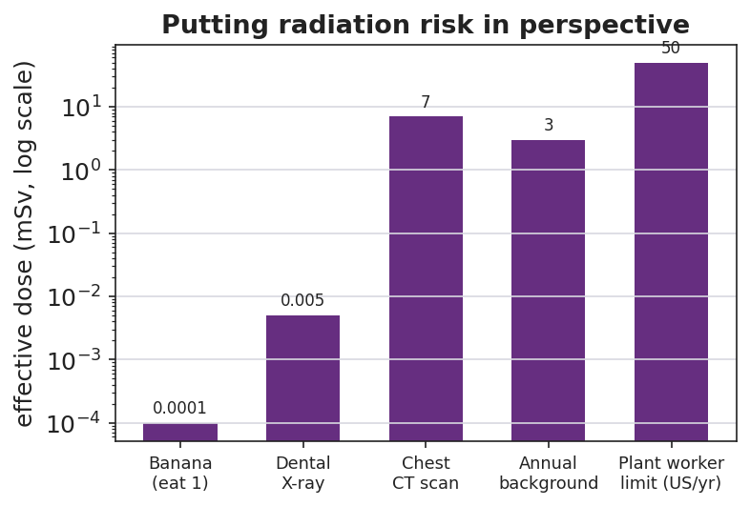
Bar chart titled ‘Putting radiation risk in perspective’ showing typical effective radiation doses on a log scale in millisieverts: eating one banana about 0.0001 mSv, a dental X-ray about 0.005 mSv, a chest CT scan about 7 mSv, average annual natural background about 3 mSv, and the US annual occupational dose limit for a nuclear plant worker about 50 mSv.
From the chart above, fill in the blanks:
- Largest single-event dose shown: ______________ (about ____ mSv)
- A chest CT (≈ 7 mSv) is a little more than ____ years’ worth of natural background radiation (≈ 3 mSv/yr).
- The annual worker limit (≈ 50 mSv) is set above / below (circle one) a single CT scan.
Why a medical isotope is safe — the decay curve:
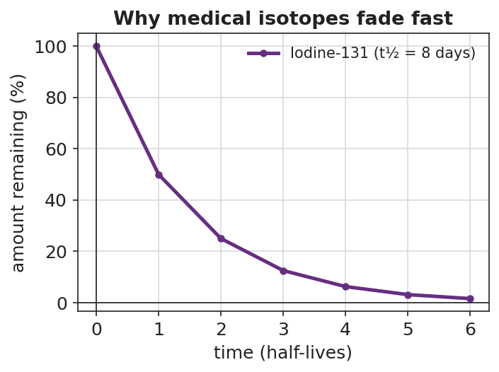
Line graph titled ‘Why medical isotopes fade fast’ showing the percent of Iodine-131 remaining versus time in half-lives; the curve starts at 100% and halves each step to 50, 25, 12.5, 6.25, 3.125, and about 1.6% after six half-lives.
- A medical isotope is radioactive — that’s why it works. It is safe because the dose is __________ and the __________ is short, so it decays away quickly.
- After 1 half-life: ____% remains. After 3 half-lives: ____% remains.
Validity vs. reliability — two different checks:
Validity asks: does the __________ actually support the claim? Reliability asks: is the __________ trustworthy, and would the result __________ if checked again?
A claim can reference a real event (like Chernobyl, 1986) and still be invalid if the reasoning to a different situation (a 2025 plant) does not hold.

Worked Example
Scenario: A campaign mailer states: “A nuclear plant uses fission and an atom bomb uses fission, so living near a plant is just like living next to a bomb that will go off.”
Step 1 — Identify the claim and its evidence:
- Claim: _______________________________________________
- Evidence offered: _______________________________________________
Step 2 — Check validity (does the evidence support the claim?):
The evidence is “both use fission.” Does that support “a plant is a bomb that will go off”? __________ (yes/no), because a reactor is engineered for a __________ (controlled / uncontrolled) chain reaction with low-enriched fuel, while a weapon needs a __________ (controlled / uncontrolled) chain reaction with highly enriched fuel.
Step 3 — Check reliability (is the source trustworthy/repeatable?):
An anonymous campaign mailer with no data is __________ (high / low) reliability compared with an engineering safety study.
Step 4 — Name the deciding variable:
The variable that turns the same fission into a benefit or a catastrophe is __________ and __________.
Step 5 — Because / But / So:
A nuclear plant is not the same as a bomb because _______________________________________________, but _______________________________________________, so _______________________________________________.
Check your reasoning: “because” should name the shared science (fission); “but” should name the difference in dose/control/enrichment; “so” should state the corrected conclusion.

Summary
Complete the Because / But / So sentence:
The same nuclear science can both cure cancer and cause harm because __________________________________________, but __________________________________________, so __________________________________________.
Reminder — how to evaluate any published claim about radiation: 1. What exactly is the claim? 2. What evidence is given? → check validity (does it fit?). 3. Who is the source? → check reliability (trustworthy? repeatable?). 4. Compare benefit and risk against the realistic alternative — no real technology is zero-risk.
Key references (from the Nuclear Chemistry unit): ionizing radiation = high-energy (gamma, X-ray); half-life = time for half a sample to decay (Lesson 03); dose is measured in millisieverts (mSv).

