Placement of Elements — Student Notes
Unit: The Periodic Table — Lesson 01 Name: _______________________ Date: __________ Period: ____

Learning Targets
By the end of today’s 42 minutes I can:
- Explain that elements are arranged in the periodic table in order of increasing atomic number (number of protons).
- Identify the period (row) and group (column) of an element from its position.
- State how many valence electrons an element has by reading its main-group number.
- Explain, using Patterns, why elements in the same group behave alike and why the table has its strange shape.

Key Vocabulary
- period — _______________________________________________ _______________________________________________
- group — _______________________________________________ _______________________________________________
- valence electrons — _______________________________________________ _______________________________________________

Guided Notes
The big idea — Patterns: The periodic table is not a random grid. It is a __________ that repeats. Elements are placed in order of increasing __________ __________ (the number of protons). Because outer-electron arrangement repeats, an element’s __________ in the table predicts its chemistry.
Two directions on the table:
Direction | Name | What the number tells you
Horizontal row | __________ | the number of electron __________ (shells) the atom fills
Vertical column | __________ | the number of __________ electrons (for main-group elements)
The key rule of placement:
Elements are arranged in order of increasing __________ __________ — that is, by how many __________ are in the nucleus. (Not by mass — atomic number is the true ordering principle.)
Valence electrons — the electrons that matter for chemistry:
- Valence electrons are the electrons in the __________ energy level (the outer ring of a Bohr model).
- Sodium has 11 electrons total, but only ________ valence electron.
- It is the __________ electrons, not the total count, that decide how an atom bonds and reacts.
Why same-group elements behave alike (the figure):
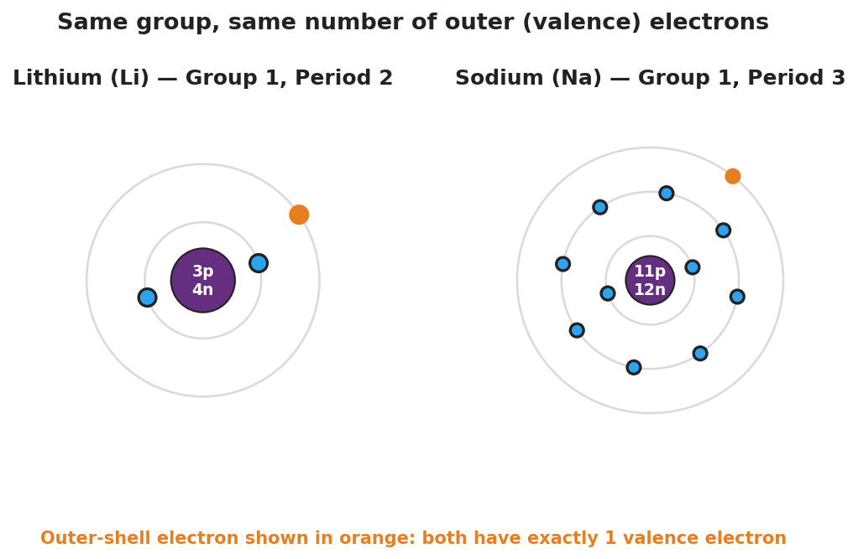
Side-by-side Bohr models of lithium (3 protons, 4 neutrons, electron shells 2 and 1) and sodium (11 protons, 12 neutrons, electron shells 2, 8, and 1). In each atom the single outer-shell electron is highlighted in orange. A caption notes that both elements, although different sizes, have exactly one valence (outer-shell) electron because both belong to Group 1.
From the figure: Lithium and Sodium are different sizes, but both have ________ valence electron(s), because both are in Group ________. That is why they react alike.
Reading across a row (the figure):
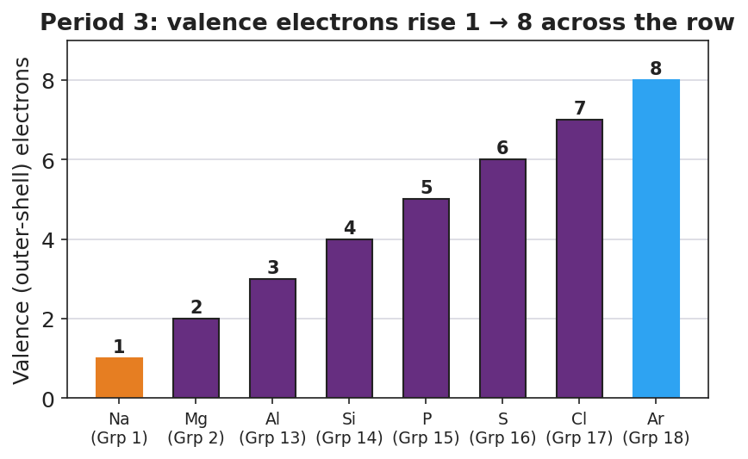
Bar chart titled ‘Period 3: valence electrons rise 1 to 8 across the row.’ Eight bars show the number of outer-shell (valence) electrons for the Period 3 elements from sodium (group 1, one valence electron) on the left rising one at a time to argon (group 18, eight valence electrons) on the right.
Going across Period 3, the valence-electron count rises from ________ (sodium) to ________ (argon), one at a time. When the outer shell fills, the table starts a __________ row.

Worked Example
Scenario: Describe the placement of magnesium (Mg) and use it to predict its chemistry.
Step 1 — Find it on the Periodic Table. Magnesium has atomic number 12, so it has ________ protons.
Step 2 — Read its period (row): Magnesium is in Period ________. This tells me its electrons fill ________ energy levels (shells).
Step 3 — Read its group (column): Magnesium is in Group ________. For a main-group element, this tells me it has ________ valence electrons.
Step 4 — Build the Bohr-model picture: Shells of magnesium: 2, ________, ________ (innermost first). The outer shell holds ________ electron(s) — the valence electrons.
Step 5 — Predict the chemistry: Because magnesium has the same number of valence electrons as ________ (another Group 2 element, such as Be or Ca), it should react in a __________ way.
Step 6 — Because / But / So
Magnesium reacts similarly to the other elements in its column because _______________________________________________, but _______________________________________________, so _______________________________________________.
Check your reasoning: “because” should name the shared valence electrons / same group; “but” should note what differs (period / number of shells / size); “so” should state that the chemistry matches even though the size differs.

Summary
Complete the sentence:
An element’s position in the periodic table tells you its chemistry: the __________ (row) gives the number of electron shells, and the __________ (column) gives the number of __________ electrons.
Complete the Because / But / So sentence:
The periodic table has its strange, lumpy shape because __________________________________________, but __________________________________________, so __________________________________________.
Reminder: Same group = same number of valence electrons = similar chemistry. Same period = same number of electron shells. Elements are placed in order of increasing atomic number (protons).
Key reference (from the 2025 NYS Reference Tables): Atomic number = number of protons (Periodic Table). Main-group number = number of valence electrons.

