Placement of Elements — Student Worksheet
Unit: The Periodic Table — Lesson 01 Name: _______________________ Date: __________ Period: ____

Phenomenon
Your teacher shows you the outline of the periodic table with no symbols inside it — just the shape. It is not a neat rectangle. The top row has two boxes far apart with a wide gap. The next rows are short. Then the rows suddenly get much longer, and a separate block floats detached at the bottom. No other chart you have seen looks like this. And yet scientists drew this shape on purpose and will not let you redraw it as a tidy rectangle.
Driving question: Why does the periodic table have such a strange, lumpy shape instead of being a plain rectangle?

Notice & Wonder
I notice… | I wonder…
Turn & Talk #1: If the shape of the table is a map of something — the way a subway map is a map of stations — what do you think it could be a map of? What about an atom could decide which row or column it goes in?

Initial Model
You are in the year 1869. The phrase “periodic table” does not exist yet. Your group has a set of element-property cards. One card is missing.
Part A — Sort. Arrange the cards so that (1) the ordering value increases as you go, and (2) cards with similar properties line up underneath each other in columns. Leave a gap where the missing card belongs.
Sketch your arrangement (boxes and a gap) here:
Part B — Predict the missing element (“wanted poster”). Using only the pattern in the cards above and below the gap, predict:
Property | Your prediction
Metal or nonmetal?
How reactive?
Formula of a compound it would form
Why do you predict this? (what pattern told you?)

Investigation

Part 1 — Why do the columns repeat? (Bohr-model evidence)
Two of the elements from your sort landed in the same column because they behave alike. Look inside them.
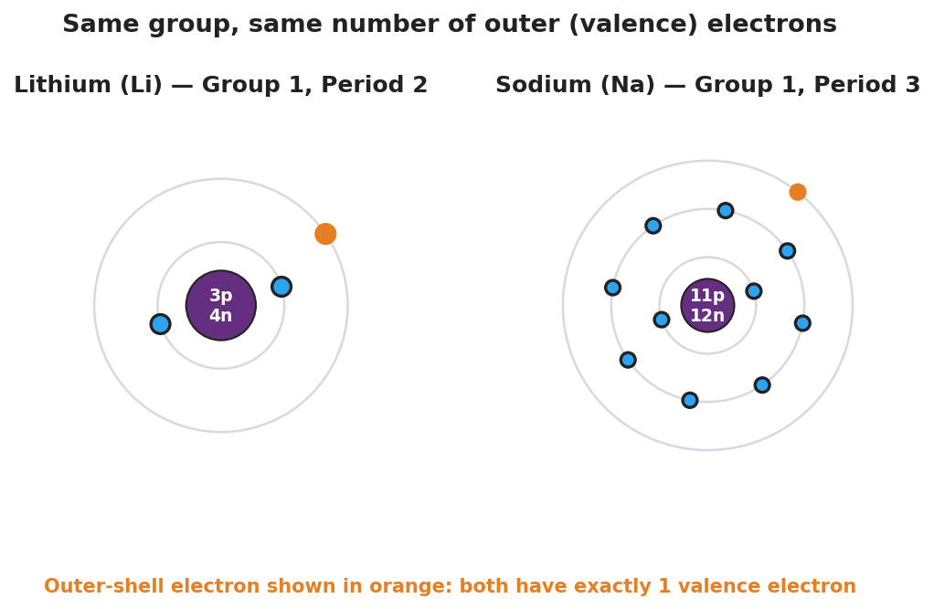
Side-by-side Bohr models of lithium (3 protons, 4 neutrons, electron shells 2 and 1) and sodium (11 protons, 12 neutrons, electron shells 2, 8, and 1). In each atom the single outer-shell electron is highlighted in orange. A caption notes that both elements, although different sizes, have exactly one valence (outer-shell) electron because both belong to Group 1.
Count the electrons in the outermost ring of each atom:
Element | Total electrons (all rings) | Electrons in the OUTER ring only
Lithium (Li)
Sodium (Na)
- The two atoms are very different sizes. What is the same about them? _______________________________________________
- These two elements landed in the same column. Based on your counts, what do you think a “column” of the table has in common? _______________________________________________

Part 2 — Reading across a row
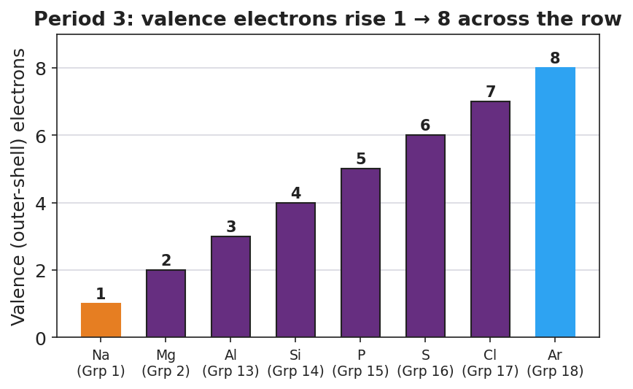
Bar chart titled ‘Period 3: valence electrons rise 1 to 8 across the row.’ Eight bars show the number of outer-shell (valence) electrons for the Period 3 elements from sodium (group 1, one valence electron) on the left rising one at a time to argon (group 18, eight valence electrons) on the right. Sodium’s bar is orange and argon’s bar is blue to mark the ends of the row.
Walk across one row (left to right) using the chart above.
- How many outer-shell electrons does sodium (Na) have? ________ Argon (Ar)? ________
- Going across the row, the outer-electron count goes up by how much each step? ________
- When the count reaches 8 and the row “fills up,” what does the table do next? _______________________________________________

Make It Make Sense
For each item, use the periodic table and what you discovered above. Show your reasoning, not just an answer.
- Potassium (K) sits directly below sodium (Na) in the same column.
  - How many outer-shell (valence) electrons will potassium have? _______________
  - Will potassium react like sodium, or differently? Why? _______________________________________________
- Two elements: one is in Group 1, the other is in Group 7 (also written Group 17).
  - Outer-shell electrons in the Group 1 element: ________ In the Group 17 element: ________
  - Why would these two elements behave very differently? _______________________________________________
- An element is in Period 4 of the table.
  - What does the period number (4) tell you about its electrons? _______________________________________________
  - Does the period number tell you how many outer electrons it has? Why or why not? _______________________________________________

Vocabulary in Action
Use each term in a sentence about today’s card sort or Bohr-model investigation. Do not copy the definition — describe something you actually did or observed.
- period: _______________________________________________ _______________________________________________
- group: _______________________________________________ _______________________________________________
- valence electrons: _______________________________________________ _______________________________________________

Revise Your Model
Return to your Initial Model “wanted poster.” Add vocabulary labels to explain why your prediction worked:
- The missing element shared a __________ (column) with its neighbors, which means it had the same number of __________ __________.
- That is why it behaved like the elements above and below it in the column.
Then finish this Because / But / So sentence:
Lithium and sodium behave almost identically because __________________________________________, but __________________________________________, so __________________________________________.

Exit Ticket
(a) Element X has atomic number 12. State its number of protons, and use the Periodic Table to give its period and group.
Protons: ________ Period: ________ Group: ________
(b) Beryllium (Be) and magnesium (Mg) are both in Group 2. How many valence electrons does each have, and what does that tell you about how they react?
Valence electrons — Be: ________ Mg: ________ What it tells you: _______________________________________________
(c) In one sentence, explain — using the idea of valence electrons — why two elements in the same group behave alike even though one is much larger than the other.

