Electron Configuration & Valence Electrons — Student Notes
Unit: The Periodic Table — Lesson 02 Name: _______________________ Date: __________ Period: ____

Learning Targets
By the end of today’s 42 minutes I can:
- Read the electron configuration of any main-group element from the Periodic Table (Reference Table S) and draw it as a Bohr shell diagram.
- Identify the number of valence electrons (the electrons in the outermost occupied shell) from a configuration or a shell diagram.
- State the rule connecting the group number to valence electrons (Group 1 → 1, Group 2 → 2, Groups 13–18 → 3–8).
- Explain, using Patterns, why elements in the same group behave so similarly.

Key Vocabulary
- electron configuration — _______________________________________________ _______________________________________________
- valence electrons — _______________________________________________ _______________________________________________
- group — _______________________________________________ _______________________________________________

Guided Notes
The big idea — Patterns: Elements in the same __________ (column) share the same number of __________ electrons. That shared number is why the whole column shares similar chemical __________. The table is arranged so the columns reveal this pattern in electron structure.
Reading the electron configuration:
The electron configuration lists how many electrons are in each shell, from the __________ shell outward. It is printed under each element on Reference Table S — you do not have to calculate it.
Element | Configuration | Number of shells (rings) | Last number = valence electrons
Lithium (Li) | 2-1
Sodium (Na) | 2-8-1
Potassium (K) | 2-8-8-1
The valence electrons are the electrons in the __________ shell — and they are always the __________ number of the electron configuration.
The group-to-valence rule (main-group elements only):
- Group 1 → ___ valence electron
- Group 2 → ___ valence electrons
- Group 13 → 3 Group 14 → ___ Group 15 → ___ Group 16 → ___ Group 17 → ___ Group 18 → ___
For Groups 13–18, the valence count is the __________ digit of the group number.
The Hochman appositive definition:
Valence electrons — _________________________ — determine how the element reacts.
The figure — three Group 1 metals, one shared outer electron:
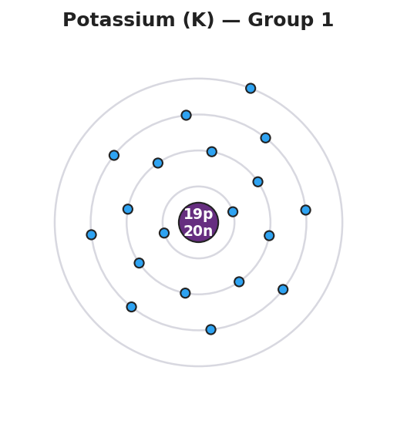
Bohr model of a potassium atom: a central nucleus labeled 19p 20n surrounded by four electron shells holding 2, 8, 8, and 1 electrons from inner to outer, with a single electron in the outermost shell, labeled Potassium (K) Group 1.
From the figure above and the table, fill in the blanks:
- Potassium’s configuration is __________, so it has ___ valence electron.
- Lithium, sodium, and potassium all have ___ valence electron, which is why they are all in Group ___.
- Their proton counts are different (3, 11, 19), but their behavior is the same because _______________________________________________

Worked Example
Scenario: A student needs to find the valence electrons and group of sulfur (S).
Step 1 — Look up the electron configuration on Reference Table S:
Sulfur (S) configuration: ___________
Step 2 — Count the shells (rings):
Number of numbers in the configuration = number of shells = ___
Step 3 — Find the valence electrons (the last number):
Valence electrons = ___
Step 4 — Use the rule to find the group:
Valence electrons = ___ → for Groups 13–18 the group number ends in that digit → Group ___
Step 5 — Appositive sentence:
Sulfur’s valence electrons — its ___ outermost electrons — make it a reactive nonmetal that tends to ___ electrons to fill its shell.
Step 6 — Because / But / So
Sulfur and oxygen react in similar ways because _______________________________________________, but _______________________________________________, so _______________________________________________.
Check your reasoning: “because” should name the shared valence count; “but” should acknowledge what is different (mass, number of shells); “so” should state why the behavior is still similar (same group).

Summary
Complete the appositive sentence:
Valence electrons — _________________________ — determine how the element reacts.
Complete the Because / But / So sentence:
All of the Group 1 metals react with water in the same way because __________________________________________, but __________________________________________, so __________________________________________.
Reminder: The last number of an electron configuration is the number of valence electrons. The number of separate numbers tells you how many shells (and which period the element is in). Group number predicts valence electrons for the main-group elements.
Key reference (from the 2025 NYS Reference Tables): Electron configurations: printed under each symbol on the Periodic Table (Reference Table S) First shell holds up to 2 electrons; second and third shells hold up to 8.

