Electron Configuration & Valence Electrons — Student Worksheet
Unit: The Periodic Table — Lesson 02 Name: _______________________ Date: __________ Period: ____

Phenomenon
Lithium, sodium, and potassium are three different elements stacked in the same column of the periodic table. When a small piece of each is dropped into water, all three react the same way: lithium fizzes, sodium pops and skitters, potassium ignites with a lilac flame. Same kind of reaction, getting stronger down the column. These three atoms have different numbers of protons and different sizes — yet they behave like a family.
Driving question: Why do all the elements in a column of the periodic table behave so similarly?

Notice & Wonder
Look at the three Bohr-model diagrams your teacher is projecting (lithium, sodium, potassium).
I notice… | I wonder…
Turn & Talk #1: The three atoms have different numbers of protons (3, 11, 19) and different numbers of shells (2, 3, 4). Find the one thing that is identical across all three diagrams. In one sentence, name it as specifically as you can.

Initial Model
Before your teacher names the process: use the Periodic Table (Reference Table S) to look up the electron configuration of oxygen (O) and chlorine (Cl). Write each one exactly as printed, then state how many electrons are in the outermost shell.
Element | Electron configuration (from Reference Table S) | Electrons in the outermost shell | Group number
Oxygen (O)
Chlorine (Cl)
- What is the last number of each configuration? __________ (O) __________ (Cl)
- Compare the last number to the group number. What relationship do you notice? _______________________________________________
- What single piece of information did you need from the formula and the table? _______________________________________________

Investigation

Part 1 — ABCs: Draw the shells before you name anything
Use the configurations from Reference Table S. Draw a nucleus and one ring per number, placing that many electrons on each ring. Then circle the outermost ring on each drawing and write the count next to it.
Element | Configuration | Draw your Bohr diagram here | Outermost electrons
Lithium (Li) | 2-1
Sodium (Na) | 2-8-1
Potassium (K) | 2-8-8-1
What is the last number of all three configurations? _______________
What does that tell you about why Li, Na, and K behave so similarly? _______________________________________________
The figure below shows the same three atoms drawn for you — compare them to your own drawings:
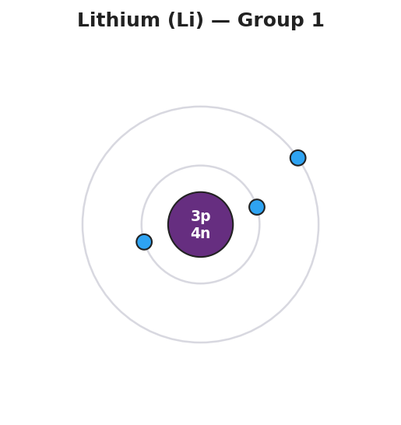
Bohr model of a lithium atom: a central nucleus labeled 3p 4n surrounded by two electron shells, the inner shell holding 2 electrons and the outer shell holding 1 electron, labeled Lithium (Li) Group 1.
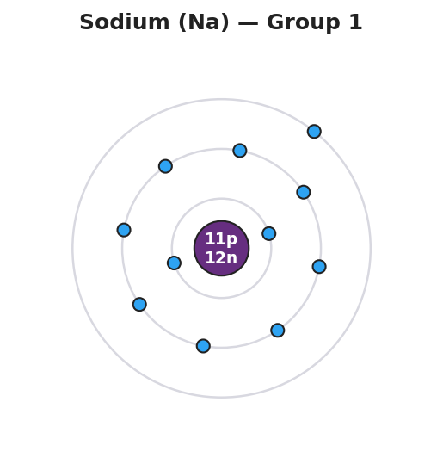
Bohr model of a sodium atom: a central nucleus labeled 11p 12n surrounded by three electron shells holding 2, 8, and 1 electrons from inner to outer, with a single electron in the outermost shell, labeled Sodium (Na) Group 1.

Part 2 — Group-property prediction stations
At each station you get a card showing only an electron configuration — no element name. Read the last number (outermost electrons), predict the group, and predict one property.
Card configuration | Outermost electrons | Predicted group | Predicted property (reactive metal? unreactive gas? gains or loses electrons?)
2-8-1
2-8-2
2-8-7
2-8-8
2-4
Key question: Two cards have different last numbers but you may have predicted both are reactive (for example 2-8-1 and 2-8-7). Why are they reactive in opposite ways — one loses an electron, one gains one?

Part 3 — Reading the pattern
Look at figures/valence_by_group.png:
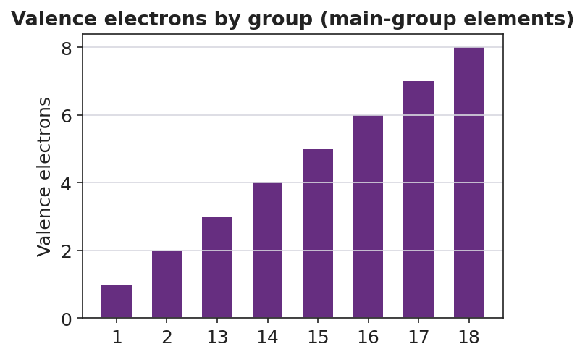
Bar chart titled ‘Valence electrons by group (main-group elements)’ showing valence electron counts on the y-axis for eight main groups on the x-axis: Group 1 has 1 valence electron, Group 2 has 2, and Groups 13, 14, 15, 16, 17, and 18 have 3, 4, 5, 6, 7, and 8 respectively; the bars rise in a steady staircase pattern from left to right.
- How many valence electrons does a Group 2 element have? _______________
- Which group has a full outermost shell of 8 valence electrons? _______________
- Carbon is in Group 14. Using the chart, how many valence electrons does it have? _______________

Make It Make Sense
For each element below, write its electron configuration from Reference Table S, state the number of valence electrons, and name its group.
- Lithium (Li)
  - Electron configuration: _______________
  - Number of valence electrons: _______________
  - Group: _______________
- Chlorine (Cl)
  - Electron configuration: _______________
  - Number of valence electrons: _______________
  - Group: _______________
- Argon (Ar)
  - Electron configuration: _______________
  - Number of valence electrons: _______________
  - Group: _______________
  - Why is argon so unreactive? _______________________________________________

Vocabulary in Action
Use each term in a sentence about today’s investigation. Do not copy the definition — describe something you actually drew, read, or predicted.
- electron configuration: _______________________________________________ _______________________________________________
- valence electrons: _______________________________________________ _______________________________________________
- group: _______________________________________________ _______________________________________________

Revise Your Model
Return to your three Bohr drawings (Li, Na, K). Add vocabulary labels:
- Next to the list of rings on each drawing, write the label “electron configuration.”
- Draw a box around the outermost ring on each drawing and label it “valence electrons.”
- Write the group number next to all three drawings. They should all be Group ____.
Now write an appositive sentence for chlorine:
Chlorine’s valence electrons — its ___ outermost electrons — make it a very reactive ___ that tends to ___ one electron.
Then finish this Because / But / So sentence:
Lithium, sodium, and potassium all react with water the same way because __________________________________________, but __________________________________________, so __________________________________________.

Exit Ticket
(a) Use the Periodic Table to write the electron configuration of magnesium (Mg). How many valence electrons does it have, and what group is it in?
Electron configuration: _______________ Valence electrons: _______________ Group: _______________
(b) Use the Periodic Table to write the electron configuration of fluorine (F). How many valence electrons does it have, and what group is it in?
Electron configuration: _______________ Valence electrons: _______________ Group: _______________
(c) In one sentence, explain why all of the Group 17 elements (fluorine, chlorine, bromine…) are highly reactive.

