Classes of Elements — Student Notes
Unit: The Periodic Table — Lesson 03 Name: _______________________ Date: __________ Period: ____

Learning Targets
By the end of today’s 42 minutes I can:
- Classify a sample element as a metal, nonmetal, or metalloid using physical-property evidence (luster, electrical conductivity, malleability/brittleness).
- Describe the property cluster typical of each class and contrast metals with nonmetals point by point.
- Explain, using Patterns, how a known property cluster lets me predict an untested element’s behavior, including its tendency to react.
- Identify a metalloid as an element with in-between properties that fits neither the metal nor the nonmetal pile cleanly.

Key Vocabulary
- metal — _______________________________________________ _______________________________________________
- nonmetal — _______________________________________________ _______________________________________________
- metalloid — _______________________________________________ _______________________________________________

Guided Notes
The big idea — Patterns: The same cluster of __________ repeats across many elements. Recognizing that pattern lets us __________ how an element will behave — including how it acts in a circuit and how readily it __________ — before we ever test it.
The three classes of elements:
Class | Luster | Conducts electricity? | Mallet test | Tendency to react
Metal |  |  |  | tends to ________ electrons
Nonmetal |  |  |  | tends to ________ or share electrons
Metalloid |  |  |  | (in-between / variable)
The three property tests (how to classify any sample):
- Luster — is it __________ or __________?
- Electrical conductivity — does it carry current? (a metal does; a nonmetal is an __________; a metalloid conducts only a __________)
- Malleability vs. brittleness — under force, does it __________ (metal) or __________ (nonmetal)?
Why metals bend and nonmetals shatter (from the Javalab model):
When a metal is hammered, its atoms __________ past one another into new positions, so the metal reshapes without breaking. In a brittle nonmetal, the particles __________ slide, so applying force makes it __________ instead.
The figure — the three classes and their property clusters:
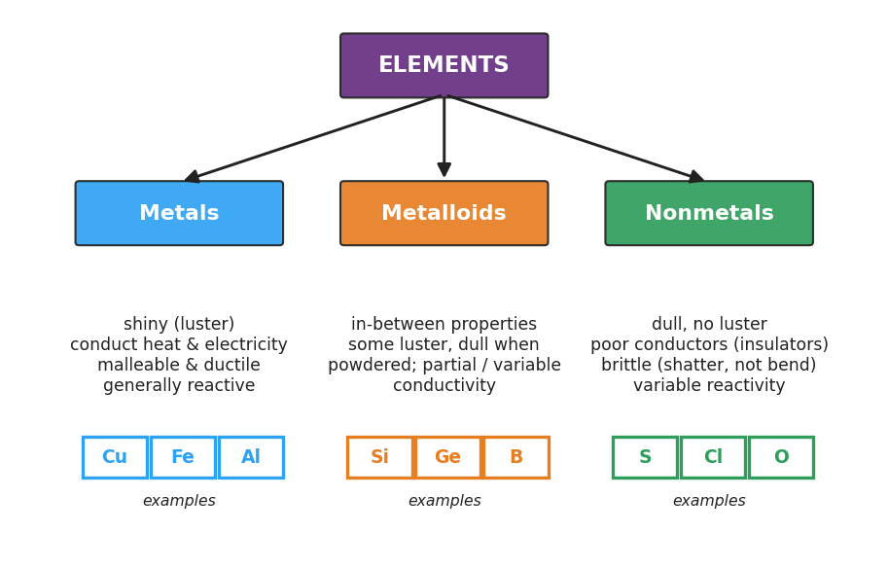
Flowchart titled ‘ELEMENTS’ branching into three classes — Metals (blue), Metalloids (orange), and Nonmetals (green). Under Metals: shiny luster, conduct heat and electricity, malleable and ductile, generally reactive, with examples copper, iron, aluminum. Under Metalloids: in-between properties, some luster but dull when powdered, partial or variable conductivity, with examples silicon, germanium, boron. Under Nonmetals: dull with no luster, poor conductors (insulators), brittle (shatter not bend), variable reactivity, with examples sulfur, chlorine, oxygen.
From the figure above, fill in the blanks:
- A class that is shiny, conductive, and malleable: ___________
- A class that is dull, insulating, and brittle: ___________
- A class with in-between / partial properties: ___________
- One example element of each class: metal ___________, metalloid ___________, nonmetal ___________

Worked Example
Scenario: A new element, “Element M,” is tested. It is shiny, it lights the conductivity bulb brightly, and it flattens under a gentle mallet tap instead of shattering. Classify it and predict its behavior.
Step 1 — Record the three property observations:
- Luster: ___________
- Conductivity: ___________
- Mallet test: ___________
Step 2 — Match the observations to a property cluster:
Shiny + conducts well + flattens (malleable) → this matches the __________ cluster.
Step 3 — Classify:
Element M is a ___________.
Step 4 — Predict using the Patterns CCC:
Because Element M fits the metal pattern, I predict it would __________ electricity in a circuit and, when it reacts, would tend to __________ electrons.
Step 5 — Because / But / So
Element M is classified as a metal because _______________________________________________, but _______________________________________________, so _______________________________________________.
Check your reasoning: “because” should name the metal property cluster; “but” should contrast it with what a nonmetal would have shown; “so” should state the classification and one prediction.

Summary
Complete the Because / But / So sentence:
We can predict an element’s class before testing it because __________________________________________, but __________________________________________, so __________________________________________.
Reminder: Classify by the cluster of properties — luster and conductivity and the mallet test — not by a single observation. A metalloid is the “third pile”: in-between, partly shiny, only weakly conductive, and brittle.
Key idea (no group names needed): Metals, nonmetals, and metalloids are defined by what they do — their physical-property pattern and their tendency to react — not by where they sit by name on the table.

